**Press Release Contacts:**

**For Immediate Release** Vinitaly International

International Media Dept.

+39 045 8101447

[media@vinitalytour.com](mailto:media@vinitalytour.com)

[www.vinitalytour.com](http://www.vinitalytour.com)

Twitter: @VinitalyTour

Join Vinitaly International Network on LinkedIn

**Vinitaly International leads efforts to increase Italian Wine sales in China: a Round table in Chengdu dedicated to Italian Wine Importers**

*Chengdu, 25 March 2014* – Coordination, communication, and dialogue. With these three elements, Italian wine could start to play a leading role in China. At the moment, Italy’s market share in the Asian giant is around 6%. The Country is the fifth exporter, clearly behind the French. The chance to grow to double digits does not seem an impossible task, however. This is what emerged from the round table with Italian wine importers and the most important Italian institutions present in the Middle Kingdom. The initiative – which was unprecedented in China – was held in Chengdu, in the country’s capital of alcohol distribution, at the beginning of the most influential wine events in Asia: Fuorisalone and the Chengdu Fair.

Participants included the Italian ambassador in Beijing, Alberto Bradanini, the First Economic Advisor of the Embassy Augusto Massari, the Consul General of Chongqing Sergio Maffettone and two representatives of the Italian Chamber of Commerce in China, Angelo Morano and Antonella Sciarra. Joining the round table were 15 importers from five metropolises (four first-tier cities plus Chengdu): Shanghai (Amore Fine Wines, Sinodrink, Hoonay, EMW, Insider and Chuxiao), Guangzhou (VM Fine Wines and Fiabe), Beijing (Venas Vinus and 100ITA), Shenzhen (Kelit, Fiabe) and Chengdu (Two Lions and Vino di Vito). The debate was held at Bookworm, the bookstore that is home to one of the most important literature festivals in China. Under the direction of Stevie Kim, Managing Director of Vinitaly International, the importers spoke one by one, expressing their opinions and sharing their experiences to date in what is indeed the most promising market in the world, but also one of the most confusing, complicated, and fragmented.

The encounter also elicited heated words among several of the participants. Over the course of two hours, the debate concluded that the so-called “Italian System” shouldn’t be just a slogan without follow-up actions that are coordinated and planned over time. “The problem,” explains Ambassador Bradanini, “Is that in China, Italy is not seen as one of the wine-producing countries. We are known for fashion, for tourism but when it comes to wine, the Chinese automatically think of France.”

“We have to start to create an image for Italian wine,” affirms Vinicio Eminenti of VM Fine Wines. “We are still too far behind in this regard.”

“There are too many initiatives and collectives, all separate and without direction,” argues Roberto Rossi of Amore Wines. “We have to make sure the knowledge of Italian wine is on the same level as that of French wine.”

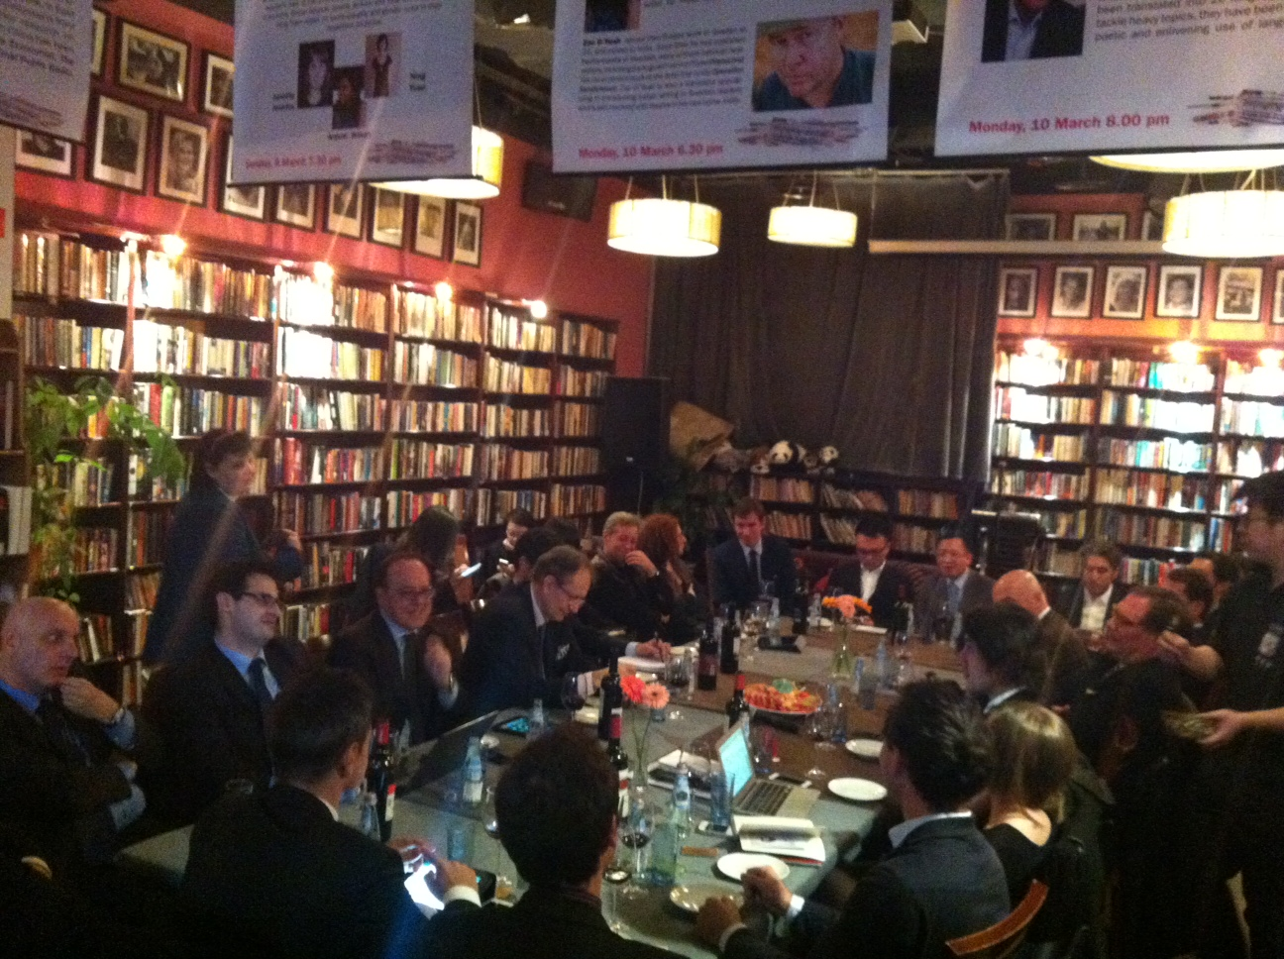

Participants unanimously agreed that the players who represent Italian wine should be few, and clear. “Importers hope that the Embassy, with the support of Vinitaly, can really create a turning point,” says Giordano Zizzi of Venas Vinus. “Here in Chengdu we are finally united and we can make a difference.”

The discussion also touched on the themes of e-commerce and the scheduling of events in which Italy – via importers and producers – should participate. Post-Chengdu, Italian wine will have to work toward better communication among the key players, in order to promote - and most of all sell - Italian wine. What will be the concrete next steps? The General Director of Veronafiere Giovanni Mantovani and the Managing Director of Vinitaly International Stevie Kim have proposed two projects, the results of which will soon be visible. The first is an online initiative, with the creation of a group on Wechat (the most popular social media app in China) that unites all of the importers to more easily disseminate information and a page on Weibo (the Chinese equivalent of Facebook) of Vinitaly International, to serve as a collector of Italian wine initiatives in China. The second project will be enacted at Sial China - to be held in Shanghai from May 13-15 – where Vinitaly will have a space dedicated to Masterclasses, and will see the full involvement of the importers. Small steps, but all toward the same goal: increasing the knowledge of Italian wine, a necessary condition for increasing the sales of our wine in China.

**About:**

**Veronafiere** is the leading organizer of trade shows in Italy including Vinitaly (www.vinitaly.com), the largest wine event in the world. The 47th edition of Vinitaly counted some 148,000 visitors (+6%), of which 53.000 were international attendees (+10%) visiting from 120 countries. On 95.000 square meters, 4.200 exhibitors welcomed trade professionals, media and producers alike. The next installment of the fair will take place on 6th- 9th April 2014. The premier event to Vinitaly, OperaWine (www.vinitalyinternational.com) “Finest Italian Wines: 100 Great Producers”, will unite international wine professionals on April 5th 2014 in the heart of Verona. Veronafiere also created Vinitaly International in 1998 to develop a global platform for the promotion of companies in the Italian wine and food sectors.

**# # #**