Press Release Contacts:
For Immediate Release Vinitaly International
International Media Dept.
+39 045 8101447
media@vinitalytour.com
www.vinitalytour.com
Twitter: @VinitalyTour
Join Vinitaly International Network on LinkedIn

Innovation in Verona as judges trade pen and paper for iPads at Vinitaly International Wine Competition

Verona, 03 April, 2014 - It was more than wine that had the judges talking at the 21st edition of the Vinitaly International Wine Competition last week in Verona. From March 26th to 30th, 105 judges from around the world gathered to evaluate nearly 3,000 wines from 30 different countries – for the first time in the history of this or any other major international wine competition using iPads rather than paper to record their scores. The application calculated each judge’s score instantly, and sent the data wirelessly to a central computer for consolidation and verification by an oversight lawyer. After some initial hesitation at adapting the new technology, judges applauded its simplicity, efficiency and confidentiality.

“I think the new system was a great investment; it saves a lot of time and is really easy to use,” says Russian wine journalist Anton Moiseenko. “During the presentation of the system I heard a few ‘Oh my Gods’ from some Italian wine makers because they saw the iPads and they were scared to use them. But paper is quite annoying, it takes a lot of time and it is quite hard for the back office to actually process the results. This is a much more relaxing experience for a judge.”

“This is the fourth time I’ve come to Verona and each time the organization gets better,” marvels Venezuelan judge Guglielmo Vargas. “The use of the iPad was perfect, because the bureaucracy behind the use of paper can waste a lot of time. We used to spend much more time filling in the papers rather than paying attention to the wine. Now with the iPad you have a lot more time to dedicate to the wine.”

“I fully supported and applauded the new system - it was quick, very easy,” agrees American wine blogger and importer Alfonso Cevola. “This the first time I have used an iPad; I thought the interface was very good, the descriptions were very good, the ability to score, the ability also to apply certain comments if you wanted to. This was one of the best competitions I have been to and I go to competitions all over the United States and Italy.”

Like Mr. Cevola, many of the most experienced judges were particularly impressed by the way the iPad simplified the rating process. “I have participated in many wine competitions, and I thought the iPad was a very nice idea. It saves you time, you don’t need to add up the points by hand, you can change your mind and change your points very easily – it’s great,” agrees Chan Jun Park, Korean wine journalist and educator.
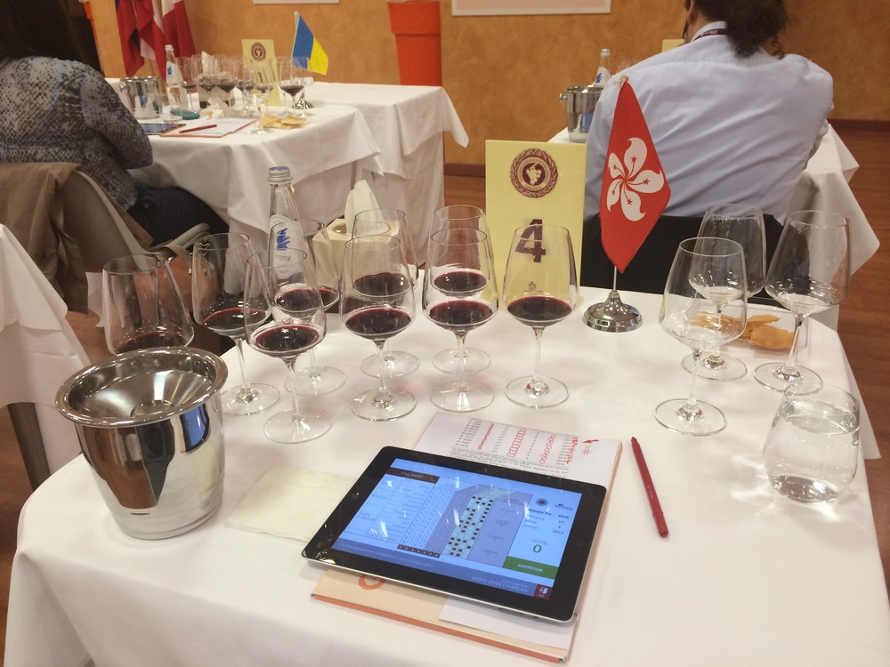
“Look, I’ve been doing this for many years, and I don’t like to change things because I think the Vinitaly wine competition works very well. When they first introduced the iPad as the new scoring tool, I was very reluctant,” admits Norwegian veteran wine judge Karl-Axel Svensson. “Now I’m a complete believer. It made my job much easier, and it allowed me to focus so much more on the tasting, and not on calculating and the paperwork. I didn’t realize how much time I’d wasted actually doing the scoring. I would never have said this before I tried it, but it was great and I would recommend it for any competition.”

“The iPad is a great idea - not only is it super-efficient and precise, but more importantly it gives detailed reports to wine makers, allowing them to understand the reactions of the judges and make improvements to their wines,” explains JC Viens, a Hong Kong-based wine educator. “And that I think is the most valuable benefit a wine maker can get from submitting their wine to a competition.”

“This is the natural evolution of Vinitaly Interactive, a similar iPad project we tried two years ago at grand tasting events in New York, Russia, and Hong Kong,” explains Managing Director of Vinitaly International Stevie Kim. “We realized that was not the ideal platform for this technology, because your natural instinct at a wine fair is to just taste, and ignore the scoring aspect. But now it’s clear the iPad is perfect as a competition tool, because it’s a quick system that keeps track of all the information for hundreds of wines – in this case, nearly 3000. Some of the judges from Moscow and Hong Kong were part of the initial Vinitaly Interactive project and they've also agreed the wine competition is the optimal ambience rather than a grand tasting context. It makes things easier for everyone – the judges, the organizers, and the overseers. But it is also designed to be a useful tool for communicating information about the wines directly to the winemakers – transforming the wine competition into a truly valuable experience for the cantina.”

About:
Veronafiere is the leading organizer of trade shows in Italy including Vinitaly (www.vinitaly.com), the largest wine event in the world. The 47th edition of Vinitaly counted some 148,000 visitors (+6%), of which 53.000 were international attendees (+10%) visiting from 120 countries. On 95.000 square meters, 4.200 exhibitors welcomed trade professionals, media and producers alike. The next installment of the fair will take place on 6th- 9th April 2014. The premier event to Vinitaly, OperaWine (www.vinitalyinternational.com) “Finest Italian Wines: 100 Great Producers”, will unite international wine professionals on April 5th 2014 in the heart of Verona. Veronafiere also created Vinitaly International in 1998 to develop a global platform for the promotion of companies in the Italian wine and food sectors.
# # #

