**Deskhacks.com Stand Steady Article**

**March 3, 2014**

[**The Perfect First Standing Desk: A Review of the Executive Stand Steady Stand Up Desk**](http://deskhacks.com/the-perfect-first-standing-desk-a-review-of-the-executive-stand-steady-stand-up-desk/)

by guest on March 3, 2014

[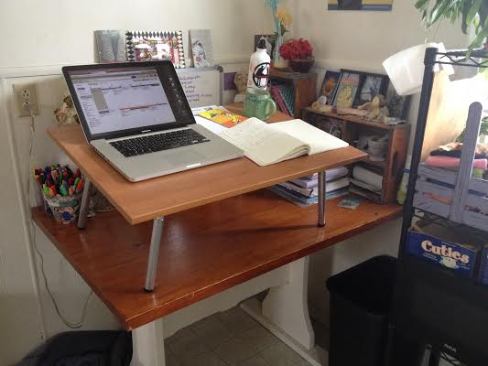](http://www.amazon.com/gp/product/B00GGQJRV0/ref=as_li_ss_tl?ie=UTF8&camp=1789&creative=390957&creativeASIN=B00GGQJRV0&linkCode=as2&tag=deskhacks-20)

The Stand Steady series of desks can easily and quickly convert a sitting desk into a standing desk. When I was invited to review this product I immediately wished I’d known about the Stand Steady desk three years ago when I was looking for an affordable standing desk for my home office.

The [Executive Stand Steady desk](http://www.amazon.com/gp/product/B00GGQJRV0/ref=as_li_ss_tl?ie=UTF8&camp=1789&creative=390957&creativeASIN=B00GGQJRV0&linkCode=as2&tag=deskhacks-20) setup is ridiculously easy, taking just about five minutes, as the company promises. The package contents consist of a wooden desktop, two lightweight metal legs, five screws, four tube reducers, and four rubber leg pegs. The parts arrived a bit scattered in the box because the bag of parts burst open during transit. The list of components on the instructions also promised a penny as a gesture for just how easy setup is, but it was missing from mine.

The desk comes with a sheet of instructions with troubleshooting tips and handy info for transitioning from a sitting to standing desk. To be honest, the instructions are a bit wordy, especially considering how simple it is to put the desk together. I got a bit lost and overwhelmed in that document, but it was all but forgotten once I starting using the desk.

I decided to try out the [Stand Steady](http://www.amazon.com/gp/product/B00GGQJRV0/ref=as_li_ss_tl?ie=UTF8&camp=1789&creative=390957&creativeASIN=B00GGQJRV0&linkCode=as2&tag=deskhacks-20) on my kitchen table, which actually serves as my partner’s desk in our house. I already have a standing desk in my home office, so to really try out the desk I needed a surface at sitting height. The Stand Steady comes with adjustable height legs, which is valuable in accounting for varied sitting desk heights and body proportions of the user.

What I immediately loved about the Stand Steady is the option of angling the desk surface, which is great for laptop users. I will often catch myself bending my head at the neck to accommodate my laptop screen, but with the Stand Steady’s angled desktop I was standing up straighter from my mid-back to my shoulders.

The Executive Stand Steady model offers a good amount of workspace. I was able to fit my laptop, a notebook, coffee, and a water bottle on the desktop. The design of the desk also offers storage space underneath the desk surface. At first I was a bit put off at the weight of the Stand Steady; it’s pretty heavy. But after using it the heft of the desk offers a necessary stability, especially for every day use.

As a grad student, my office space changes year to year, and in an institutional setting I’m not in the position to demand a standing desk. But the Stand Steady will allow me to adapt any sitting desk into a standing desk. And if you are in the position to request a desk from your company, organization, or institution, the Stand Steady is an ideal choice because it’s drastically less expensive than a standing desk.

Overall, the [Executive Stand Steady](http://www.amazon.com/gp/product/B00GGQJRV0/ref=as_li_ss_tl?ie=UTF8&camp=1789&creative=390957&creativeASIN=B00GGQJRV0&linkCode=as2&tag=deskhacks-20) is perfect for first-time standing desk users who are looking to affordably and easily convert their current sitting desk into a standing workspace.

*Casey Miles is a PhD student at Michigan State studying queer rhetorics through documentary filmmaking and digital rhetoric. You can find out more about her work at* [*www.soulsmiles.com*](http://www.soulsmiles.com/)*, or follow her on Twitter* [*@soulsmiles*](http://twitter.com/soulsmiles)*.*