**Press Release Contacts:**

**For Immediate Release** Vinitaly International

International Media Dept.

+39 045 8101447

[media@vinitalytour.com](mailto:media@vinitalytour.com)

[www.vinitalytour.com](http://www.vinitalytour.com)

Twitter: @VinitalyTour

Join Vinitaly International Network on LinkedIn

**Find your niche, and tell your story, advise Russian and US panelists at Vinitaly International’s *Talk Business* seminar series.**

Verona, 10 April 2014 – During its new Talk Business series at Vinitaly this week, Vinitaly International brought together importers, educators, sommeliers and press from various markets they’ve visited on their world tour over the past year – including Russia, the US, China, and Hong Kong – for targeted sessions aimed at helping Italian producers understand how to best position their brands in those countries. Despite vast market differences, panelists from Russia and the US had similar advice for producers, emphasizing the importance of finding their niche within each of these vast nations, and of playing to the strengths of Italian wine – especially the uniqueness of Italy’s native grapes and regional varieties.

Russian wine journalist Anton Moiseenko, moderated Sunday’s Russian seminar, which quickly acknowledged the difficulties of working in the Russian market, especially given current economic and political conditions. “Russia is struggling with a post-Olympic budget deficit,” explained Vladislav Volkov, General Manager of boutique wine importer Vinoterra. “The Russian ruble is devaluating fast. Most companies have increased prices up to 30%, so the market is quite unfavorable.”

But there were plenty of reasons to be optimistic about the potential of the Russian wine market, as Mr. Moiseenko explained, “Russia’s wine consumers are developing their taste for wine, even if it’s not happening as quickly as it could if the economic situation and alcohol regulations were more positive. But the good news is Italian wine is growing in Russia – Italy is already among the top three importers, and the vast diversity of Italian wine is an advantage because Russians like to try new things. The important thing is how we can communicate with them.”

Important, also, is identifying the target audience, and focusing communication efforts on that audience. “Producers have to ask themselves if they are selling top-level or mass-market wines,” explained Andrey Savchenko, Import Director for AST International. “For top wines, that market is Moscow. But for the rest of the countryside, you need a different strategy.”

“You need to know which niche you’re targeting,” agreed Mr. Volkov. “And don’t expect too much in a year or two years. You need to have at least a three-year plan, because establishing a new brand takes time.”

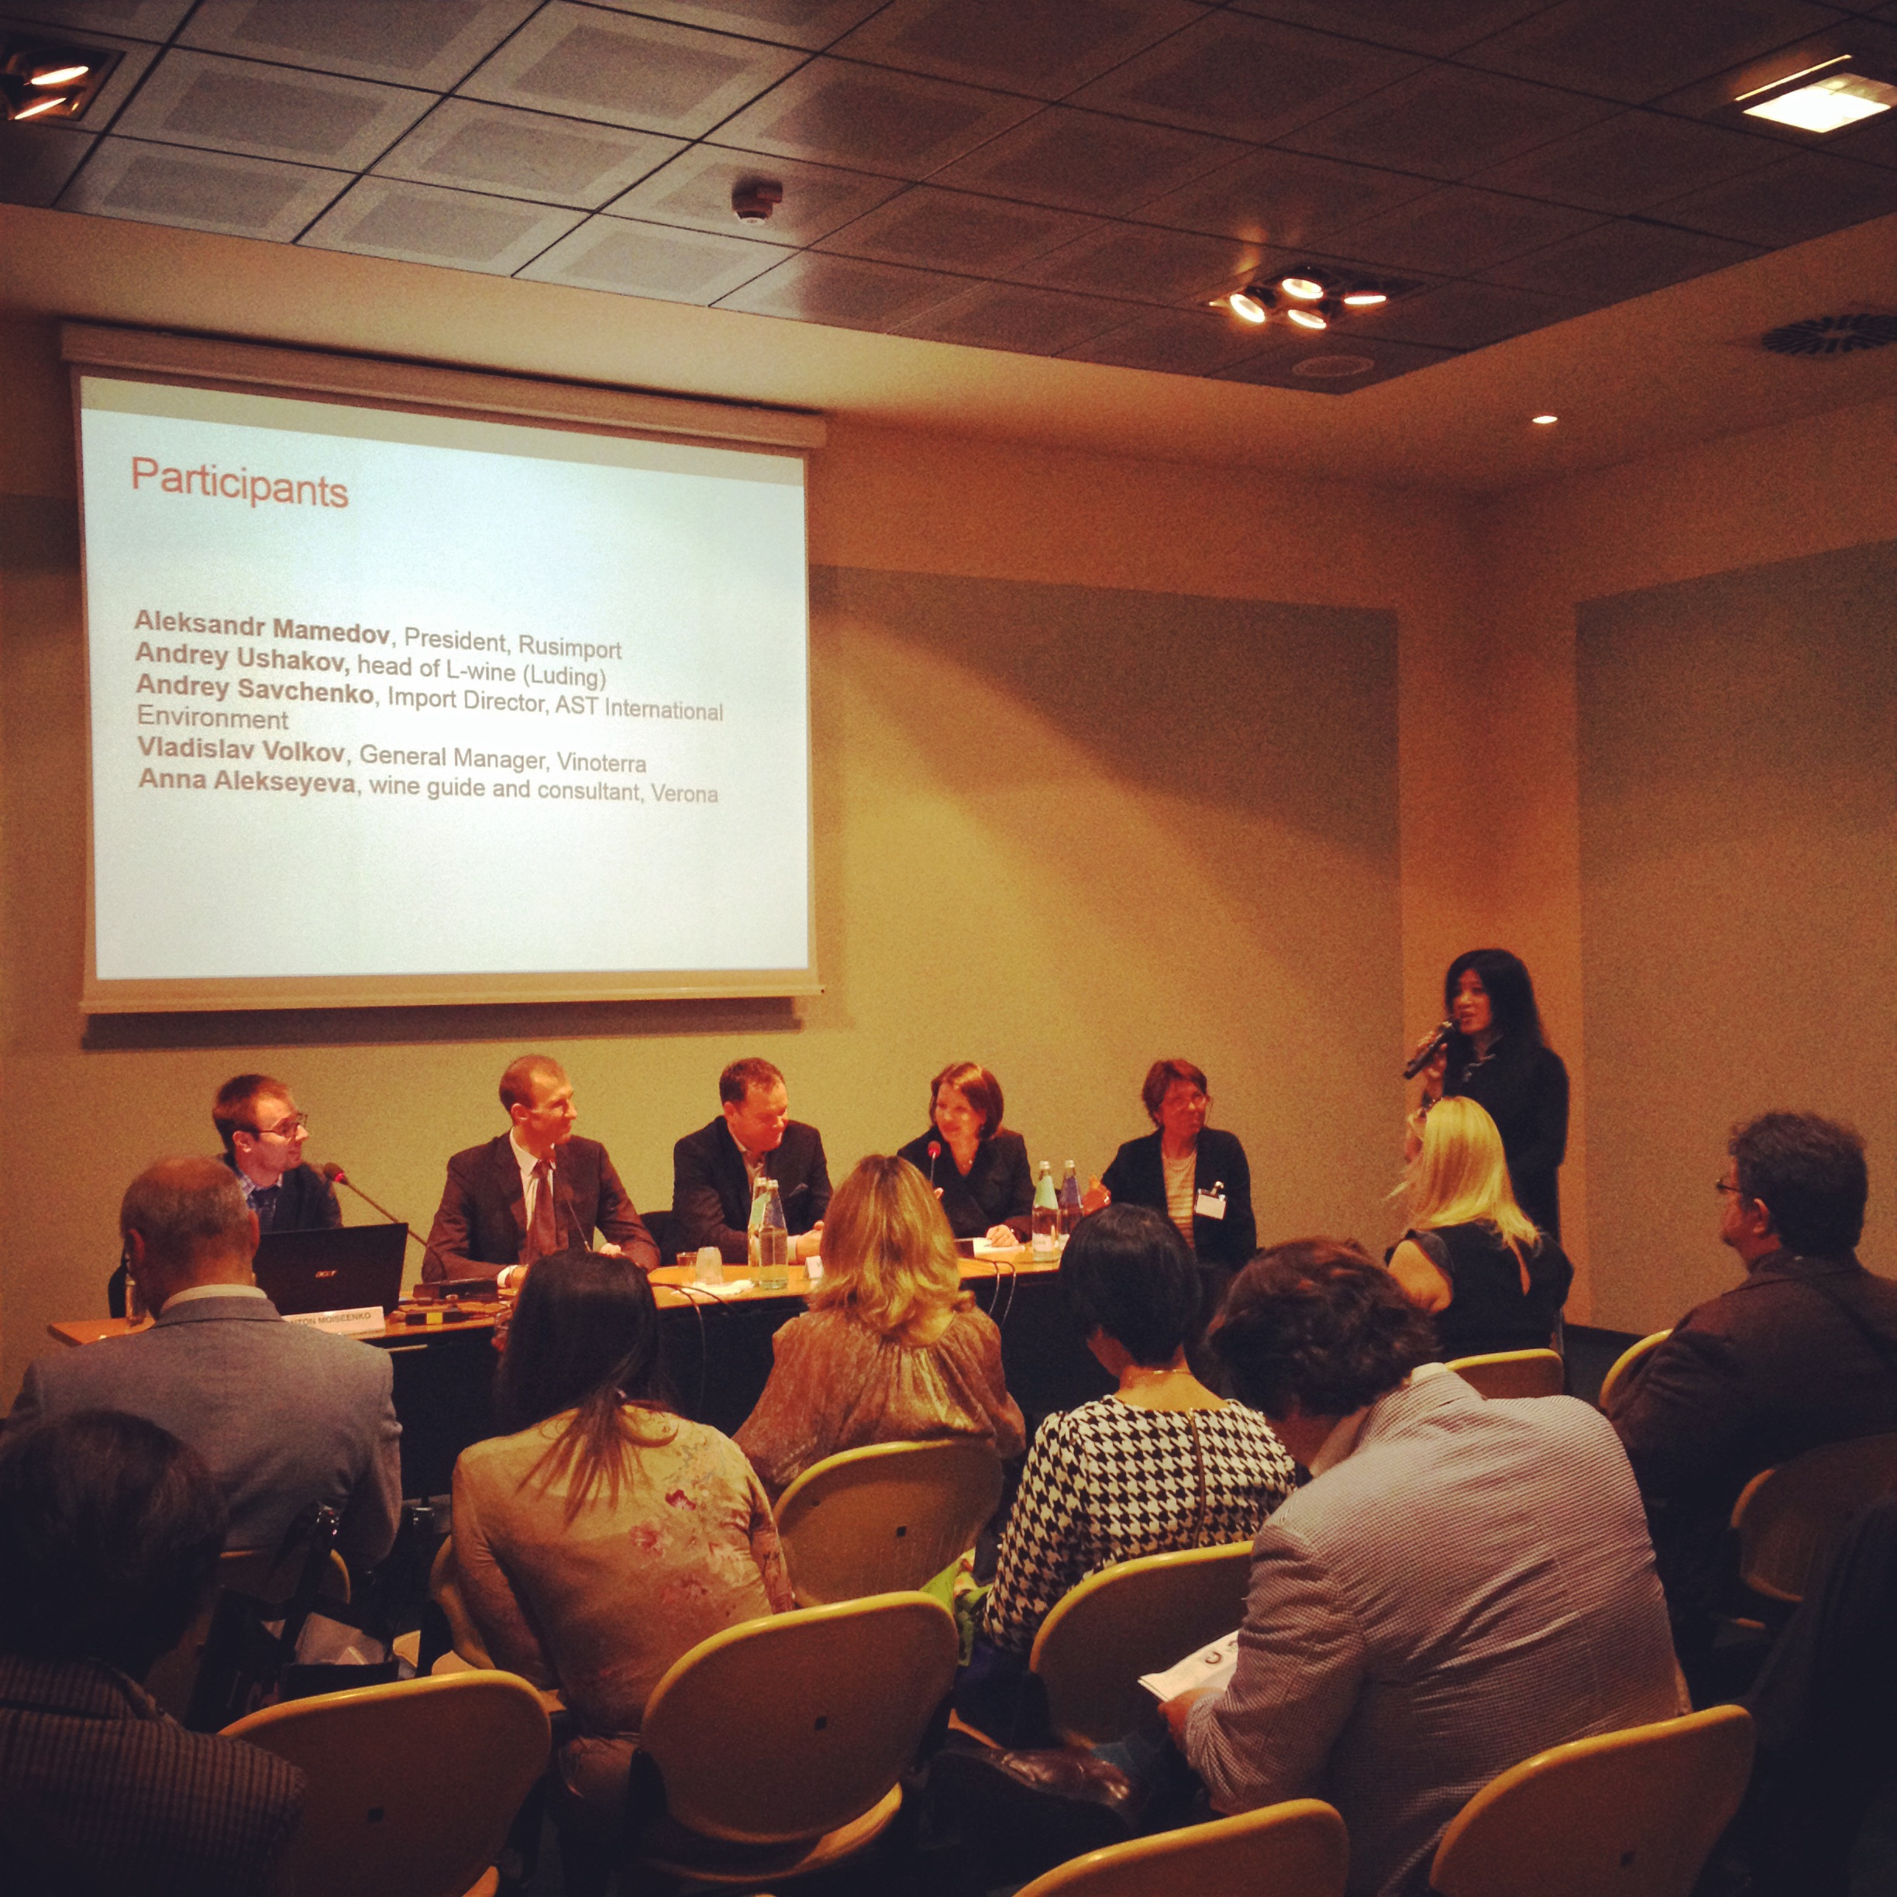

Identifying a particular niche market was a dominant theme of Monday’s US panel, “Navigating the Complexities of the US Wine Market: the three-tier system, media relations and more.” Panel moderator and wine blogger Jeremy Parzen began by explaining that the three-tier system – which separates the activities of importing, distribution, and retail sales – is still not well understood by Italian producers, and is further complicated by the fact that each state has its own set of regulations.

“When you consider that you need to multiply the three-tier system by 51 – 50 states, plus one county in Maryland – and that in each of those systems, every wine needs to be imported, distributed, and sold through a retailer, the picture becomes incredibly complex,” explained Cathy Huyghe, wine columnist for Forbes. “Therefore producers really need to focus on particular states, and even cities – and not necessarily just New York, Chicago, and San Francisco.”

Panelists also observed that for many producers, physically coming to the US is essential for understanding the market. “We have a saying in America, ‘90% of success is just showing up,’” explained Steve Raye, principal at the wine and spirits marketing firm Brand Action Team. “Producers need to pick a market, and invest time and energy in getting to understand and appreciate that market. Getting the product in is just the beginning. The real challenge is getting the product out.”

And key to reaching US consumers is communicating the story behind the wine, as Cathy Huyghe explained: “In my opinion what works is producers who take time to tell their own story. Italy has an advantage because the wines are unique, and there’s a trend now in the US market toward ‘off-roading’ – discovering new grapes and regions. The US market wants to hear the story of the producer, and that needs to come from the producer. The danger of leaving the storytelling to the distribution network is that by the time it gets to the consumer your voice is lost.”

“You have to be communicating digitally in some way,” added Alfonso Cevola, wine blogger and Italian wine manager for Glazers. “There are huge numbers of young people in the US reaching wine drinking age, and they are very interested in and knowledgeable about Italian wine. Reaching them through social media is key.”

And how can producers know what kind of story will sell in the US market? “Americans want a unique story. Italian producers should focus on indigenous grapes, because it’s unique,” advised Steve Raye.

“I don’t want to hear about French oak – those kinds of details are not what draw consumers to a wine,” continued Alfonso Cevola. “Find something really cool about your winery - even if it’s not specifically about the wine.”

“You know what your story is,” Cathy Huyghe reminded the producers in the room. “It’s what you hang your hat on. It’s what gets you out of bed in the morning. That’s what consumers want to know.”

“Many of the speakers in our Talk Business series are the same key players of the wine industry we’ve met during our events around the word,” explains Managing Director of Vinitaly International Stevie Kim. “We’ve brought them here to Verona, and now in this seminar series it’s their turn to tell their stories – to share their expertise in the realm of market intelligence, educational approaches, and explain how we can engage the most interested audience, and scout the next potential Italian wine enthusiasts.”

**About:**

**Veronafiere** is the leading organizer of trade shows in Italy including Vinitaly (www.vinitaly.com), the largest wine event in the world. The 47th edition of Vinitaly counted some 148,000 visitors (+6%), of which 53.000 were international attendees (+10%) visiting from 120 countries. On 95.000 square meters, 4.200 exhibitors welcomed trade professionals, media and producers alike. The next installment of the fair will take place on 6th- 9th April 2014. The premier event to Vinitaly, OperaWine (www.vinitalyinternational.com) “Finest Italian Wines: 100 Great Producers”, will unite international wine professionals on April 5th 2014 in the heart of Verona. Veronafiere also created Vinitaly International in 1998 to develop a global platform for the promotion of companies in the Italian wine and food sectors.

**# # #**