Media Contact: Nicholas Zurko FOR IMMEDIATE RELEASE

Tel: 212.674.4300

Email: Nicholas.z@nyfa.edu

**New York Film Academy Survey Finds YouTube Tops Video Streaming Sites**

A [New York Film Academy](http://www.nyfa.edu) survey that polled 1,546 respondents found that even in a time where there are more video streaming services available to users than ever before, YouTube has a significant lead over more pay-to-play sites like Netflix and iTunes. Of the participants, 76.8% selected YouTube as the service they use to stream movies and TV shows, although the paid service Netflix was not too far behind with 54.6% of respondents choosing to pay and use the streaming service and the free streaming site Vimeo taking third place with 28.9% of individuals using the service.

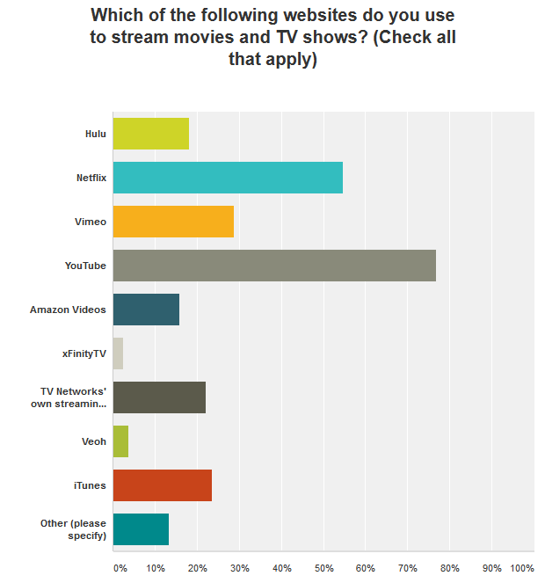

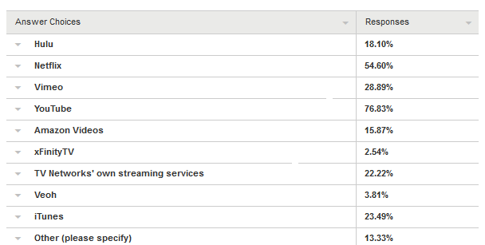

The demographics of the survey participants revealed a strong response from international users as they made up 54.3% of those polled versus the 45.7% who identified the USA as their place of residence. Such a strong response from international users might go some way in explaining why the popular streaming service like Hulu ranked fifth out of the nine options as it is not available outside of the US. The gender of the users was significantly more even with 51.6% of users identifying as male and 48.3% identifying as female. Looking at age, the majority of the responses came from individuals in the 18-24 age range with 34.5% of users comprising that demographic. This was closely followed by 20.5% of users in the 13-17 age range and 18.9% of users in the 25-34 age range.

In looking at the frequency of how often respondents used streaming services, 46.9% identified themselves as using streaming sites every day, 45.0% use them every few days, and 8.1% stating that they did not use any streaming site whatsoever. Regarding how much time users spend on streaming sites in a single day, 29.8% stated they spend one to two hours streaming video with those who spend two to three hours a day comprising 23.5% and those only spending zero to one hour a day making up 23.2% of responses.

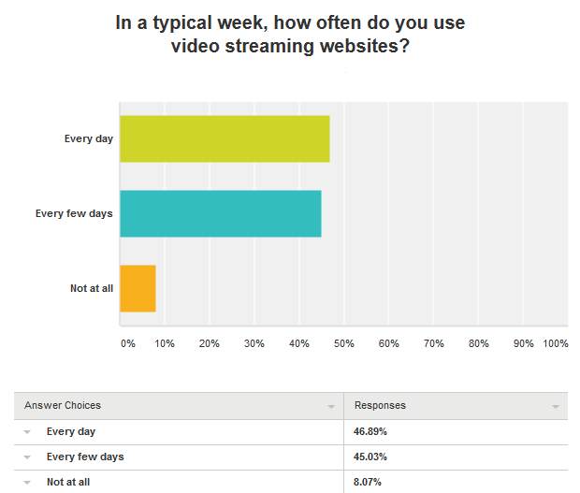

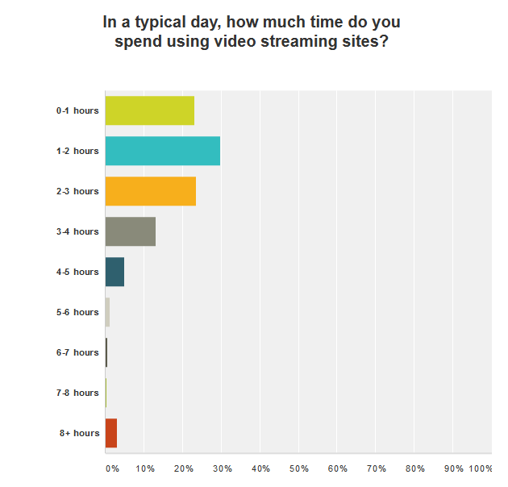

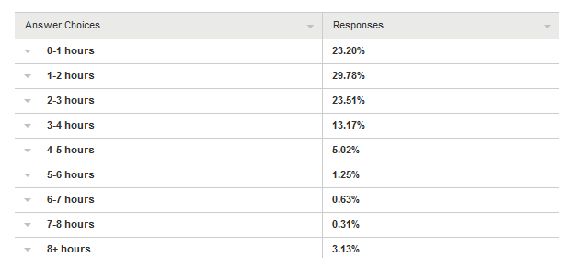

Accounting for the volume of movies and TV shows watched in a single week, respondents typically watched six movies and five television shows. When it came to the amount spent per month on such services, 37.2% of users claimed to spend no money on such streaming services with 34.0% spending up to ten dollars and 17.2 percent spending between eleven to twenty dollars.

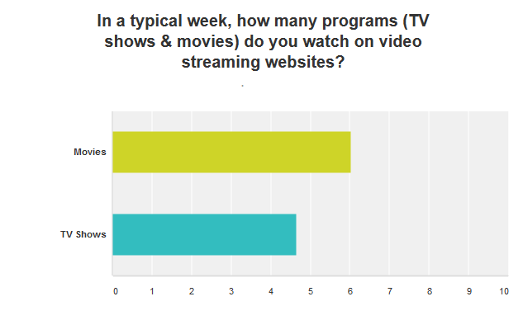

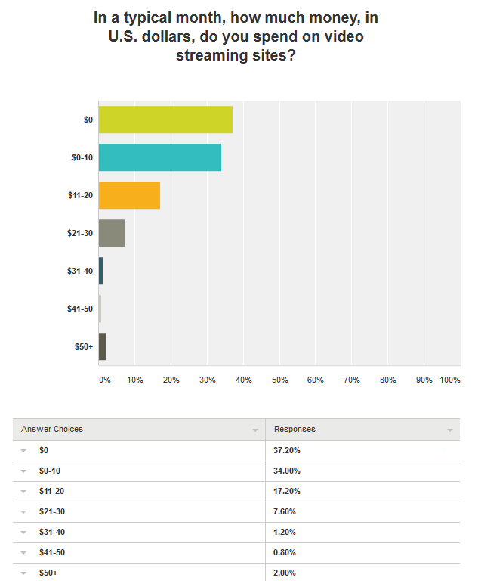

Taking into account the devices participants used, 78.5% identified their laptop as a device on which they stream video with smartphone users making up a distant second with 49.4% and in third place, 27.9% used their tablets to stream.

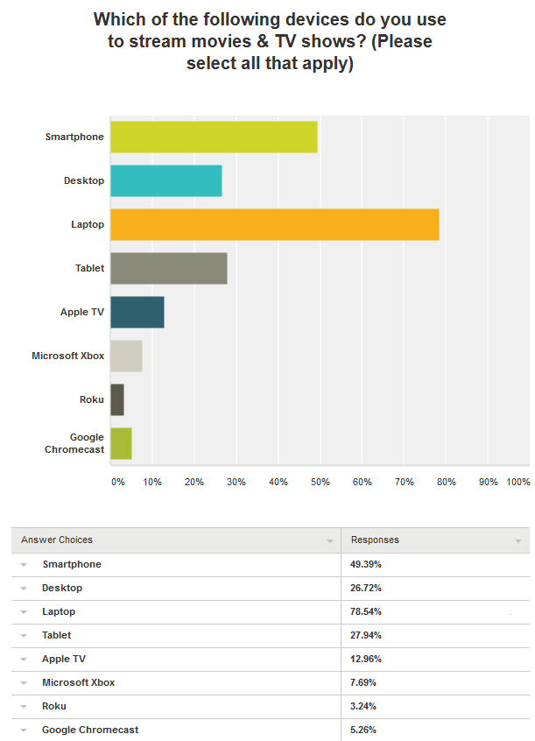

Finally, in finding where respondents were most likely to be when streaming, 98.1% said they did so from home with 14.0% streaming while at work and 9.4% doing so on public transport.

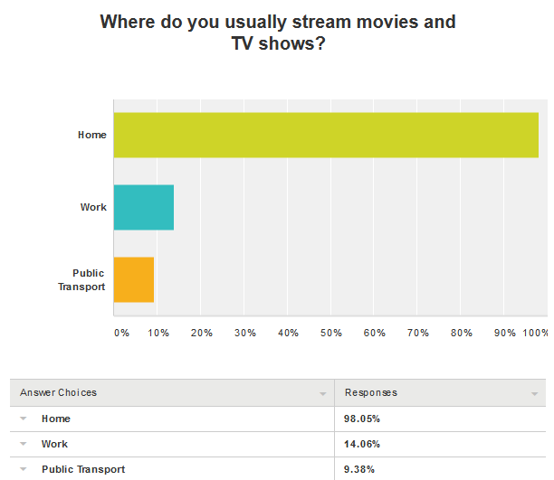

Since its inception in 2005, YouTube receives over one billion unique visitors per month with 80% of traffic coming from outside of the U.S. However, the streaming landscape has grown significantly more varied and competitive with pay-to-play services like Netflix and Amazon Video encroaching on YouTube’s dominance by offering full-length movies and entire seasons of popular TV shows in addition to original programming. In addition, Hulu offers both free and paid options for users to keep up on the latest TV shows and offering a large repository of Criterion Collection movies to paying users.

*“In looking at the viewing habits of streaming video users, the Academy hopes to inform aspiring filmmakers and actors of the many options available to them in the digital domain to have their films and performances seen by a wider audience,”* says New York Film Academy Student Advisor Nicholas Zurko.

Founded in 1992, the New York Film Academy has grown from a New York City-based film school to an international school with locations all around the world. The Academy offers a variety of MFA, BFA, AFA, MA, and BA degree and certificate programs and short-term workshops that include filmmaking, acting for film, producing, screenwriting, digital editing, cinematography, broadcast journalism, music video production, photography, animation, game design, musical theatre, and dance.