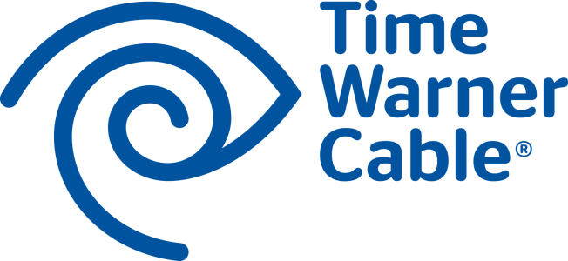


For Immediate Release

TIME WARNER CABLE ANNOUNCES THEME-BASED LINEUP
IN NEW YORK CITY

New Digital Channel Lineup Will Be Simpler and Easier to Navigate

DVR and Parental Control Settings Transition Automatically

NEW YORK CITY, April 17, 2014 — Time Warner Cable today announced it will introduce a new, theme-based channel lineup in May and June to customers in New York City. The new lineup groups channels together intuitively, making it simpler and easier for customers to find the programming they want to view — and to discover other content.

Channels will be grouped into themes like Entertainment, News & Info, Sports Music, Kids & Teens and Premiums. Likewise, On Demand content will be found on channels 1000 and above in categories like Primetime On Demand, Entertainment On Demand, Kids On Demand and Music On Demand.

“Our new, theme-based lineup will make it much simpler and easier for our customers to navigate through the lineup,” said John Quigley, Regional Vice President of Operations at Time Warner Cable. “And with the new lineup, customers with an HD box will automatically receive the HD feed of the corresponding standard-definition channel, providing the best picture available.”

All parental control and DVR settings will transition automatically, so customers don’t have to worry about reprogramming their parental control settings or losing recordings of their favorite shows.

There is no change in channels 1 to 99, and no change in which channels are part of a customer’s Time Warner Cable TV package.

Customers can find out more about the new theme-based lineup at twc.com/mychannels and watch a helpful video by visiting http://youtu.be/Ri833EtCfzw.

Time Warner Cable customers in New Jersey; Mount Vernon, N.Y.; and on Staten Island will receive the lineup May 28. The new lineup will launch in Queens on June 3, Brooklyn on June 5, southern Manhattan on June 10 and northern Manhattan on June 12.

About Time Warner Cable
Time Warner Cable Inc. (NYSE: TWC) is among the largest providers of video, high-speed data and voice services in the United States, connecting more than 15 million customers to entertainment, information and each other. Time Warner Cable Business Class offers data, video and voice services to businesses of all sizes, cell tower backhaul services to wireless carriers and enterprise-class, cloud-enabled hosting, managed applications and services. Time Warner Cable Media, the advertising arm of Time Warner Cable, offers national, regional and local companies innovative advertising solutions. More information about the services of Time Warner Cable is available at www.twc.com, www.twcbc.com and www.twcmedia.com.

###
Media Contact:
Ziggy Chau
(212) 379-5828
Ziggy.Chau@twcable.com

