Armacell Photo Credits

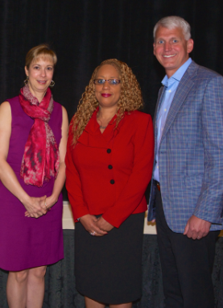

Left to right:

Roslyn Smith, Armacell Business Director – Insulation; Monica Loy Armacell Training Coordinator – Mebane; David Dzina, President of the National Insulation Association (NIA)

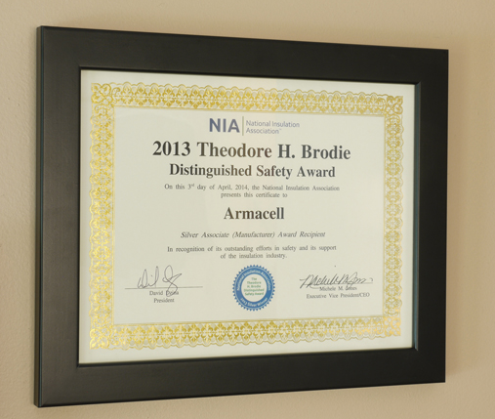
Award Photo:
2013 Theodore H. Brodie Distinguished Safety Award – Armacell, Silver Associate Recipient

