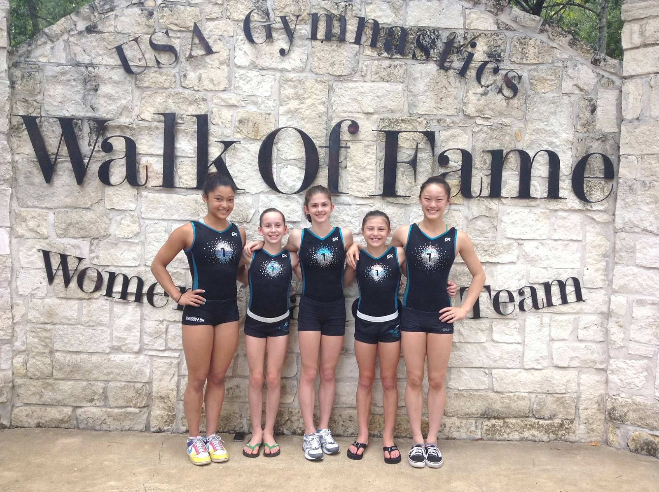
Head Over Heels Athletic Arts Sends
Five Gymnasts to the USA Gymnastics National Team Training Center

Emeryville, CA

Five of Head Over Heels Athletic Arts’ athletes have been invited to the USA Junior Olympic Training Camp at Karolyi Ranch, the USA Gymnastics National Team Training Center for USA Gymnastics.

Head Over Heels Athletic Arts (HOH) is pleased to announce that five of their athletes have been invited to the USA Junior Olympic Training Camp at Karolyi Ranch, the USA Olympic Training Center for USA Gymnastics. This special invitation only camp held from September 19th – 22nd is an opportunity for the USA Olympic gymnastics coaches to meet the athletes who performed well at National Championships.

Talia Brovedani, Kate Cilley, Kassina Kim-Hayes, Courtney Klausen, and Nina Schank are all Level 10 gymnasts, the highest level in the Junior Olympic Program. These young athletes, along with two of their coaches, Katreece Stone, HOH executive director and head girls’ team coach, and David Seiler, will travel to Karolyi Ranch in Huntsville, Texas. Head Over Heels has sent gymnasts to this camp in past years but never this many.

About the company:
Head Over Heels Athletic Arts has been providing a positive athletic experience for children of the San Francisco Bay Area for over 35 years. Its 22,000+ square-foot main facility and 7,000 sq. ft. preschool facility in Emeryville, Calif. makes them one of the largest non-profit athletic arts facilities in California. Head Over Heels Athletic Arts instills a lifelong love of being physically active through various gymnastics classes, including recreational gymnastics, gymnastics for special needs children, and competitive gymnastics as well as dance. Head Over Heels has been offering kids gymnastics programs to keep youngsters physically active since 1977.

