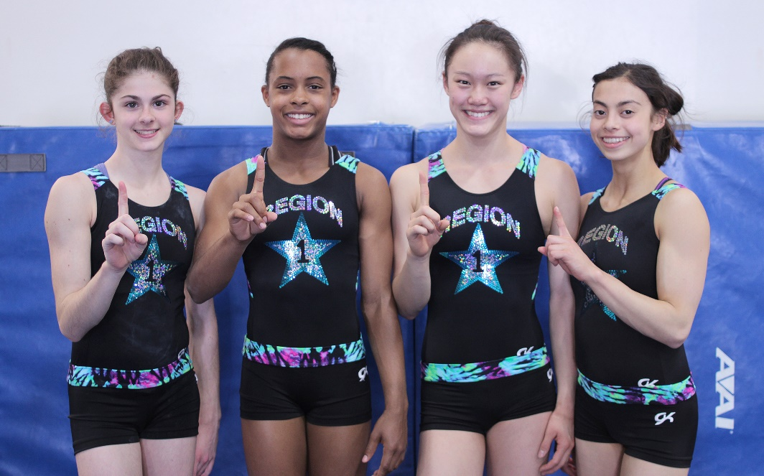

Four Head Over Heels Athletes Qualify for Junior Olympic Nationals

Emeryville, CA

Head Over Heels Athletic Arts (HOH) is pleased to announce that four of its young athletes have qualified for Junior Olympic Nationals after successfully qualifying at Regional Championships on April 11th through 13th in Anaheim, CA.

“For any gymnastics program sending four girls to Nationals is quite an accomplishment,” says Katreece Stone, HOH’s Executive Director and Girls Competitive Program Director. “Our athletes train really hard and we are enjoying the success they’ve achieved these past few years due to their effort. It is truly exciting.”

At the Regional Championships, in the Junior Olympic Nationals hosts the most elite young athletes in gymnastics in the US. Those who compete in this competition are one of the top seven athletes in the country from each age division. The event is highly scouted by colleges looking for talent for their teams making the pressure to perform well very intense.

In the Junior B Division, Cairo Leonard Baker won 1st place in her age division with a 37.90 and secured the All-Around title. Also in Junior B Division, Talia Brovedani came in 4th place and won the beam title with a score of 9.75. In the Junior C Division, Nina Schenk came in 4th and won All Around with a 37.825 in her age division and Katelyn Lentz came in 3rd winning All Around as well with a 38.05.

The 2014 Junior Olympic Level 10 National Championship will be held on May 8th – 12th in Jackson, Mississippi.

About the company:
Head Over Heels Athletic Arts has been providing a positive athletic experience for children of the San Francisco Bay Area for over 35 years. The 22,000+ square-foot main facility as well as the 7,000 square-foot preschool facility in Emeryville, Calif. makes them one of the largest non-profit athletic arts facilities in all of Northern California. Head Over Heels instills a lifelong love of being physically active through various gymnastics classes, including recreational gymnastics, special needs gymnastics, and competitive gymnastics as well as Dance. Head Over Heels has been offering kids gymnastics programs to keep youngsters physically active since 1977.

