Upgrade to Dr. Dave’s!
Use inside and outside the bikini line.
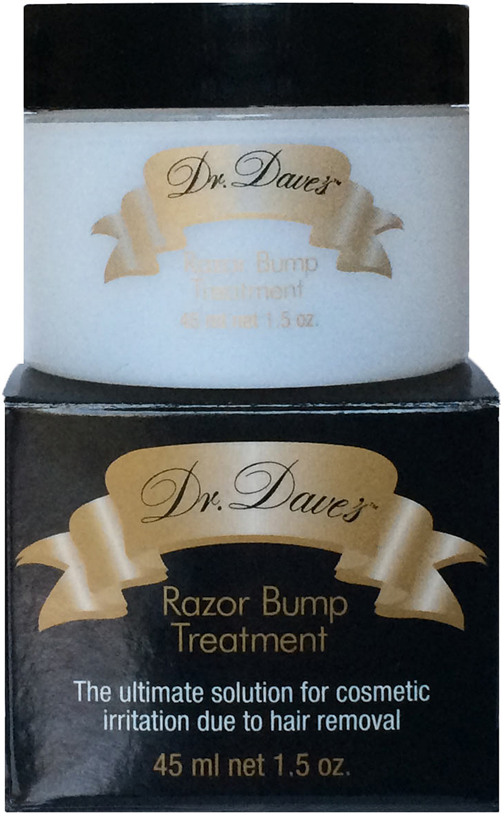
Use immediately after hair removal. Massage into skin. Use morning and night for beautiful results.

Thank you for your order.
http://www.drdavesskincare.com
Use coupon code Daves2014b for 25% off

