**Press Release Contacts:**

**For Immediate Release** Vinitaly International

International Media Dept.

+39 045 8101447

[media@vinitalytour.com](mailto:media@vinitalytour.com)

[www.vinitalytour.com](http://www.vinitalytour.com)

Twitter: @VinitalyTour

Join Vinitaly International Network on LinkedIn

**Italian Wineries join forces with the American Cancer Society in fight against cancer**

United for once in the name of a just cause Italian wine producers, headed by Vinitaly International, the Ambassador of Italian Wine, will join forces with the American Cancer Society on the occasion of the ninth edition of Taste of Hope, one of New York’s top fundraising events.

The coming Thursday, Mercer Street will play host once again to more than 800 guests who will be offered the opportunity to taste delectable bites provided by New York’s most famous restaurants accompanied by some of Italy’s finest wines. For the occasion wine sponsor Vinitaly International will be showcasing fine Italian Wineries from the country’s top wine producing regions including Allegrini, Zenato, Bellenda, Villa Sandi and Terredora who will donate their labels for this unique event.

Attendees are invited to participate in the silent auction, which will feature culinary prizes such as dinners for two, Broadway tickets, eco-friendly designer Alex and Ani, as well as travel packages. All proceeds support the American Cancer Society’s mission to eliminate cancer as a major health problem. In the past, Taste of Hope has raised over $175,000 and this year the event hopes to exceed their $200,000 goal.

This year’s edition of Taste of Hope will also be honouring celebrity chef Elizabeth Falkner for her dedication to the fight against cancer, marking the first female honouree at this annual event.

Ticket Prices:

(VIP Admission 6:30PM; General Admission 7:30PM)

* •  *General Admission Ticket:* $175 per person
* •  *VIP Ticket:* $250 per person (includes early entry and gift bags)
* •  *VIP Table:* $1,500 per five guests (includes early entry and gift bag)
* •  *VIP Table:* $3,000 per ten guests (includes early entry and gift bag)

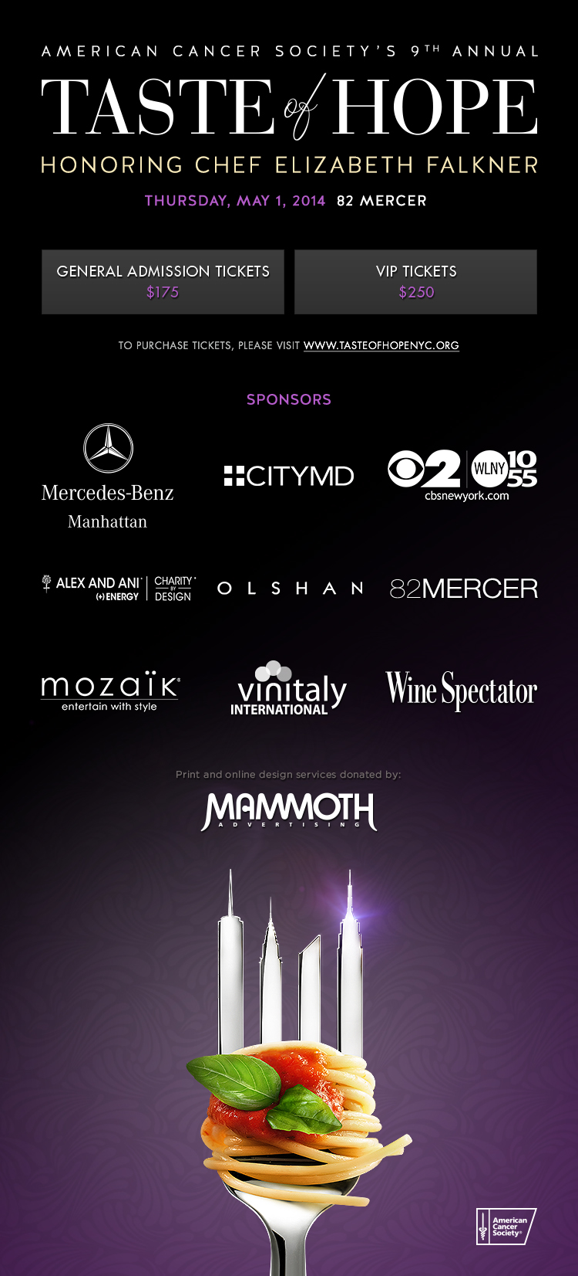

For more information about the event and to purchase tickets, visit www.tasteofhopenyc.org, follow on Twitter @ACSTasteofHope, or Facebook www.facebook.com/tasteofhope If you cannot attend the event but wish to donate a gift to the American Cancer Society please visit the website. For media inquiries, please contact KB Network News at 212-777-3455, Stephanie@kbnetworknews.com or Kylene@kbnetworknews.com. For event inquiries, please contact Elizabeth Mayer at American Cancer Society at 212-237-3889 or Elizabeth.Mayer@Cancer.org.

**About:**

**Veronafiere** is the leading organizer of trade shows in Italy including Vinitaly ([www.vinitaly.com](http://www.vinitaly.com/" \t "_blank)), the largest wine event in the world. The 48th edition of Vinitaly counted some 155,000 visitors (+6%) in four days of event, of which 56.000 were international attendees representing 36% of the total. On 100.000 square meters, 4.000 exhibitors welcomed trade professionals, media and producers alike. The next instalment of the fair will take place on 22 – 25 March 2015. The premier event to Vinitaly, OperaWine ([www.vinitalyinternational.com](http://www.vinitalyinternational.com/" \t "_blank)) “Finest Italian Wines: 100 Great Producers,” will unite international wine professionals on March 21st 2015 in the heart of Verona, allowing them to discover and taste the 100 best Italian wines, as selected by Wine Spectator. In 1998 Veronafiere also created Vinitaly International to develop a global platform for the promotion of Italian wine producers in foreign markets such as Russia, China, USA and Hong Kong.

**Taste of Hope®** was founded in 2005 by the American Cancer Society. They created this fundraiser as a way to celebrate New York dining while raising funds to help underwrite the ACS’s mission to fight for every birthday threatened by every cancer in every community. Between the early 1990s and 2013 the Society has seen a 20 percent decrease in the overall cancer death rate, which means they have helped to avoid about 1.2million cancer deaths and created the potential for more birthday celebrations.

**# # #**