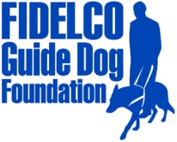
PRESS RELEASE

FOR IMMEDIATE RELEASE Fidelco Guide Dog Foundation
DATE: April 28, 2014 103 Vision Way
CONTACT: Heidi Voight, Director of Communications Bloomfield, CT 06002
860-906-2086 Cell; 860-243-4800 Office hvoight@fidelco.org www.fidelco.org

FIDELCO GUIDE DOG FOUNDATION CELEBRATES VOLUNTEERS AND INVITES COMMUNITY TO SHARE THE VISION®
BLOOMFIELD, Conn. – The Fidelco Guide Dog Foundation capped off National Volunteer Month by celebrating its more than 350 volunteers who actively support the nonprofit’s life-changing mission of providing the highest quality guide dogs to men and women who are blind.
Fidelco honored its volunteers during an annual Volunteer Recognition Day event on Saturday, which featured powerful and emotional testimonials from some of the organization’s volunteers who help to raise future guide dog puppies in their homes and socialize them in the community as the all-important first steps to becoming highly skilled Fidelco Guide Dogs.
Adding an extra dose of inspiration to the spirited event was Fidelco client and renowned NYC-based musician Frank Senior. Blind from birth, Senior has been a client of Fidelco since 1992, and is currently partnered with his third Fidelco Guide Dog, “Que.” The talented singer crooned for the crowd after delivering an uplifting message of gratitude and hope, describing how his Fidelco Guide Dogs have given him the freedom and independence to pursue his music performance passion and provide for his family.
“It is so important to honor our volunteers, because simply put, Fidelco would not exist without them,” said Eliot D. Russman, Fidelco’s CEO and Executive Director. “Whether it’s raising a puppy, hosting a fundraiser or helping out behind the scenes in our kennel and administrative office, volunteers are the heartbeat of Fidelco. Their contributions are priceless – and the lives of our clients and their families are forever changed because of our volunteers.”
Fidelco breeds and trains its elite German Shepherd Guide Dogs for people who are blind across North America. It takes two years, 15,000 hands-on hours and $45,000 to produce each Fidelco Guide Dog, and they are given to clients at no cost. Fidelco offers many volunteer opportunities for people and groups of all ages and it encourages people to bring their passions to Fidelco. For more information visit www.fidelco.org/volunteer.

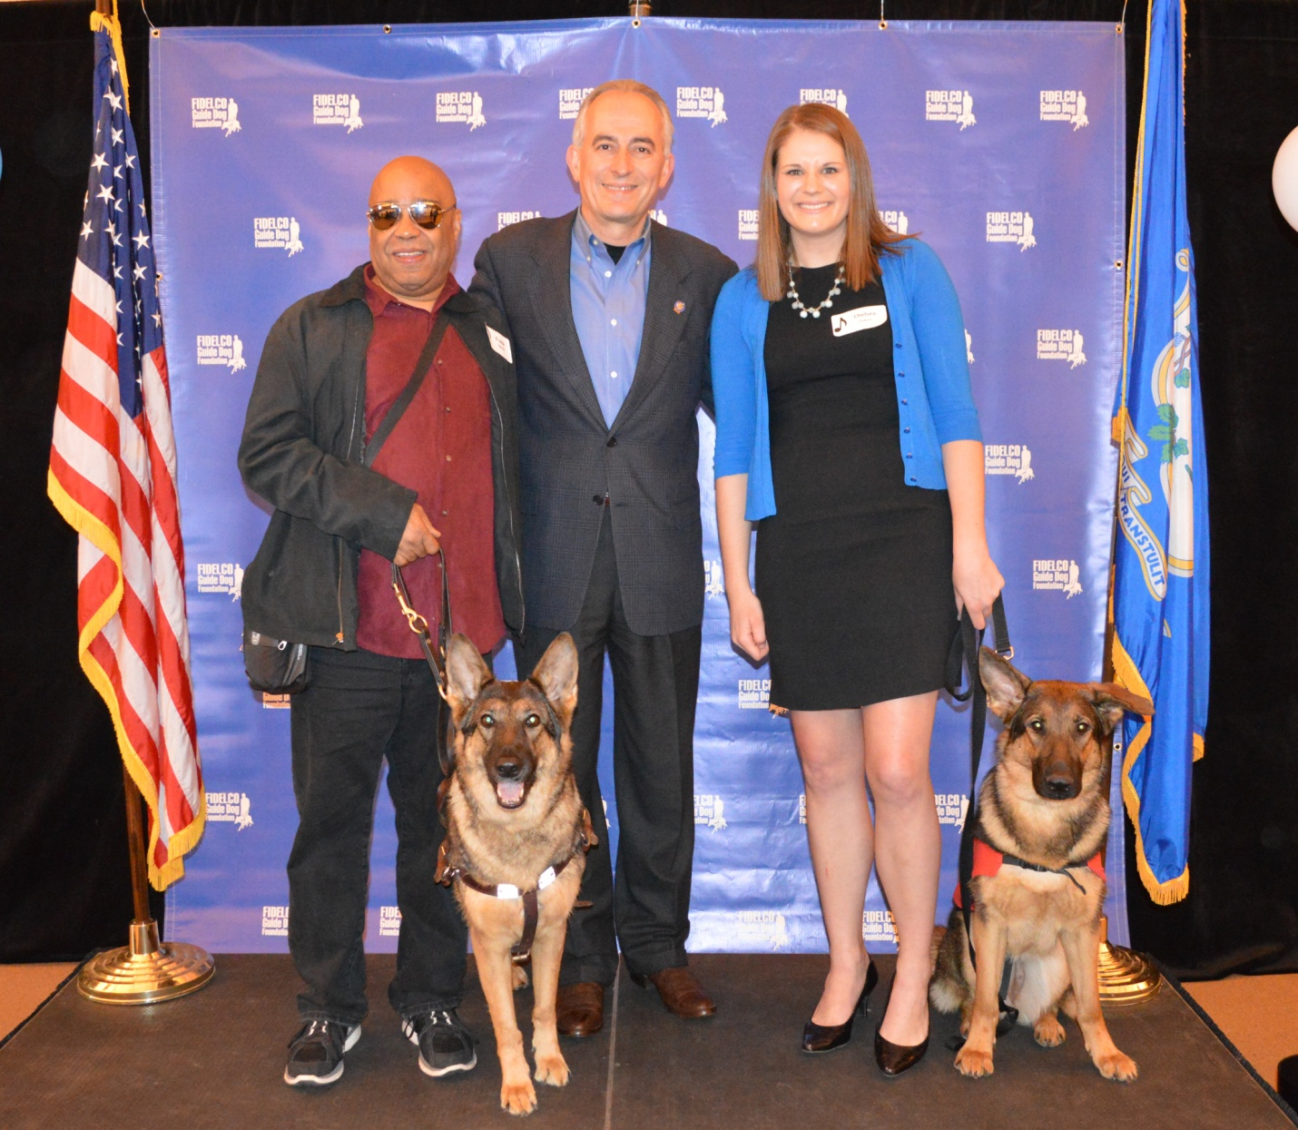
L to R: Fidelco client Frank Senior with Fidelco Guide Dog “Que”; Fidelco CEO & Executive Director Eliot D. Russman; Fidelco Volunteer Puppy Raiser Chelsea Cracco with Fidelco puppy “Ella”

About Fidelco Guide Dog Foundation
The Fidelco Guide Dog Foundation is a 501(c)(3) nonprofit based in Bloomfield, CT. Fidelco is an internationally accredited organization and an admired expert throughout the world for its highly valued German Shepherd Guide Dogs.

Each Fidelco Guide Dog takes two years, 15,000 hands-on hours and $45,000 to produce. They are given to clients at no cost. Fidelco provides 24/7 client support for the entire working life of its guide dogs – typically 10 years. Fidelco relies solely on the generosity and financial support of individuals, foundations, corporations and civic organizations to help Share the Vision®.

Fidelco has trained and placed over 1,350 German Shepherd Guide Dogs throughout North America – in 41 states and five Canadian provinces. Fidelco pioneered In-Community Placement in the United States — a process that allows all guide dog users to be trained in the communities where they live and work.

Fidelco also has placed hundreds of its German Shepherd Dogs with law enforcement agencies, first responders, search and rescue, and missing child recovery organizations to help protect our fellow citizens and keep our communities safe. For more information visit www.fidelco.org.

###

