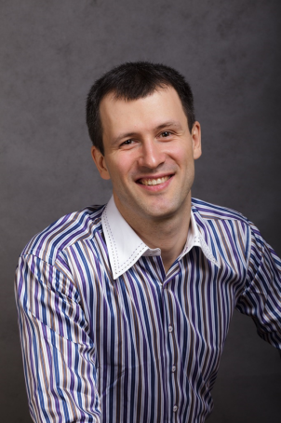
Michael Gotalsky, TrueConf CEO

Was born on July 31, 1978, graduated from Bauman Moscow State Technical University, Information Technology and Management Faculty.

Michael started working in the field of IT as a programmer. Since late 1990-s he has been working in video conferencing business, since 2002 – as an executive. As he started, he was paying more attention towards audio conferencing because of the peculiarities of the market, then he proceeded with video solutions. He was holding the position of CEO at Sitronics corporation up to 2007, when he became TrueConf CEO.

Area of expertise: video conferencing, team strategy, essential sales, business development.

