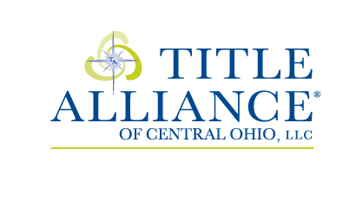
260 Northland Blvd. Suite 114E
Cincinnati, OH 43246
www.taofcentraloh.com
513.371.5228 | f: 513.823.2842
e: orders@taofcentraloh.com

REQUEST FOR TITLE

Property Address: ______________________________________________________________________

_____________________________________________________________________________________

Lender Name: _________________________________________________________________________

Lender Contact Phone/Email: _____________________________________________________________

Loan Amount: _________________________________________________________________________

Sale Price: _____________________________________ Estimated Closing Date: ___________________

Buyer Name(s): ________________________________________________________________________

Buyer Contact Phone/Email: _____________________________________________________________

Buyer’s Agent: _________________________________________________________________________

Buyer’s Agent Phone/Email: ______________________________________________________________

Seller Name(s): ________________________________________________________________________

Seller Contact Phone/Email: _____________________________________________________________

Seller’s Agent: _________________________________________________________________________

Seller’s Agent Phone/Email: ______________________________________________________________

PLEASE PROVIDE COPY OF CONTRACT VIA EMAIL OR FAX ABOVE.

