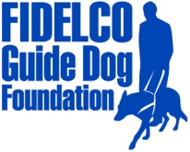 **PRESS RELEASE**

**FOR IMMEDIATE RELEASE Fidelco Guide Dog Foundation**

**DATE:**  April 30, 2014 103 Vision Way

**CONTACT:** Heidi Voight, Director of Communications                                  Bloomfield, CT 06002

860-906-2086 Cell; 860-243-4800 Office [hvoight@fidelco.org](mailto:hvoight@fidelco.org)                         [www.fidelco.org](http://www.fidelco.org)

**FIDELCO GUIDE DOG FOUNDATION SALUTES INTERNATIONAL GUIDE DOG DAY 2014**

**BLOOMFIELD, Conn.** – Celebrated each year on the last Wednesday in April, International Guide Dog Day honors the life-changing partnerships between man’s best friend and people who are blind. On this day and throughout the year, the Connecticut-based Fidelco Guide Dog Foundation salutes guide dog training organizations across the globe that share a common mission to help men and women who are blind lead more independent lives.

“Fidelco is one of only 10 accredited guide dog training organizations in the United States,” said Fidelco CEO and Executive Director Eliot D. Russman. “When you consider that every seven minutes, someone in America becomes blind, that’s a very small community of experts working to deliver critical services. The goal of International Guide Dog Day is to raise awareness of the growing demand for life-changing guide dog partners and the financial support required to produce them.”

Fidelco breeds, trains and places it own unique breed of German Shepherd Guide Dogs. It takes two years, 15,000 hands-on hours and $45,000 to produce each Fidelco Guide Dog, and they are given to clients at no cost.

According to the International Guide Dog Federation, the earliest guide dogs may have existed in Roman times, but the modern guide dog story began during the First World War. The first guide dog training schools were established in Germany to enhance the mobility of returning veterans who were blinded in combat. Today there are 80 accredited guide dog schools in the world.

Founded in 1960, Fidelco remains unique among all guide dog schools: Fidelcopioneered In-Community Placement in the United States — a process that allows all guide dog users to be trained in the communities where they live and work. And Fidelco is the only guide dog school in the world that exclusively produces the German Shepherd Dog for guide dog work.

With an ever-increasing demand for its world-class guide dogs, Fidelco relies solely on the generosity and financial support of individuals, foundations, corporations and civic organizations to help Share the Vision®. Visit [www.fidelco.org](http://www.fidelco.org) for more information and to donate today.

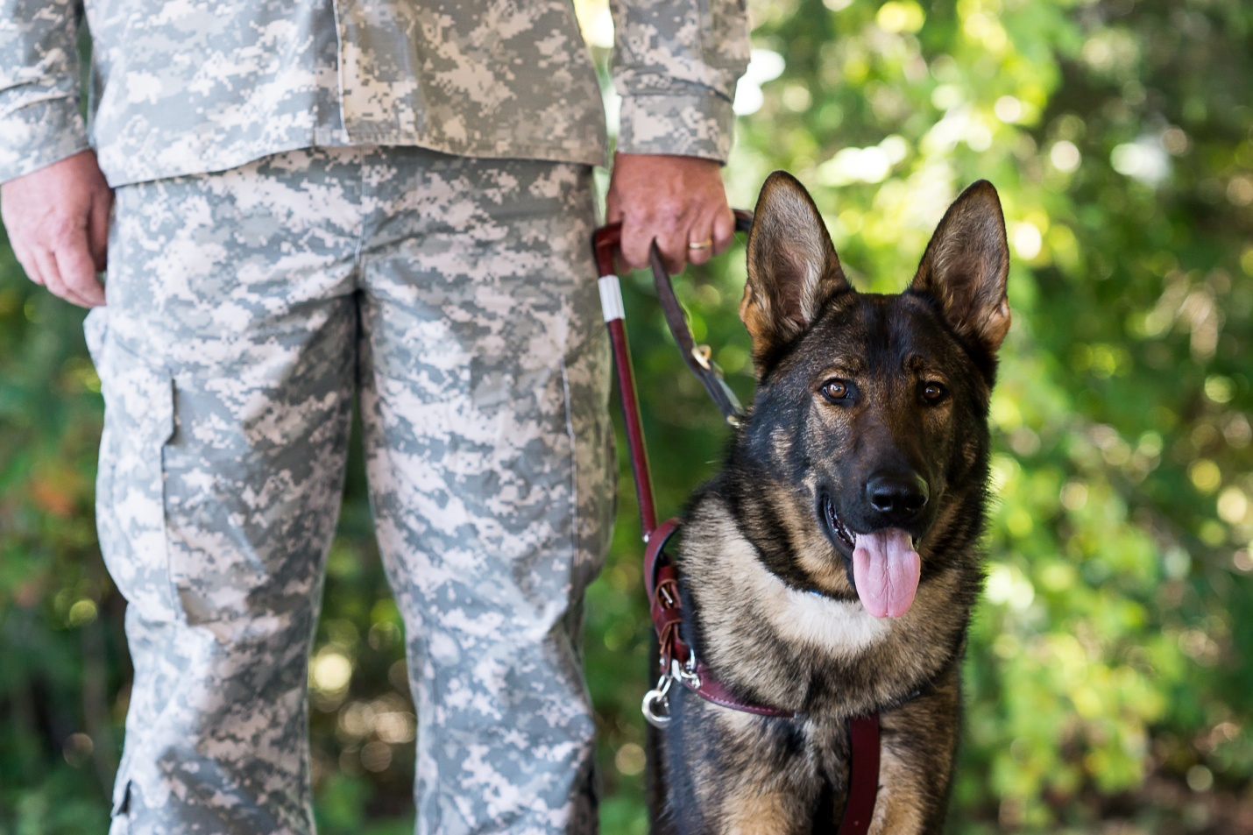

***About Fidelco Guide Dog Foundation***

*The Fidelco Guide Dog Foundation is a 501(c)(3) nonprofit based in Bloomfield, CT. Fidelco is an internationally accredited organization and an admired expert throughout the world for its highly valued German Shepherd Guide Dogs.*

*Each Fidelco Guide Dog takes two years, 15,000 hands-on hours and $45,000 to produce. They are given to clients at no cost. Fidelco provides 24/7 client support for the entire working life of its guide dogs – typically 10 years. Fidelco relies solely on the generosity and financial support of individuals, foundations, corporations and civic organizations to help Share the Vision®.*

*Fidelco has trained and placed over 1,350 German Shepherd Guide Dogs throughout North America – in 41 states and five Canadian provinces. Fidelco pioneered In-Community Placement in the United States — a process that allows all guide dog users to be trained in the communities where they live and work.*

*Fidelco also has placed hundreds of its German Shepherd Dogs with law enforcement agencies, first responders, search and rescue, and missing child recovery organizations to help protect our fellow citizens and keep our communities safe. For more information visit* [*www.fidelco.org*](http://www.fidelco.org)*.*

***###***