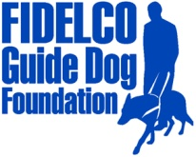
PRESS RELEASE

FOR IMMEDIATE RELEASE Fidelco Guide Dog Foundation
DATE: May 5, 2014 103 Vision Way
CONTACT: Heidi Voight, Director of Communications Bloomfield, CT 06002
860-906-2086 Cell; 860-243-4800 Office hvoight@fidelco.org www.fidelco.org

FAMILIES FLOCK TO FIDELCO GUIDE DOG FOUNDATION’S OPEN HOUSE; DOGS “OUT AND ABOUT” IN CONNECTICUT COMMUNITIES
BLOOMFIELD, Conn. – The Fidelco Guide Dog Foundation opened its doors and training kennels this past weekend, attracting hundreds of families and dog lovers from all over New England to its Bloomfield campus. Saturday’s Open House event offered a behind-the-scenes glimpse into the making of a Fidelco Guide Dog from “pup to partner,” featuring puppy playtime, training demonstrations and the ever-popular blindfold walks with Fidelco Guide Dogs.
Adding some star power to the event were radio and television celebrity guests Renee DiNino of The River 105.9 and Clear Channel Connecticut, and WFSB morning traffic reporter Nicole Nalepa. Author Teresa M. Pelham and illustrator Kim Wood were featured in a book signing session for “HEROES: A Life-Changing Journey.” Created to benefit Fidelco, this children’s book tells the story of one family’s struggles after a mother serving in the military becomes blind. Bloomfield Police K9 “Koda” provided a great demonstration of other jobs performed by working German Shepherd Dogs.
Since its founding in 1960, Fidelco remains Connecticut’s own – and New England’s only – guide dog school, engaging more than 350 active volunteers throughout the region. Many volunteer opportunities were showcased at the Open House for those looking to get involved by becoming puppy raisers; event supporters, including the 2014 Ride for Independence motorcycle ride in July and Team Fidelco at the Hartford Marathon in October; or helping out in Fidelco’s kennels or administrative office.
As part of their ongoing socialization and early training for future guide dog work, Fidelco’s younger dogs also made appearances at other community events happening around the state. Fidelco puppies were spotted in the opening ceremonies of the New England Regional Chili Cookoff in Somers to benefit the Somers Fire Department and the Connecticut Patriot Guard Riders. Other four-legged Fidelco ambassadors headed to Nevers Park in South Windsor to support the South Windsor Jaycees’ Paws In The Park event, which benefits Fidelco and other local dog-related charities.
“As a nonprofit, Fidelco relies on the kindness and generosity of our communities to support our mission,” said Eliot D. Russman, Fidelco’s CEO and Executive Director. “So we are pleased to give back whenever and wherever we can. It’s a win-win, because not only are these charitable events helping others, these experiences help our young dogs in training increase their socialization skills and confidence, setting them up for success as Fidelco Guide Dogs.”
Fidelco breeds, trains and places it own unique breed of German Shepherd Guide Dogs. It takes two years, 15,000 hands-on hours and $45,000 to produce each Fidelco Guide Dog, and they are given to clients at no cost. With an ever-increasing demand for its elite guide dogs, Fidelco relies solely on the generosity and financial support of individuals, foundations, corporations and civic organizations to help Share the Vision®. For more information visit www.fidelco.org.
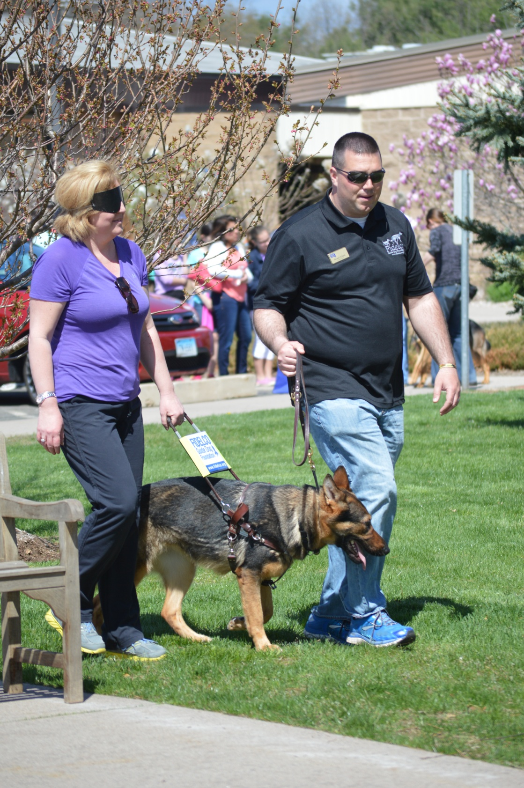
A woman experiences a blindfold walk with a Fidelco Guide Dog at Fidelco’s Open House on Saturday, May 3rd. Hi-res images available for download via this Dropbox link.

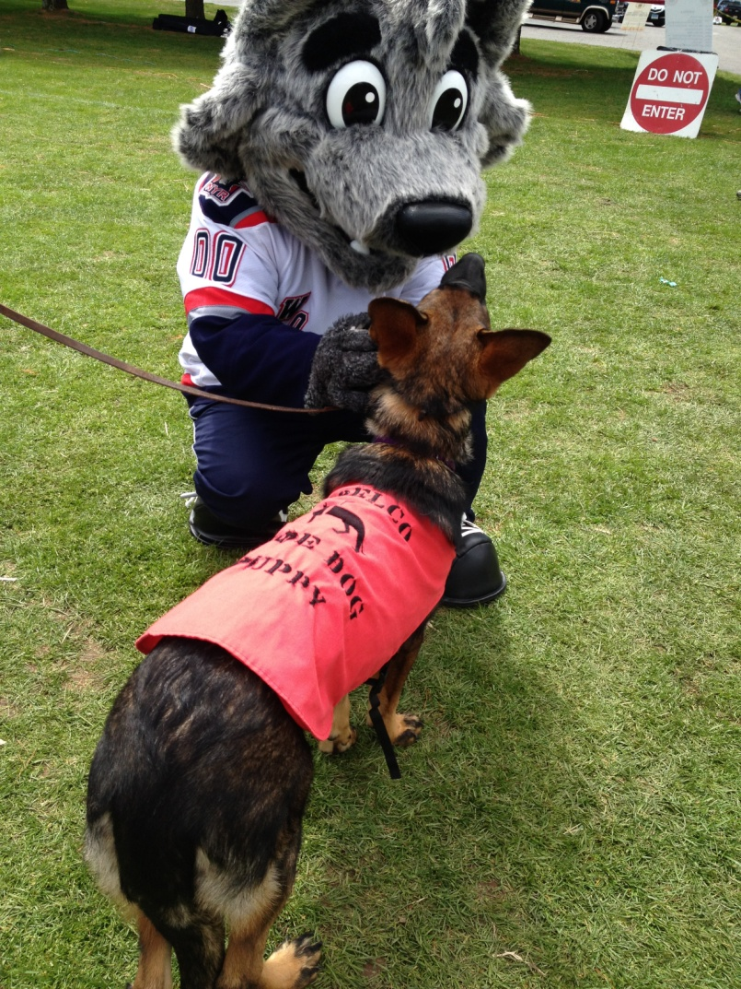
Fidelco puppy “Kacie” meets Sonar, the Hartford Wolf Pack mascot, at the New England Regional Chili Cookoff in Somers on Saturday, May 3rd. Hi-res images available for download via this Dropbox link.

About Fidelco Guide Dog Foundation
The Fidelco Guide Dog Foundation is a 501(c)(3) nonprofit based in Bloomfield, CT. Fidelco is an internationally accredited organization and an admired expert throughout the world for its highly valued German Shepherd Guide Dogs.

Each Fidelco Guide Dog takes two years, 15,000 hands-on hours and $45,000 to produce. They are given to clients at no cost. Fidelco provides 24/7 client support for the entire working life of its guide dogs – typically 10 years. Fidelco relies solely on the generosity and financial support of individuals, foundations, corporations and civic organizations to help Share the Vision®.

Fidelco has trained and placed over 1,350 German Shepherd Guide Dogs throughout North America – in 41 states and five Canadian provinces. Fidelco pioneered In-Community Placement in the United States — a process that allows all guide dog users to be trained in the communities where they live and work.

Fidelco also has placed hundreds of its German Shepherd Dogs with law enforcement agencies, first responders, search and rescue, and missing child recovery organizations to help protect our fellow citizens and keep our communities safe. For more information visit www.fidelco.org.

###

