**Press Release Contacts:**

**For Immediate Release** Vinitaly International

International Media Dept.

+39 045 8101447

[media@vinitalytour.com](mailto:media@vinitalytour.com)

[www.vinitalytour.com](http://www.vinitalytour.com)

Twitter: @VinitalyTour

Join Vinitaly International Network on LinkedIn

**Italian wine producers and the American Cancer Society drink to a new success in fight against cancer**

There can be nothing better than a just cause behind a successful evening: 180.000 dollars were raised last Thursday during the ninth edition of Taste of Hope, one of New York’s top charity events which brought together more than 800 eager donors and philanthropists who happily spent the evening savouring culinary specialities and delectable fine Italian wines, provided once again by Vinitaly International, the ambassador for Italian wines. The event also included tops chefs such as Elezabeth Falkner (honoree), Marc Murphy, Francois Payard, Julian medina as well as a special appearance from New York Knicks basketball player A'mare Stoudemire.

“The American Cancer Society could not be more grateful for the continuous support of Vinitaly International and the individual Italian wine producers that participate in this event. We are thrilled to have them as our partner and to showcase their wine to our guests” said Kris Kim, Chief Operating Officer of the American Cancer Society from New York, when talking about the renewed support offered to the event by some of the top names of Italian wine production. Most of them are now in their third year at Taste of Hope proving an unfaltering devotion to the cause that is reflected in their words:

Alberto Lusini, who oversees the American sales and marketing for Mezzacorona, Italy's largest producer of Pinot Grigio and Chardonnay, was proud to return for the third time and participate in “one of the most socially important events in the food and wine industry: Taste of Hope. Mezzacorona believes in the fight against cancer and was more than pleased to support the fundraising by featuring its finest bottle of sparkling Rotari Rosè Trento DOC, together with two brand new products: Cliffhanger Vineyards – pinot Grigio and Proprietary Red Blend”.

Camilla Lunelli from the fine sparkling winery Cantine Ferrari also expressed great enthusiasm for the successful evening: “Cantine Ferrari proudly participated to the Taste of Hope event which blends the noble cause of fundraising for the American Cancer Society with an outstanding wine and culinary experience. As a supporting vendor, we were highly impressed by the organization and participation that made this event one of the key spectacles of Metro NY scene.”

According to Marilisa Allegrini of Allegrini Estates, which is known for its Amarone from Veneto “fantastic progress is being made in the fight against cancer but it still affects too many families, and my own is no exception. I continue to support the campaign to raise funds for research in the hope that one day, our children and our children’s children can look forward to a brighter future”.

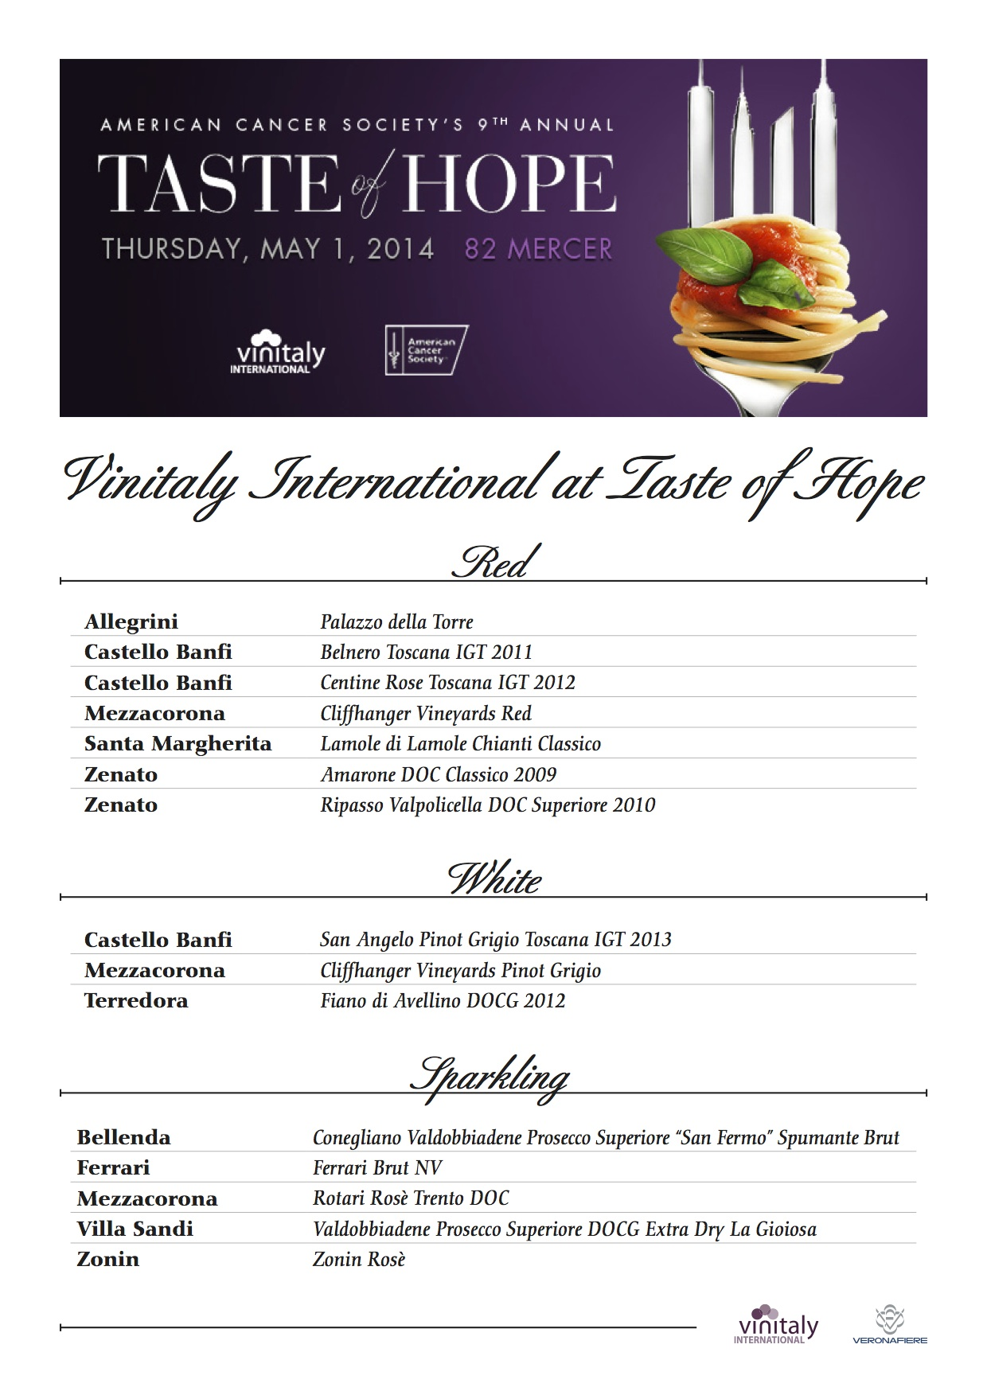

Zenato also decided to take part again in Taste of Hope this year and support the cause of the American Cancer Society. “We have always been sensitive to this type of initiative and we believe important to help in a concrete way the scientific research against cancer also presenting two of our most important wines: the Amarone Classico and the Ripassa” said Nadia Zenato of Zenato Winery.

“For all the positive aspects we associate with wine it’s beautiful that it can also be representative of important battles like the fight against cancer” said the owner of Terredora Winery, Daniela Mastroberardino.

“Together we can obtain important results for research in order to build hope. Thank you Taste of Hope. Thank you Vinitaly for wanting Italian wines to be promoters of a healthy lifestyle.”

The fine Italian Wineries that donated wines for this edition were: Casa Vinicola Zonin, Mezzacorona, Zenato, Allegrini - Corte Giara, Castello Banfi, Cantine Ferrari, Santa Margherita, Terredora, Villa Sandi and Bellenda.

For more information about the event, visit <http://www.tasteofhopenyc.org>, follow us on Twitter @VinitalyTour and the American Cancer Society on @ACSTasteofHope.

**About:**

**Veronafiere** is the leading organizer of trade shows in Italy including Vinitaly ([www.vinitaly.com](http://www.vinitaly.com/" \t "_blank)), the largest wine event in the world. The 48th edition of Vinitaly counted some 155,000 visitors (+6%) in four days of event, of which 56.000 were international attendees representing 36% of the total. On 100.000 square meters, 4.000 exhibitors welcomed trade professionals, media and producers alike. The next instalment of the fair will take place on 22 – 25 March 2015. The premier event to Vinitaly, OperaWine ([www.vinitalyinternational.com](http://www.vinitalyinternational.com/" \t "_blank)) “Finest Italian Wines: 100 Great Producers,” will unite international wine professionals on March 21st 2015 in the heart of Verona, offering them the unique opportunity to discover and taste the 100 best Italian wines, as selected by Wine Spectator. In 1998 Veronafiere also created Vinitaly International to develop a global platform for the promotion of Italian wine producers in foreign markets such as Russia, China, USA and Hong Kong.

**Taste of Hope®** was founded in 2005 by the American Cancer Society. They created this fundraiser as a way to celebrate New York dining while raising funds to help underwrite the ACS’s mission to fight for every birthday threatened by every cancer in every community. Between the early 1990s and 2013 the Society has seen a 20 percent decrease in the overall cancer death rate, which means they have helped to avoid about 1.2million cancer deaths and created the potential for more birthday celebrations.

**# # #**