HI-MACS® a huge success at Milan Design Week 2014
Sparkle Krib by Karim Rashid and other projects at the 2014 main show and fringe events
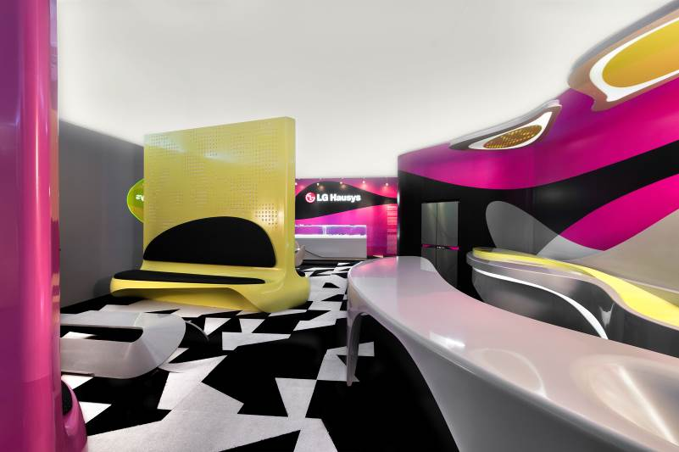
Design.
The dictionary definition of design is 'the process of constructing an idea which makes it visible and brings it into being'.
What is missing from this definition, however, is that design, like art and music, is a form of heritage. This means that it should be available to all and should be a common ground where people can come together regardless of the distance or differences between them. With its functionality and the power it represents, design is reality. It is brought to life in projects created to evolve and to make people evolve. It exists to make life easier, or simply give aesthetic pleasure.
Design is therefore a project and a ‘construction process’. It is a set of ideas and steps that can be made into reality and produced, and that have a specific goal, whether it be simple or complex.
In this sense, HI-MACS® is the perfect material for giving life to design in its purest, most absolute sense of projects, goals and above all, something that is open to all without distinction.
Milan Design Week was yet another opportunity for HI-MACS® to stamp its influence and to prove its place as the most versatile hi-tech material on the market, adapting to an endless variety of projects.
The next generation acrylic stone brought to life Karim Rashid's visionary concepts in his Sparkle Krib design, an evocative installation at the Temporary Museum for New Design in collaboration with LG Electronics.
This dream-like, animated living space literally lit up the Tortona circuit of the fringe show. The stunning installation gives us a fresh angle on modern living environments, breaking down architectural barriers and incorporating furniture into a continuous structure with an organic feel and high visual impact.
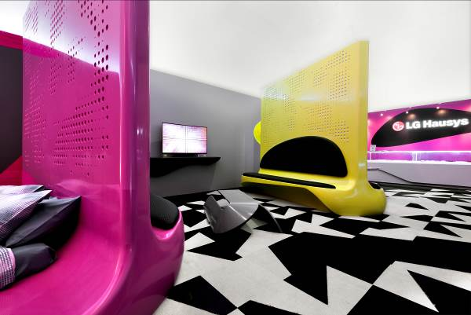

Photo credits Sparkle Krib: ©Federico Torra

HI-MACS® was also the perfect material for a project in a more strictly technical vein. It formed part of Poliform Varenna's AdaptLiving kitchen prototype, designed by Politecnic of Milan, to be used by people with limited mobility.
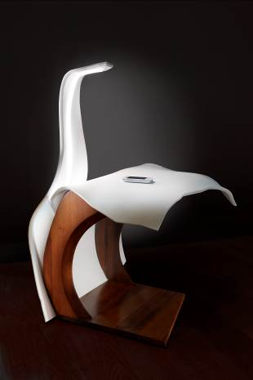
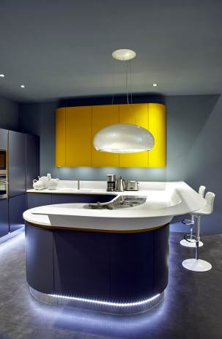
The next generation acrylic stone also featured in a range of other designs at the 2014 main and fringe shows: furniture, with the Balance Lounge Chair by Pure Design; high technology instruments, with Cobra by Archi(Struc)tures DesLAB, bathroom accessories with the EllenbergerDesign project and Rifra's items Box, Smooth, Bowl and Adam lamp and kitchens with the decorative Zen hood for Novy, the Mod.Progetto Sistema by Ar-Tre and the Volare system by Aran Kitchens.
‘Cobra’, by Archi(Struc)tures DesLAB Mod.Progetto Sistema by Ar-Tre fabricated by Union

This year, as never before, HI-MACS® showed that it can be adapted to any idea and can be moulded to create the most ambitious projects. It proved that it really is capable of bringing ideas to life.
Available in approximately 100 colourways, HI-MACS® is capable of reproducing the hard, cold tones of minerals and earth, but also fresher, more fashionable shades like the ones designed by Karim Rashid for the new Sparkle collection.
“HI-MACS® by LG Hausys is an outstandingly high quality material that offers designers and architects the optimum technical performance and almost endless possibilities, allowing them to create exciting spaces and projects. Today, people are looking increasingly for a holistic experience in their own living space and working in partnership with LG Electronics Italy on the Sparkle Krib stand allowed us to offer visitors an interactive multimedia vision of a living space, making it even more absorbing and interesting for them. All of the LG group's products are designed to complement each other and they are all produced with the same aim of making life better for people. To be able to display them together in the same space is a great opportunity for us."
Alex Kim, HI-MACS® Product Manager, LG Hausys Europe.
HI-MACS® is the high technology material that 'builds ideas and makes them visible'.
Design.
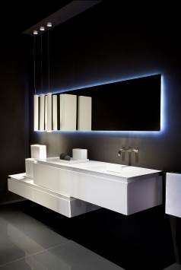
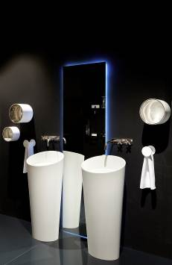
Rifra’s Box, Smooth, Bowl and lamp Adam

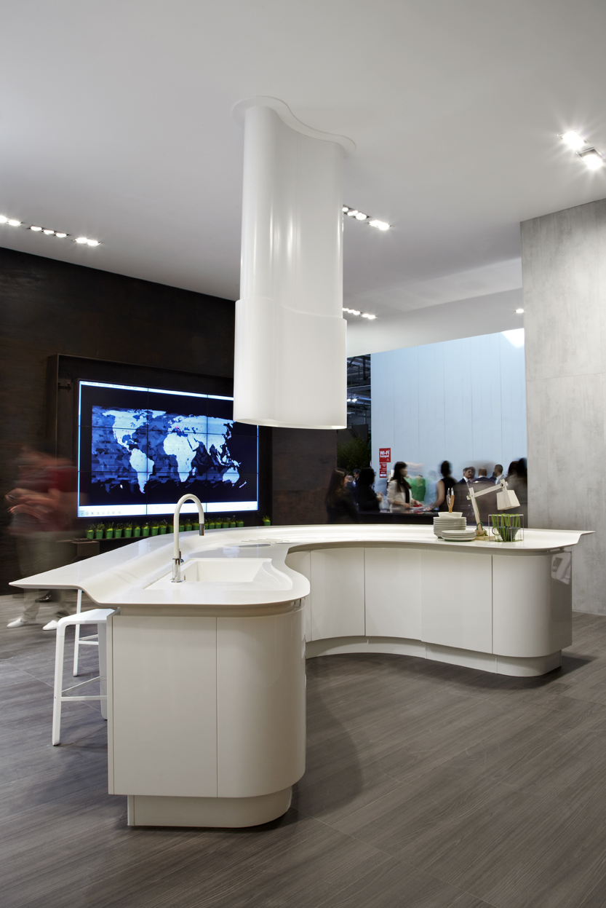
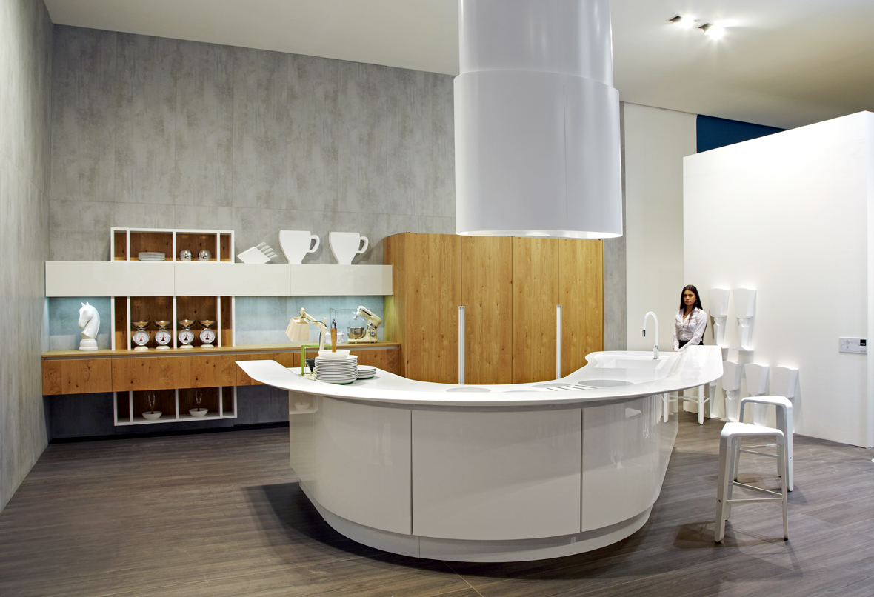

Kitchen “Volare” by Aran Cucine, made with HI-MACS®, fabricated by DForm

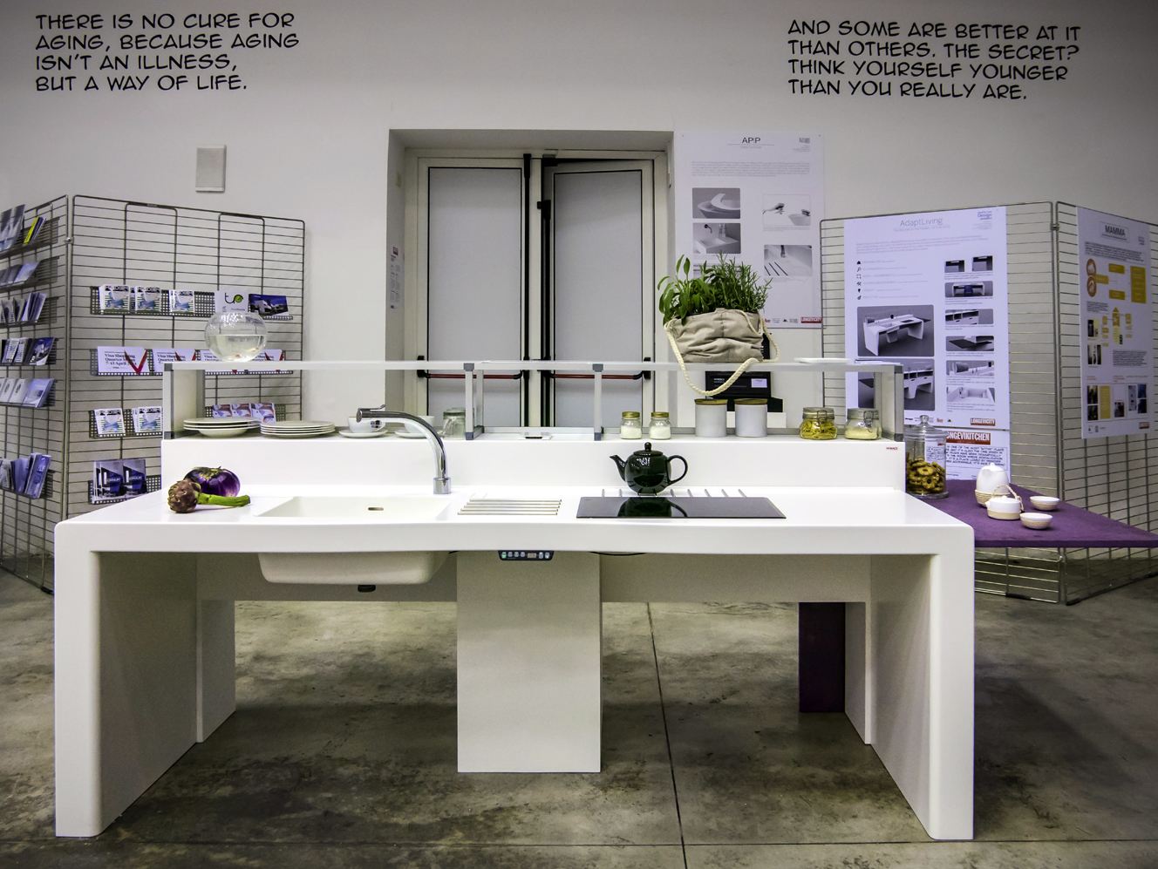
AdaptLiving designed by Politecnico of Milan in colaboration with Poliform Varenna.
Photo credits Rifra, Aran Cucine, Ar-Tre, Cobra: ©Tiziana Arici

HI-MACS® by LG Hausys
Surfacing the World
^{www.himacs.eu}
HI-MACS® is a solid surface material that can be moulded into any shape. It is widely used for architectural and interior applications, such as sculptural and high performance wall-cladding or kitchen, bathroom and furniture surfaces, in commercial, residential and public space projects. It is composed of acrylic, natural minerals and pigments that come together to provide a smooth, non-porous and visually seamless surface which meets the highest standards for aesthetics, fabrication, functionality and hygiene – offering manifold advantages over conventional materials.
HI-MACS® provides limitless possibilities for surfacing solutions and inspires creative minds from all over the world. Zaha Hadid, Jean Nouvel, Rafael Moneo, Karim Rashid and David Chipperfield, among others, have completed fabulous projects using HI-MACS®, from kitchens to bathrooms, including decorative items, in hotels as well as in museums, shopping centres and on external façades.
LG Hausys’ HI-MACS® uses a simple heating process to give three-dimensional thermoplastic forming capabilities, allows visually seamless designs, offers a virtually limitless range of colours and – for some shades - exhibits a special translucency when exposed to light. Although HI-MACS® is almost as robust as stone, it can be worked in a similar way as wood: it can be sawn, routed, drilled or sanded.
HI-MACS® is manufactured using a new generation technology, the thermal cure. The temperature reached during the manufacturing process sets HI-MACS® apart from other solid surfaces and creates a denser, even more homogeneous, sturdy, durable surface – with a better resistance and superior thermoforming performance.
As regards hygiene, HI-MACS® does not absorb humidity, is highly resistant to stains, and is easy to clean, maintain and repair.
Countless internationally recognized certificates attest to the quality of HI-MACS® in terms of ecological commitment, hygiene and fire resistance – being the first Solid Surface in the market to receive the official European Technical Approval (ETA) for façades – for Alpine White S728 colour.
HI-MACS® offers the longest warranty on the solid surface market with a 15-year warranty for products fabricated and installed by a member of the HI-MACS® Quality Club.
HI-MACS® The New Generation
Inspired by Architecture
For more information and to stay connected, visit our website.
Let’s connect!

* HI-MACS® is designed and produced by LG HAUSYS, a world leader in the technology sector belonging to LG Group, and distributed by LG HAUSYS EUROPE based in Geneva (Switzerland).

