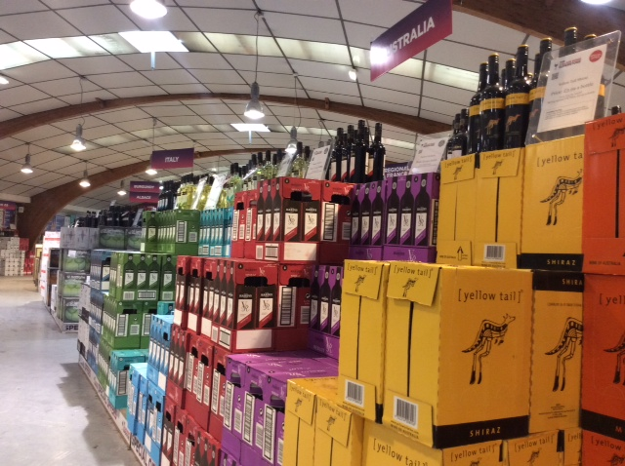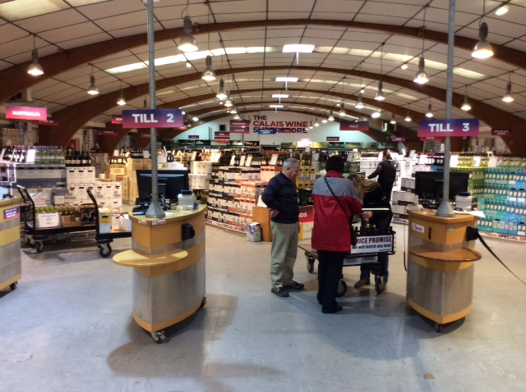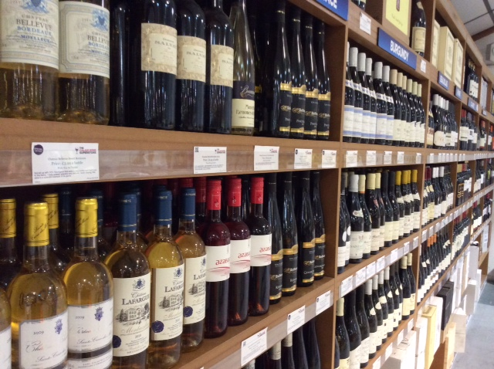

The Tides of Change
Why it is worth traveling to Calais again to buy your wine

The era of the booze cruise seemed consigned to the history books, due to the economic crash, fuel increases, the strength of the Euro and cut-price supermarket deals. Hopping across the Channel to go wine shopping simply didn’t seem worth it. However with UK wine duty having risen 50% since 2008 and buying wine under £5 a dim memory, the squeezed middle are looking for savings wherever they can.
Enter the 100% independent and British-owned Calais Wine Superstore.
The owners Simon Delannoy and Marco Attard have been in the cross-Channel trade for over 20 years and have poured all their wine knowledge and commitment to excellent service into bringing British customers the biggest savings on both sides of the Channel.
At The Calais Wine Superstore, customers save 60% on UK supermarket prices, which means at least £3 per bottle. Take the Jacob’s Creek Trilogy Sparkling wine, which usually retails for £9.99 at Ocado, but is only £2.49 when you buy 6 in Calais. Or the Vina Maipo Shiraz, £6 in the UK, which is available for just £2 at The Calais Wine Superstore.
The reason for these enormous savings is UK excise duty, which accounts for over 50% of the cost of a £5 wine bottle. With UK duty being nearly 100 times that of France, buying wine across the Channel just makes sense. As Mr Delannoy states, “The more you spend, the more you save!”
The Calais Wine Superstore takes pride in providing excellent customer service and removing the hassle and expense from travelling to Calais. Customers can place a pre-order on the website, which has plenty information on all 500 wines stocked, and ask the store to pay for their Channel crossing. The Calais Wine Superstore is the only wine store in Calais which can book and pay for your Eurotunnel ticket.
However, The Calais Wine Superstore understands that placing a large order for unknown wines may seem risky so they allow you to request free travel without pre-ordering! You can then browse and select wines in-store - there are state-of-the-art tasting machines with temperature-controlled wines and a tasting bar with over 50 wines open and available to taste for free every day.
“Even pre-orders can be changed or added to after tasting, says Simon Delannoy, “so our customers are never committed to purchasing a wine they don’t like.”
The English-speaking staff are always on hand to advise and will go out of the way to provide friendly, personal and knowledgeable service. “We understand that coming all the way to Calais to a huge store can be an intimidating experience, so we aim to make you feel relaxed,” says Mr Delannoy
The Calais Wine Superstore offers a price match guarantee and customers can pay in Sterling cash or cheque in-store.
While the Euro has strengthened against the Pound, the exchange rate has no impact on the savings to be had in Calais because the savings are due to the UK duty. In fact, it could even mean bigger savings, as Simon explains. “If the Euro is stronger, it means we can buy more for the same amount, since we buy in Euros. And we pass these savings on to the customer.”
So whether you’re planning a wedding, a party or simply stocking up, for real savings on alcohol, look no further than The Calais Wine Superstore.

Customer Comments
“I just wanted to say how impressed I've been about dealing with you guys. From first email to leaving the shop with my purchases, everything has been absolutely first class. The selection of wines is good as well; the prices are unbeatable (even amongst the local competition- and I did check) and the customer service is first class” Nigel.
“…highly recommend your Company to all who may contemplate using your services.” Rod & Ingrid F
“Thanks very much for sorting my order so efficiently today. Really appreciate it. You guys have nailed it. Way ahead of the competition. You've obviously worked very hard to understand what your customers want. Well done. It's quite rare to come across great customer service but you've done it: from the website to the staff. Thanks” Peter M
http://www.calaiswine.co.uk/blog/guest-blogs-customers/the-calais-wine-superstore-tony-h/

- ENDS -
For press information, contact:
Erica Hodges
The Calais Wine Superstore
erica@thelondonwine.co.uk
01484 222 466 | 07584 304368

NOTES TO EDITOR
- The Calais Wine Superstore has been open since 2010 and is 100% independent and British owned
- Owners Simon Delannoy and Marco Attard have been in the cross-Channel wine business since the early 1990’s.
- The Calais Wine Superstore is a 5 minute drive from the Ferry Terminal and 10 minute drive from the Euro Tunnel terminal
- It stocks over 500 wines, many French, but a good selection of New World wines including many brands familiar to UK consumers. There is also a large range of wine bag in box.
- The shop also stocks Champagne, Fine wine and beers.
- All products are featured on http://www.calaiswine.co.uk/ customers can find all the information they need on current products and offers, booking their travel and information to help plan their trip to Calais.

