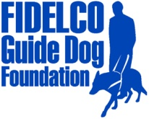
PRESS RELEASE

FOR IMMEDIATE RELEASE Fidelco Guide Dog Foundation
DATE: May 13, 2014 103 Vision Way
CONTACT: Heidi Voight, Director of Communications Bloomfield, CT 06002
860-906-2086 Cell; 860-243-4800 Office hvoight@fidelco.org www.fidelco.org

FIDELCO GUIDE DOG FOUNDATION SALUTES ARMED FORCES WEEK 2014 WITH “FIELD OF FLAGS”
BLOOMFIELD, Conn. – In honor of Armed Forces Week, Connecticut’s own Fidelco Guide Dog Foundation joins the nation in saluting the unparalleled service and bravery of America's military forces. Fidelco recognizes the selfless sacrifices made by military personnel and their families – especially blinded veterans who can no longer see the stars and stripes for which they served.
For more than five decades, Fidelco’s elite German Shepherd Guide Dogs have helped Americans rejoin the fight of everyday life in a world that presumes the ability of everyone to see. And the demand for Fidelco’s life-changing guide dogs will continue long after current armed conflicts have ended.
Every seven minutes, someone in America becomes blind or visually impaired. There are more than 160,000 blind veterans now living in the United States, according to the Department of Veterans Affairs. And 17 percent of military wounded returning from Iraq and Afghanistan suffer penetrating eye injuries from IEDs and other trauma, according to the American Foundation for the Blind.
“Armed Forces Week is another occasion for all citizens to honor the brave men and women who defend America,” said Fidelco CEO and Executive Director Eliot D. Russman. “For military personnel blinded in defense of our nation, the support they require continues long after the battlefield action ends. It takes two years, 15,000 hands-on hours and $45,000 to produce each Fidelco Guide Dog, and they are given to clients at no cost. Fidelco’s commitment to continue providing guide dogs depends upon its donors and volunteers who help us Share the Vision®.”
To support its mission and to honor America’s heroes, Fidelco launched its second annual “Field of Flags” tribute that will be unveiled at its annual Ride for Independence motorcycle fundraising event on Sunday, July 20th.
Fidelco’s commemorative display of American flags is dedicated to all heroes – those who are living and those who made the ultimate sacrifice – including mothers, fathers, sons and daughters, veterans, military branches of service, first responders and personal heroes like teachers and parents.
Each flag costs $10 and can be purchased today by visiting https://www.fidelco.org/honoryourhero. All proceeds directly support Fidelco’s mission. Honoree names will be included in the Field of Flags tribute.
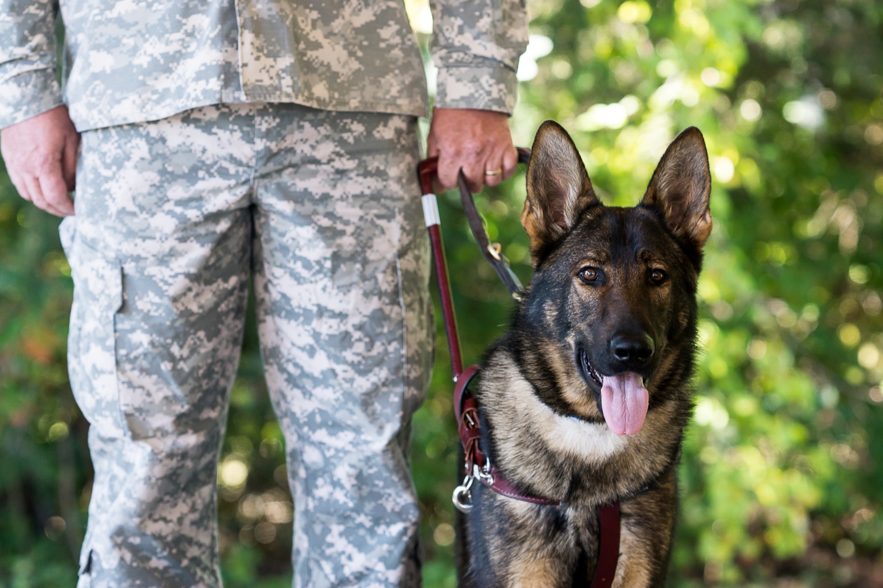
Meet Some of Fidelco’s Veteran Clients (Hi-res images available via this Dropbox link)
Lt. Bradley Snyder, USN (Ret), USNA 2006
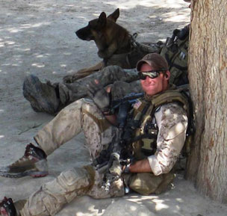   | 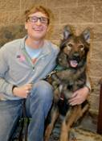
A Naval Academy graduate, Lt. Brad Snyder was blinded while serving with a Navy SEAL Team in Afghanistan in September 2011. Just one year later, he climbed to the top podium at the 2012 London Paralympic Games to claim his second gold medal for the United States. Brad is partnered with Fidelco Guide Dog “Gizzy.”

SSgt. Michael Malarsie, USAF (Ret)
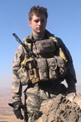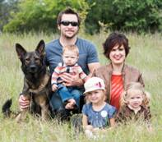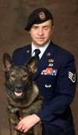
On January 3, 2010, in the remote mountains of Afghanistan, SSgt Michael Malarsie was blinded and severely wounded by a powerful improvised explosive device (IED) that killed four team members and blew him off a bridge. Exactly one year later, Michael was partnered with Fidelco Guide Dog “Xxon” and he returned to active duty status as the only blind airman serving in the United States Air Force.

TSgt. Matthew Slaydon, USAF (Ret)
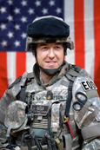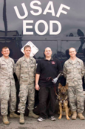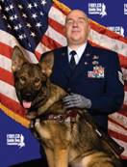
Having volunteered for three tours of duty during Operation Iraqi Freedom, where he disarmed over 100 improvised explosive devices serving as an EOD Team Leader, Matt was critically wounded by an IED in October 2007. His left arm was immediately amputated on the battlefield and he suffered shattered face and the loss of vision in both eyes. Matt is partnered with Fidelco Guide Dog “Legend.”

About Fidelco Guide Dog Foundation
The Fidelco Guide Dog Foundation is a 501(c)(3) nonprofit based in Bloomfield, CT. Fidelco is an internationally accredited organization and an admired expert throughout the world for its highly valued German Shepherd Guide Dogs.

Each Fidelco Guide Dog takes two years, 15,000 hands-on hours and $45,000 to produce. They are given to clients at no cost. Fidelco provides 24/7 client support for the entire working life of its guide dogs – typically 10 years. Fidelco relies solely on the generosity and financial support of individuals, foundations, corporations and civic organizations to help Share the Vision®.

Fidelco has trained and placed over 1,350 German Shepherd Guide Dogs throughout North America – in 41 states and five Canadian provinces. Fidelco pioneered In-Community Placement in the United States — a process that allows all guide dog users to be trained in the communities where they live and work.

Fidelco also has placed hundreds of its German Shepherd Dogs with law enforcement agencies, first responders, search and rescue, and missing child recovery organizations to help protect our fellow citizens and keep our communities safe. For more information visit www.fidelco.org.

###

