Lecture
Toronto, Canada

Date: May 30th, 2014
Location: Glendon College | York University more information
Progressive Workshop
Toronto, Canada
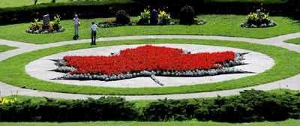
Date: May 30th - June 1st, 2014
Location: Glendon College | York University more information
Hay House World Summit
Online Series

Date: May 31st - June 9th, 2014
Location: Online more information
Lecture
Sydney, Australia

Date: June 6th, 2014
Location: Sydney more information
Workshop
Sydney, Australia

Date: June 6th - 8th, 2014
Location: Sydney more information
Lecture
Melbourne, Australia

Date: June 13th, 2014
Location: Melbourne more information

Workshop
Melbourne, Australia

Date: June 13th - 15th, 2014
Location: Melbourne more information
I Can Do It !
Baltimore, MD
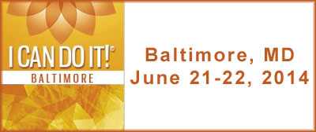
Date: June 21st - 22nd, 2014
Location: Hippodrome Theater more information
Progressive Workshop
Lakewood, CO

Date: June 27th - 28th, 2014
Location: Mile Hi Church more information
Progressive Workshop
Vancouver BC, Canada

Date: July 4th - 6th, 2014
Location: Renaissance Harbourside Hotel more information
Lecture
Miami, FL
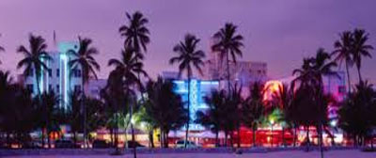
Date: July 10th, 2014
Location: Unity Church on the Bay more information
Progressive Workshop
Miami, FL

Date: July 10th - 12th, 2014
Location: Unity Church on the Bay more information
Advanced Workshop
Cancun, Mexico
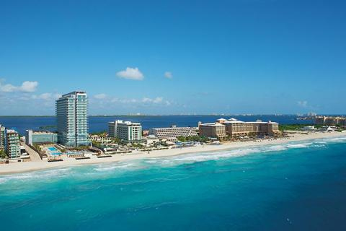
Date: July 23rd - 27th, 2014
Location: Secrets The VIne Resort more information
Lecture
Baltimore, MD
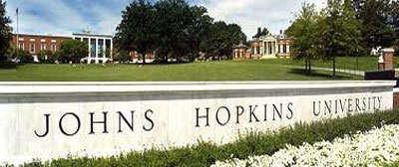
Date: September 5th, 2014
Location: Johns Hopkins University more information

- Pages 1 2 3 4

Progressive Workshop
Baltimore, MD
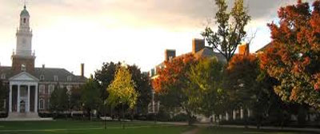
Date: September 5th - 7th, 2014
Location: Johns Hopkins University more information
Progressive Workshop
Carefree, AZ
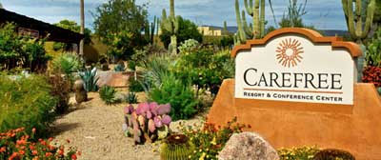
Date: September 12th - 14th, 2014
Location: Carefree Resort & Conference Center more information
Lecture
Honolulu, HI

Date: October 6th - 9th, 2014
Location: Hale Koa Hotel more information
Lecture - Registration Opens in July
Seattle, WA

Date: October 17th - 19th, 2014
Location: Seattle Hilton Conference Center more information
I Can Do It !
Pasadena, CA
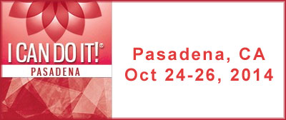
Date: October 24th - 26th, 2014
Location: Pasadena Civic Convention Center more information
Progressive Workshop
Norwalk, CT
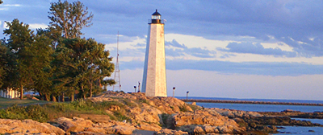
Date: November 7th - 9th, 2014
Location: Dolce Norwalk Hotel more information
Keynote Lecture
Reston, VA

Date: November 13th - 16th, 2014
Location: Hyatt Regency Reston more information
Extended Progressive Workshop
Munich, Germany
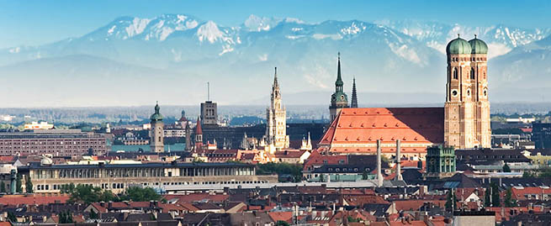
Date: November 21st - 23rd, 2014
Location: Stadthalle Erding more information

- Pages 1 2 3 4
- Lecture
Portugal
- 
- Date: November 28th, 2014
Location: Lisboa more information
- Progressive Workshop
Portugal
- 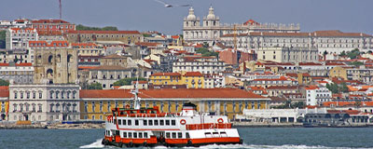
- Date: November 28th - 30th, 2014
Location: Lisboa more information
- Retreat & Workshop
Guanacaste, Costa Rica
- 
- Date: December 7th - 13th, 2014
Location: Hotel Sugar Beach more information
- Advanced Workshop
Carefree, Arizona
- Date: April 22nd - 26th, 2015
Location: Carefree, AZ more information

