

**FOR IMMEDIATE RELEASE**

**Wastequip Ushers in New Grease Container with Anti-Theft Lid**

*Versatile Grease Vault Lid Thwarts the Most Ardent of Thieves*

**CHARLOTTE, N.C. [May 21, 2014]** — [Wastequip](http://www.wastequip.com)®, the leading North American manufacturer of waste and recycling equipment, today announces the launch of a new line of grease containers that prevents the frustrating problem of grease theft. Featuring the Grease Vault lid, these new grease containers provide safe, simple storage of used food grease – and will discourage the most pesky grease burglar around.

To alleviate the aggravating – and costly – issue of grease theft, Wastequip’s Grease Vault lids have lid plates that interlock, leaving no edges to pry open; a shielded lock; and a heavy-duty grate. Available in middle-dump or end-dump configurations, with drop-in box or flat grates, the Grease Vault lid and grate system is standard on Wastequip grease containers, and also can be retrofitted on most existing grease containers. Assembly of the lid takes no more than 15 seconds, and requires no welding or tools. User simply slides the two plates together, aligns holes, attaches grate, and puts a padlock in place.

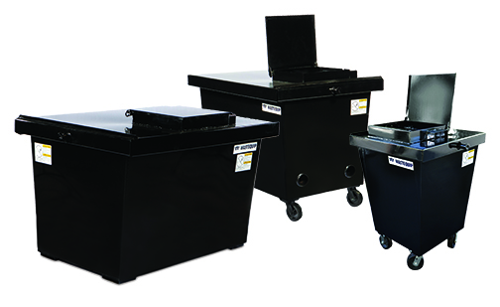

Available in the most popular capacities (100, 208, 294, and 360 gallons), Wastequip’s new grease containers are ideal for any environment that generates food grease, such as restaurants, grocery stores, schools, hospitals, hotels, etc. They’ve been thoroughly tested against leakage, and have a lip overhang that prevents spills. Plus, they can be easily emptied by vacuuming *or* dumping.

“Growth in the bio-fuel market and stringent regulations governing the collection and disposal of grease has been driving the demand for safe, simple grease storage products for several years,” said Amanda Maeyaert, product manager for Wastequip containers. “As the value of used cooking oil skyrockets, so does the number of people willing to resort to theft to make a few bucks. Wastequip is extremely excited to introduce this new grease container that discourages grease theft, so our customers can dispose of used food grease in an appropriate manner.”

Options include bottom rails to keep container off the ground, container dollies to simplify maneuvering, heat tubes, and dumping pins.

###

**ABOUT WASTEQUIP**

Wastequip is the leading North American manufacturer of waste and recycling equipment, with an international network of manufacturing facilities and the most extensive dealer network in North America. Wastequip’s broad range of waste and recycling equipment and systems is used to collect, process and transport recyclables, solid waste, liquid waste and organics. The company’s brands include Wastequip, Toter, Galbreath, Pioneer, Accurate, Cusco, Mountain Tarp and Parts Place. For more information, visit [www.wastequip.com.](http://www.wastequip.com)

**Media Contact:**

Amy Wright

Vice President, Marketing

704-936-5615

[awright@wastequip.com](mailto:awright@wastequip.com)