

PRESS RELEASE: May 20, 2014
FOR IMMEDIATE RELEASE
El Portal Announces New Green Rooftop Garden

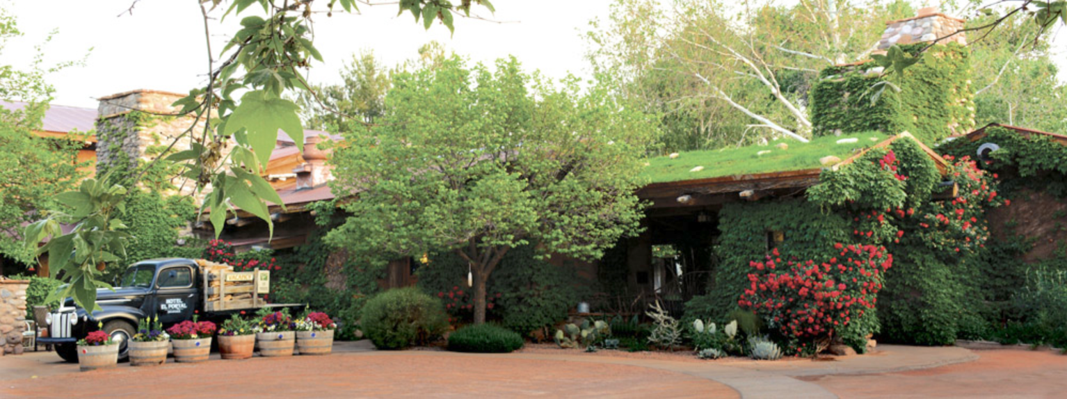
El Portal, Sedona’s premiere boutique hotel located in the heart of the beautiful red rock country of Arizona, announces the installation of its new green rooftop garden.

With a longstanding history of dedication to local farmers through hosting open garden spaces to produce vegetables and herbs for fresh and local meals, El Portal Sedona Hotel strives to be at the forefront of supporting sustainability initiatives in its community. The hotel continues this commitment to going green by using its rooftop to install a living green space for it’s guests and hotel staff to visually enjoy, and reduce its carbon footprint.

Green roofs carry a rich tradition of creatively using space to absorb rainfall, provide thermal protection, and engage the aesthetic structures of landscapes and buildings. They consist of a partial or complete covering over the top surface of a building with a variety of plants, grasses, and growing medium spread of a waterproofing membrane. Modern designs include advanced drainage and irrigation systems but it is a technique that has been practiced for centuries with examples as grand and as old as the Hanging Gardens of Babylon.

At El Portal, owner Steve Segner started the process of going green in early February by installing grass sod on the roof. Seeded with wildflowers native to the area, El Portal is hoping that this new endeavor will bring ambiance and distinctive beauty to the already extraordinary architecture of this boutique hotel. Plus, with the grueling summer temperatures, this green mindset will lend itself to making El Portal the energy efficient and cool natural summer retreat from life that it is well known to be.

Built on the site of an old apple orchard in the turn of the century Southwestern style and utilizing 18-inch thick handmade adobe walls, El Portal already takes advantage of natural insulation. With special attention to the conservation of natural resources, each of the twelve unique guest suites feature recycled wood beams and trim, natural native stone, and are aesthetically designed with museum quality Arts and Craft furnishings. Designed to reinforce the subtle connection with nature that surrounds Sedona, El Portal’s attention to simplicity and function enables guests to enjoy a property that thoughtfully integrates a spiritual connection to nature. This new green rooftop endeavor seeks to expand on the already relaxing and rejuvenating atmosphere that countless guests enjoy and relish.

For more information: http://www.elportalsedona.com/
CONTACT:
Steve Segner
El Portal Sedona Hotel
1-800-313-0017
info@ElPortalSedona.com

