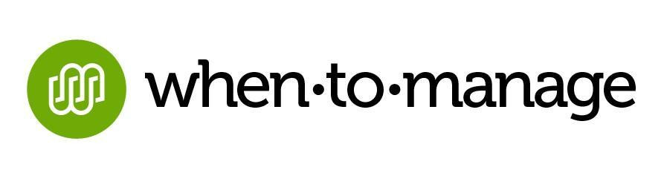
For Immediate Release

Panera Bread® Deploying Customized WhenToManage Solution for
Improved Operational Technology
Norwalk, CT (May 29, 2014) – WhenToManage, the leading innovator of cloud-based software for the restaurant, hospitality and retail industries, announced today that it has provided a full license of its software to Panera Bread®, the fast casual restaurant leader which owns and/or franchises 1800 bakery-cafes.
WhenToManage tailored the design of its applications to improve the usability of Panera’s back of house system. With the WhenToManage Solution, Panera Bread bakery-cafe managers will be able to access operational management systems through one simplified, accessible mobile dashboard. Here they can manage food costs, inventory, forecasting and employee communications.
“WhenToManage really understands restaurant operations. They customized the solution for our distinct needs,” says Mike Nettles, Vice President of Architecture and Cafe Solutions, Panera Bread.
“Everyone on our professional consulting team has previously worked in the restaurant industry,” says Jeff Schacher, CEO, WhenToManage. “We feel the pain of needing to manage and gather data on a moment’s notice.”
Until now, cafe managers have required training on a number of different systems with separate log-ins. Going forward, they will only need training on one App. With just one click on a tablet or computer, the bakery-cafe manager can access and enter the cafe’s full operational console.
The new back of the house solution, powered by WhenToManage, is currently available to approximately 800 company bakery-cafes. They hope to have the Panera franchise community onboard by mid-2015 as well.
About WhenToManage
WhenToManage is comprised of a team of professionals with years of true restaurant operations experience from the top down, and a passion for creating software that they, in turn, would be excited to use. The result is a restaurant operating system that is more accessible, easier to use, and requires less training and support. WhenToManage offers subscription-based solutions for POS intelligence, inventory management and employee scheduling, as well as customized deployments. For more information, please visit http://whentomanage.com.
WhenToManage is also the founder of Community Plates, a 501(c)3 non-profit organization committed to ending food insecurity in the United States through food rescue. Founded in 2011, Community Plates utilizes breakthrough, proprietary technology to manage food donors, receiving agencies and volunteer drivers. Community Plates’ GoRescue App, created by WhenToManage, was awarded the 2013 Computerworld Honors Program 21st Century Achievement Award in Human Services. To donate, volunteer and get involved, visit http://www.communityplates.org.
###
Media Contact:
Lynn Schwartz
Newsmaker Group for WhenToManage
lschwartz@newsmakergroup.com
973.736.7118

