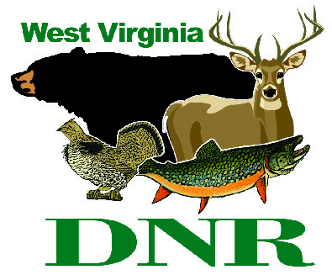 | West Virginia Division of Natural Resources  www.wvdnr.gov  Earl Ray Tomblin, Governor  Frank Jezioro, Director  News Release: May 29, 2014  Facebook: WV Commerce - State Parks  Hoy Murphy, Public Information Officer 304-957-9365 hoy.r.murphy@wv.gov  Contact: Bret Preston, Wildlife Resources Section 304=558-2771 Bret.A.Preston@wv.gov

West Virginia’s Free Fishing Weekend is June 7-8, 2014

SOUTH CHARLESTON, West Virginia – National Fishing and Boating Week 2014 will be highlighted by the 24th annual Free Fishing Weekend June 7-8, according to Frank Jezioro, Director of the West Virginia Division of Natural Resources (DNR). During these two days, residents and nonresidents can fish in West Virginia without a license.
“It is a great opportunity to remind people of the fun of fishing, especially with family and friends. If you already have a license, take someone fishing -- it may be your children, spouse or co-worker – and introduce them to a lifetime of outdoor enjoyment,” Jezioro said.
DNR participates in a number of activities during National Fishing and Boating Week and Free Fishing Weekend. One of the largest and most successful events is the Bowden Fishing Derby that will be held June 7 at the Bowden Hatchery in Randolph County. Children must register for the event, and they will receive basic fishing instruction and will have the opportunity to enjoy time fishing with friends and family. Registration information for the Bowden Derby can be found at www.wvdnr.gov/2014%20Derby%20Flier.pdf.
National Fishing and Boating Week began as a promotional activity sponsored by the sportfishing industry, encouraging fishing around Father’s Day. The recreational boating industry partnered with its sportfishing counterparts to develop a fishing and boating educational campaign.
From those beginnings, National Fishing and Boating Week has evolved into a very effective private/public partnership. The sportfishing and boating industries, fishing organizations and local, state, and federal agencies work together to bring the message home that fishing is great fun and that healthy aquatic ecosystems are important.

**DNR**

Photo Courtesy of the West Virginia Department of Commerce.
West Virginia’s Free Fishing Days are June 7 and 8, 2014.

