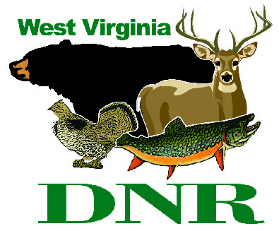 | West Virginia Division of Natural Resources  www.wvdnr.gov  Earl Ray Tomblin, Governor  Frank Jezioro, Director  News Release: May 29, 2014  Facebook: WV Commerce - State Parks  Hoy Murphy, Public Information Officer 304-957-9365 hoy.r.murphy@wv.gov  Contact: Sissie Summers, Parks and Recreation Section 304-558-2764 Sissie.A.Summers@wv.gov

Summer Fishing at West Virginia State Parks

SOUTH CHARLESTON, W.Va. – West Virginia’s state parks offer many opportunities and types of waters for a favorite summertime pursuit – fishing – with ponds, lakes, streams and rivers. Catchable warmwater and coldwater fish include bluegill, bass, catfish, trout and other species. Residents and visitors to the state are invited to wet some lines and try their luck (or skill) at angling, an activity that can be enjoyed at any age throughout a person’s lifetime.

Catfishing
West Virginia Division of Natural Resources (WVDNR) personnel are stocking tagged channel catfish into eight state park lakes in May as part of the Catfish in the Parks Program. These state parks include: Cacapon, Cedar Creek, Chief Logan, Little Beaver, North Bend, Pipestem, Tomlinson Run, and Watoga. As part of the program, anglers who report a tagged catfish caught in a state park will receive a certificate good for one free night of camping at several state park campgrounds.
Anglers who catch a tagged fish are asked to return the tag or the tag number, along with information on the date of capture, if the fish was kept or released, and the name and address of the angler, to WVDNR, 2311 Ohio Ave, Parkersburg, WV 26101.
Anglers also can call 304-420-4550 or provide the information by sending an email report to dnrfishtags@wv.gov. Additional information about the tagging programs can be found at www.wvdnr.gov/Fishing/Fish_Tagging.shtm.

Fishing without a license
A fishing license is required except for two specific days each year known as Free Fishing Days, during which the public is allowed to fish without a license. In West Virginia, the two dates in 2014 are June 7 and 8. According to takemefishing.org, “Fishing with kids is a great way to connect as a family and to experience the outdoors.” There are more than 35 state park areas to enjoy fishing.

Spec”TACKLE”lar Fishing, June 8 at Cacapon Resort State Park
What a great way to become more aware of and build appreciation for one of our natural resources and it's all free! Activities include a fishing derby, fish printing and a stream search. For overnight reservations, call Cacapon Lodge at 304-258-1022. For information about the event, contact Renee Fincham at 304-258-1022 x 5209.

23rd Annual Fishing Derby, June 14 at Little Beaver State Park
Little Beaver State Park is the place for a fun-filled day of fishing. Bait and a free lunch will be provided and prizes and t-shirts will be given out after the derby, while supplies last. The event is sponsored by the Wildlife Resources Section of the Division of Natural Resources in cooperation with Little Beaver State Park. The derby is scheduled from 9 a.m. to noon. Contact Mark Scott, WVDNR Wildlife, at 304-256-6945 for more information.

First Fish – It’s a big deal
Sometimes a youngster or an adult needs a small acknowledgement or recognition to reinforce a positive experience. State parks naturalists award paper certificates to visitors who catch their first fish in state park waters. Presentations can be at campfire programs or with the individual or family.
WVDNR also offers an online method of fishing rewards – a First Fish Certificate – which can be completed online and printed. The document webpage is at www.wvdnr.gov, Fishing, First Fish Certificate.

The woods and waters in West Virginia make for ideal fishing conditions throughout the year, whether at a West Virginia state park and forest area or the multiple wildlife management areas and public waters throughout the Mountain State. To learn more about West Virginia State Parks, visit www.wvstateparks.com. WVDNR includes state parks, wildlife resources, natural resources police, Office of Land and Streams and Wonderful West Virginia magazine. The WVDNR website is www.wvdnr.gov.

**DNR**

Photo Courtesy of the West Virginia Department of Commerce.
Adults and children are encouraged to try fishing during West Virginia’s Free Fishing Days June 7 and 8, when they can fish without a license. Several state parks offer fishing opportunities all year.

