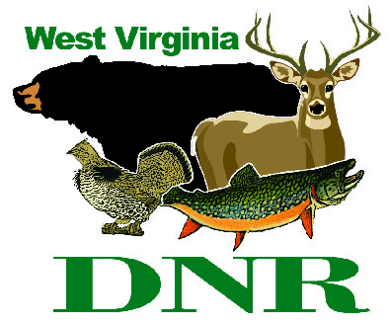 | West Virginia Division of Natural Resources  www.wvdnr.gov  Earl Ray Tomblin, Governor  Frank Jezioro, Director  News Release: May 29, 2014  Facebook: WV Commerce - State Parks  Hoy Murphy, Public Information Officer 304-957-9365 hoy.r.murphy@wv.gov  Contact: Sissie Summers, Parks and Recreation Section 304-558-2764 Sissie.A.Summers@wv.gov

Celebrate West Virginia Day Weekend June 20-22, 2014

at West Virginia State Parks

SOUTH CHARLESTON, W.Va. – West Virginia Day, June 20, falls on a Friday in 2014, opening up the whole weekend to a variety of outdoors activities at West Virginia’s state parks. Planned events include a Civil War encampment, concerts and birthday parties. Here is a list of planned activities for West Virginia Day weekend, June 20-22, but check www.wvstateparks.com frequently as new events are being added.

Happy Birthday West Virginia! June 20 at Blennerhassett Island State Park
Board the Island Belle sternwheeler, visit the island and enjoy birthday cake. It's West Virginia's 151st birthday Friday, June 20, 2014. Free cake served at 1:30 p.m. as long as it lasts. 304-420-4800

Civil War Encampment and Battle Reenactment June 20-22 at Blennerhassett Island State Park
To celebrate the state's birthday, visit with reenactors, historians and encampments on the island. The camps are open to the public during the entire weekend. Blennerhassett Island also will be the setting for a re-enacted Civil War battle each day, June 21 and 22. 304-420-4800

West Virginia Day June 20 at Prickett’s Fort State Park
On June 20, 1863, West Virginia became the 35th state to enter the Union. Come to Pricket’s Fort State Park to help celebrate West Virginia statehood. Half price fort admission June 20, from 10 a.m. to 4 p.m. 304-363-3030

West Virginia Day Weekend Celebration June 21-22 at Camp Creek State Park
A statehood birthday weekend celebration at Camp Creek State Park's amphitheater! Bluegrass Music Saturday from 1 - 6 p.m. and gospel music Sunday from 1 - 6 p.m. Food concessions will be sold on both days by the Camp Creek State Park & Forest Foundation. Free admission. 304-425-9481

Other activities are scheduled at state parks this weekend, including storytelling at Pipestem Resort State Park, a dinner train at Cass Scenic Railroad State Park, a 5K run at Cacapon Resort State Park, a Halloween party at Tomlinson Run State Park’s campground, and a bluegrass concert at the Pipestem Resort State Park amphitheater. For details on these and other events, visit www.wvstateparks.com or call 1-800-CALL-WVA.
**DNR**

Photo Courtesy of the West Virginia Department of Commerce.
A Civil War encampment and battle reenactment will be part of the West Virginia Day celebration on Blennerhassett Island State Park June 20.

