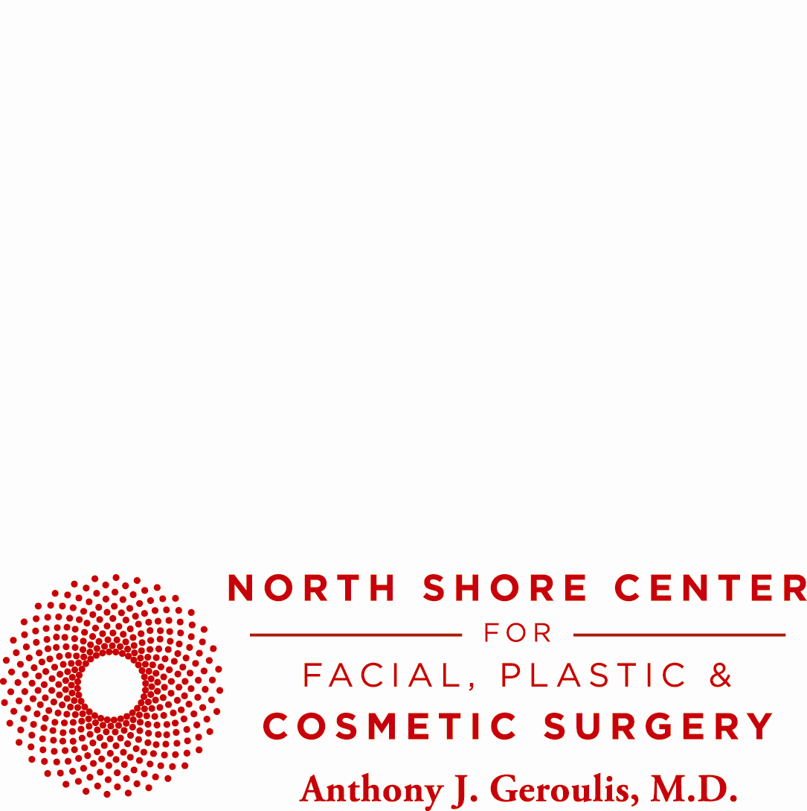

**NORTH SHORE CENTER FOR FACIAL PLASTIC & COSMETIC SURGERY UNVEILS RENOVATED WEBSITE**

**NORTHFIELD, IL—MAY 30, 2014—**North Shore Center for Facial Plastic & Cosmetic Surgery is excited to announce the unveiling of their refurbished, state-of-the-art website, [www.geroulis.com](http://www.geroulis.com), which boasts a variety of novel features designed to improve ease of navigation and accessibility. The renovated website displays a new layout and presentation style for enhanced functionality. The content, as well as the imagery, has been updated so that visitors may learn in great detail about all of the procedures offered at North Shore Center for Facial Plastic & Cosmetic Surgery. Patient satisfaction and comfort were instrumental in determining the implemented changes.

Among the enhancements is a detailed and interactive procedure finder, which assists men and women in selecting the type of procedure which will be right for them. “I’ve been practicing cosmetic surgery for over thirty years. Throughout the decades, advancements in technology have altered and adapted the medical field greatly. The clinical team and I find it vital for current and prospective patients to have an easy method of researching our facility while presenting the best proven procedures offered. It’s very important to stay up-to-date with the latest trends in technology both inside the operating room and with our patient communications,” remarks Dr. Geroulis.

Additional enhancements of the website include the “Latest News” section which offers current articles on every aesthetic subject including body contouring, facial enhancements and dermal injections. The “Latest News” section delves into specifics relating individually to men, women and children with a search button to sift through and provide tailored results. The broad scope of information, in addition to the frequency at which it is updated, makes it an invaluable addition to the website.

Social media has been incorporated into the patient communication platform to provide anyone with the latest and most up-to-date information on promotions, featured procedures and gossip from the world of aesthetics. Facebook and Twitter pages are updated daily. For those not active on social media, individuals may stay in the loop via the bi-monthly e-newsletter which brings the news into their inbox.

For more information about Dr. Geroulis and his fully accredited facility, North Shore Center for Facial Plastic & Cosmetic Surgery, please visit [www.geroulis.com](http://www.geroulis.com) or call 847.441.4441.

**About Dr. Anthony J. Geroulis:**

Bringing over 33 years of surgical and artistic experience to the field of facial plastic & cosmetic surgery, Anthony J. Geroulis, MD, FICS, has repeatedly been named a “Top Doctor” by *U.S. News & World Report*. Board certified in cosmetic surgery, author and active sculptor, Dr. Anthony Geroulis is a clinical professor of surgery at University of Chicago Medicine. His practice is headquartered in Northfield, with offices in Chicago, at University of Chicago Medicine and at St. Alexius Medical Center in Hoffman Estates.

**PR Contact:**

Mirofora Constantino, B.A., M.B.A

Communications Officer

North Shore Center for Facial Plastic & Cosmetic Surgery

Ph: (847) 441-4441 | [Mirofora@geroulis.com](mailto:Mirofora@geroulis.com)

Madelaine Kukanza, B.A.

Marketing Communications Assistant

North Shore Center for Facial Plastic & Cosmetic Surgery

Ph: (847) 441-4441 | [Madelaine@geroulis.com](mailto:Madelaine@geroulis.com)