The beauty of acrylic stone in the Dreer house
The Minimalism and Elegance of HI-MACS® in a Dream Garden
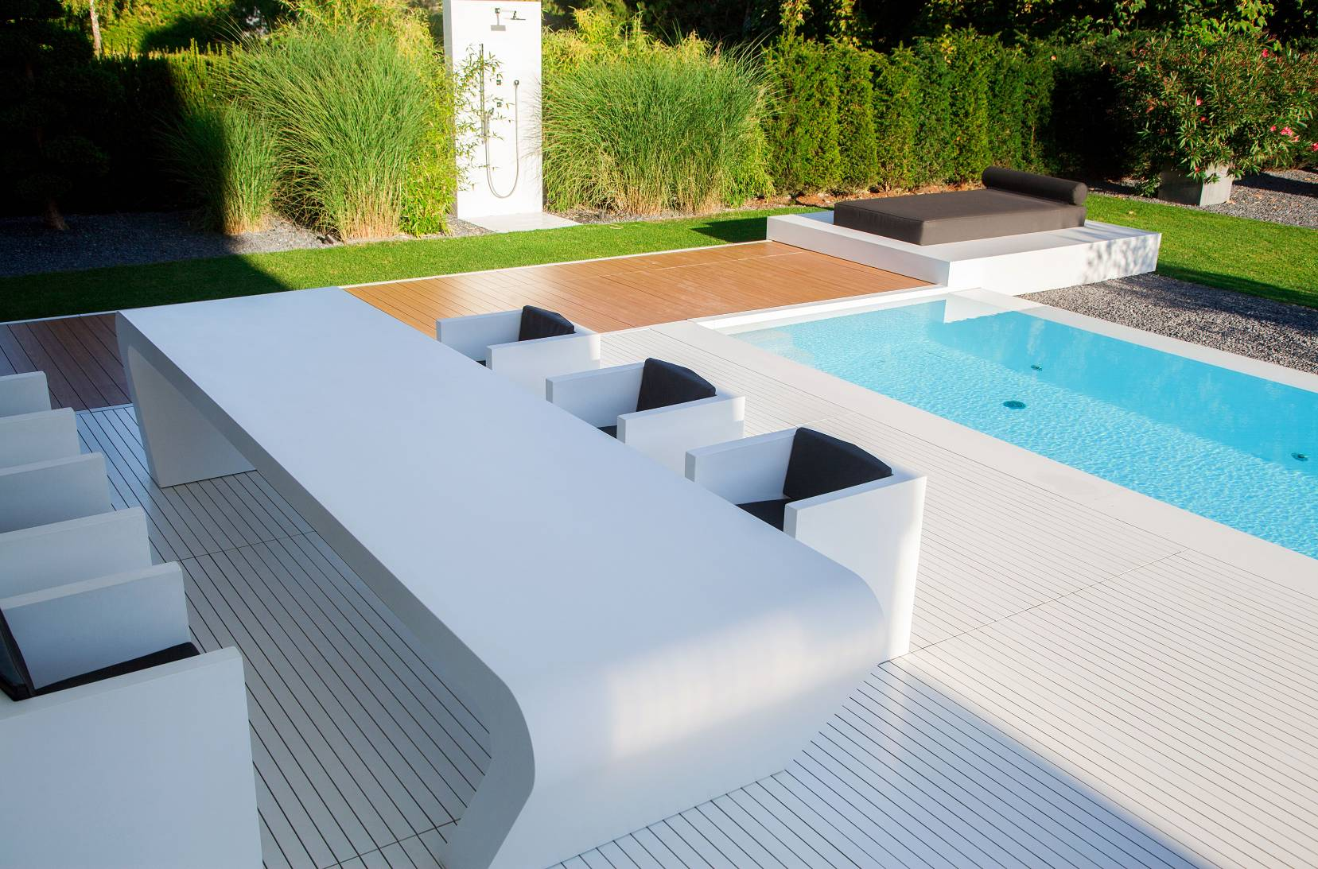

The Dreers’ garden is a dream come true. The German family, who live in Upper Bavaria, had always longed for a space where they could relax and disconnect from everyday life, and now their wish has been granted thanks to a fantastic terrace, where HI-MACS® clearly plays the leading role.

The Dreer family’s private residence is located in the Ammersee region, nestled in the forests of Upper Bavaria. That is where you will find this extraordinary house with minimalist and futuristic aesthetics, where the color white, straight lines and geometric forms all predominate. Its large garden featuring a striking long, turquoise pool emanates tranquility, serenity, and peace enhanced by the whiteness and freshness of HI-MACS® – the star of the space. This cutting-edge acrylic stone is present in the majority of the elements that make up the elegant outdoor area, from the furniture and lining of the pool down to part of the floor.

For Karl Dreer, owner and builder of this dream garden, the choice of HI-MACS® for this very personal project was a clear one. Dreer is proprietor of Dreer GmbH, a manufacturing company renowned for exclusive interior designs, making him an expert in the use of high-tech materials. As such, Dreer’s positive experience with HI-MACS® and its excellent results led him to use the material once again for one of his most prized possessions: his own home.

“The lack of visible joints, which ensures the highest level of hygiene possible, the elegant appearance, durability, and sturdiness of HI-MACS® were all decisive factors in choosing the material. In addition, the fact that it is easy to maintain and resistant to sunlight, water, and the elements – even during periods of harsh frosts – gave us the essential qualities we needed for the outdoor furniture,” explains Dreer.

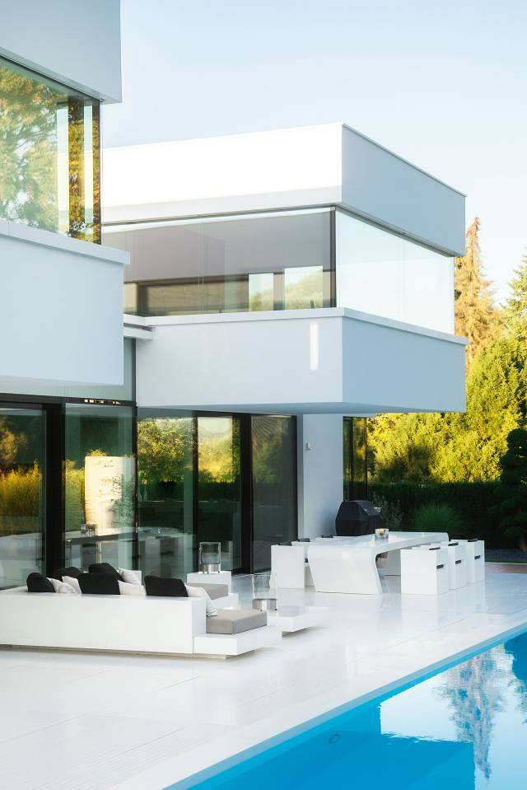
An Outdoor Gem

A long table (3900 x 1000 x 720 mm) with a futuristic look and free-floating form is one of the elements of this amazing garden that draws the eye in. The thermoformable and malleable properties of the acrylic stone were ideal when it came to creating this unique, custom-designed piece of furniture, characterized by its undulating shapes that are perfectly joined in a uniform way. The result is a singular piece that marries design and functionality, which would have been impossible to build with other conventional materials such as stone or wood.

“The structure of the top of the table consists of a metal construction with interwoven fibers, which made it possible to reinforce the tension of the table in different directions. Thanks to its flexibility, the piece is perfectly level despite its remarkable length. The elements were applied to the metal frame, fitted together, adhered, and sanded. The stylish square chairs provide a touch of uniqueness to this outdoor gem, where classic craftsmanship and more innovative design come together,” add the experts from Karl Dreer GmbH - Klopfer Surfaces.

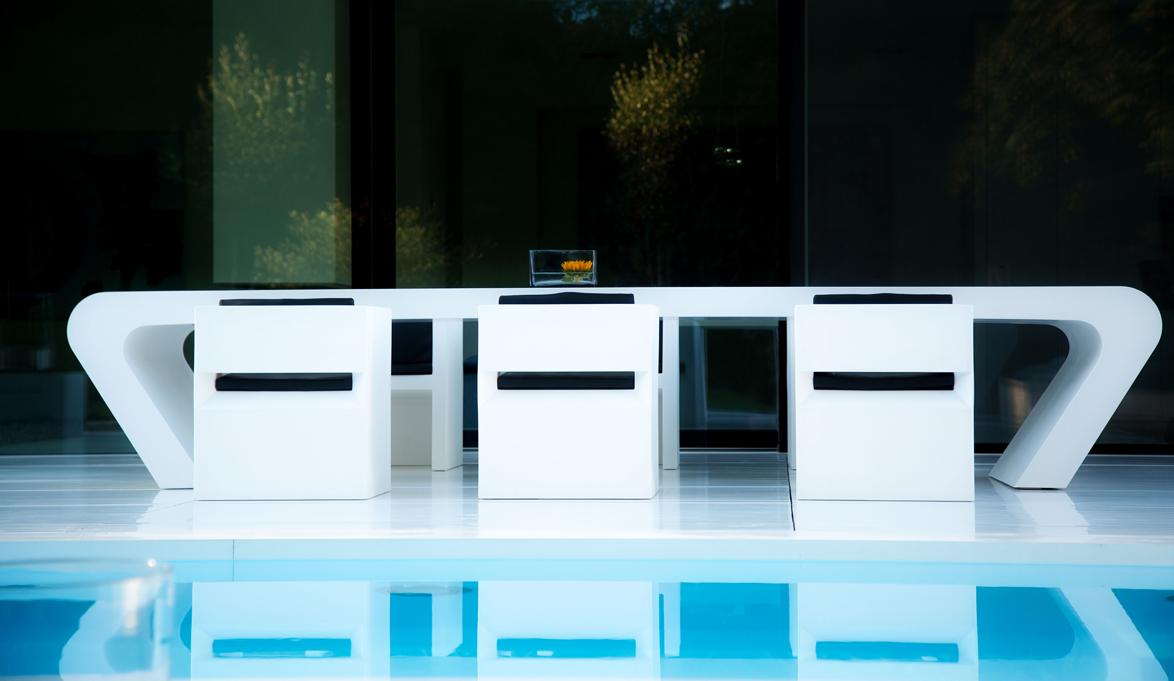

Pieces such as the square chairs, sofa and side table, as well as the surfaces of the two comfortable sun loungers situated at either end of the pool, were also developed using the HI-MACS® Alpine White color scheme. Meanwhile, the interior of the house is linked to the exterior by means of the pure white floor executed in acrylic stone that surrounds the pool.

FACT SHEET:
Design: Karl Dreer
Manufacturer: Karl Dreer GmbH - Klopfer Surfaces
Photographer: Melanie Gotschke
Material: HI-MACS® Alpine White

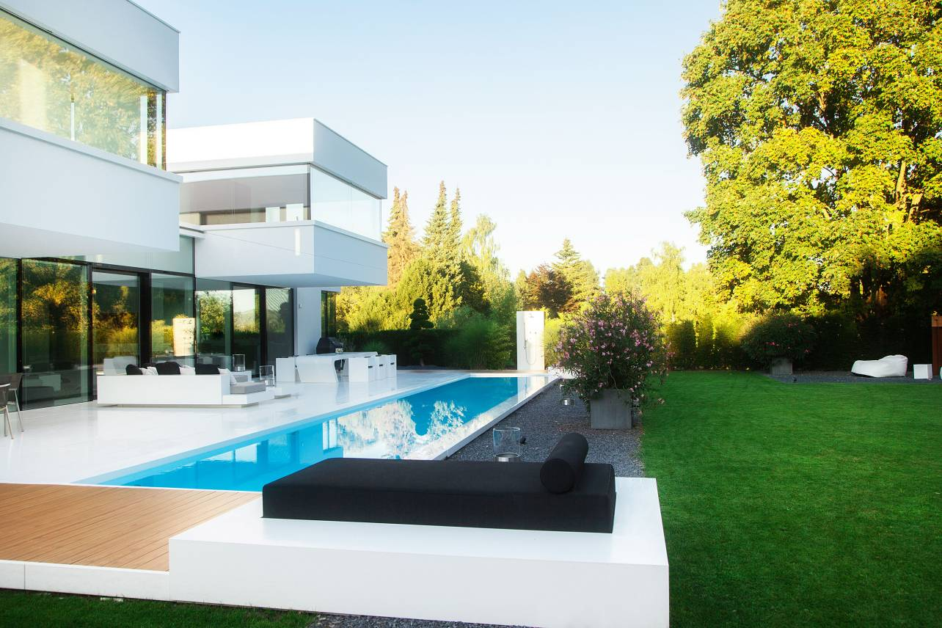
Images available:
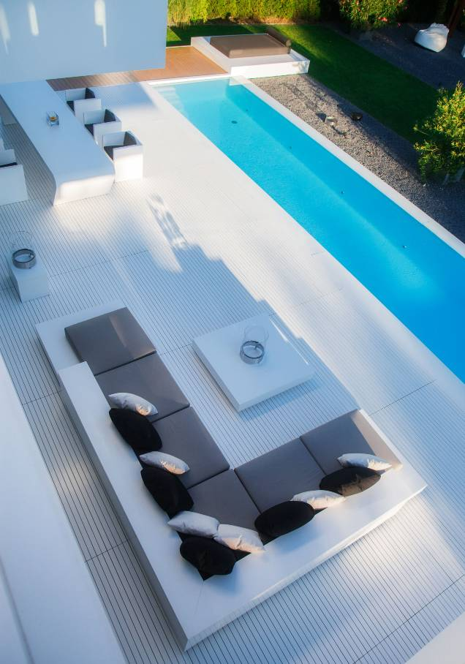
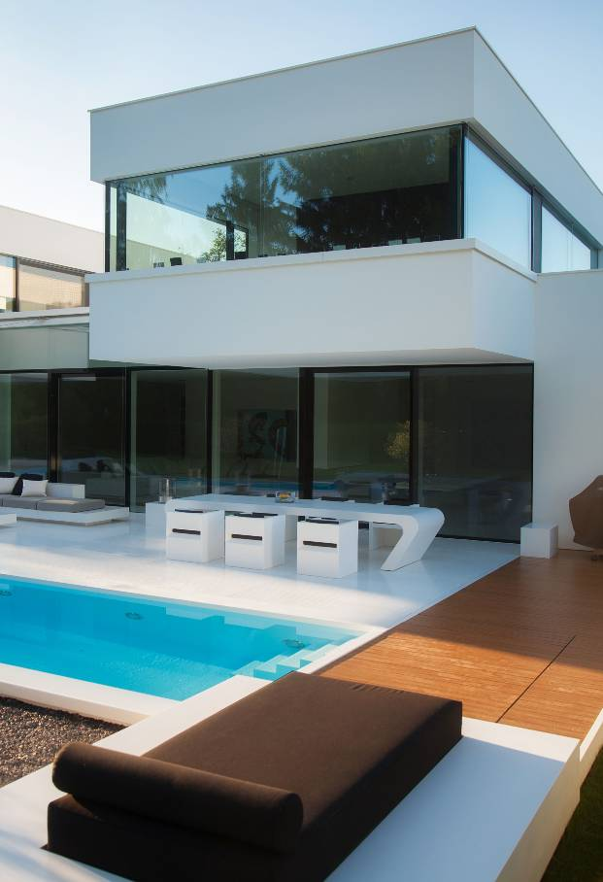

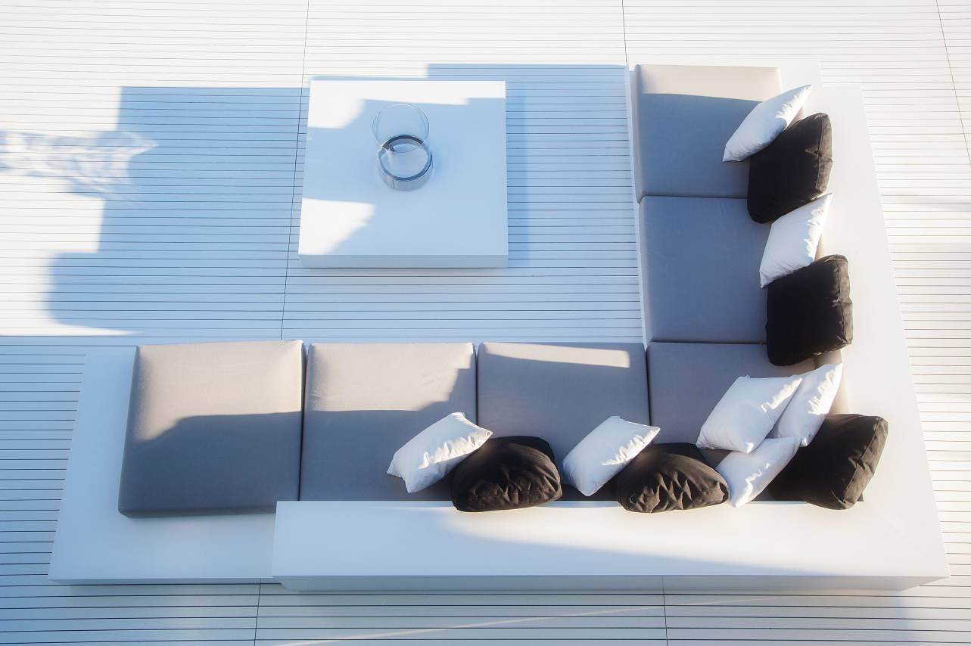

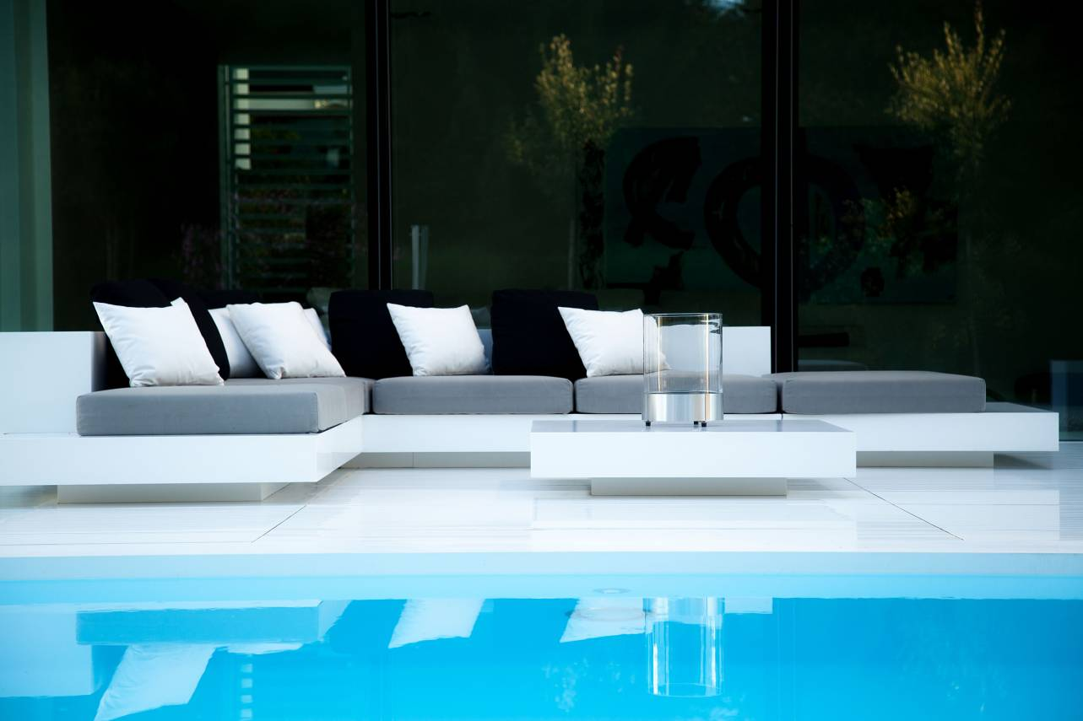

HI-MACS® by LG Hausys
Surfacing the World
^{www.himacs.eu}
HI-MACS® is a solid surface material that can be moulded into any shape. It is widely used for architectural and interior applications, such as sculptural and high performance wall-cladding or kitchen, bathroom and furniture surfaces, in commercial, residential and public space projects. It is composed of acrylic, natural minerals and pigments that come together to provide a smooth, non-porous and visually seamless surface which meets the highest standards for aesthetics, fabrication, functionality and hygiene – offering manifold advantages over conventional materials.
HI-MACS® provides limitless possibilities for surfacing solutions and inspires creative minds from all over the world. Zaha Hadid, Jean Nouvel, Rafael Moneo, Karim Rashid and David Chipperfield, among others, have completed fabulous projects using HI-MACS®, from kitchens to bathrooms, including decorative items, in hotels as well as in museums, shopping centres and on external façades.
LG Hausys’ HI-MACS® uses a simple heating process to give three-dimensional thermoplastic forming capabilities, allows visually seamless designs, offers a virtually limitless range of colours and – for some shades - exhibits a special translucency when exposed to light. Although HI-MACS® is almost as robust as stone, it can be worked in a similar way as wood: it can be sawn, routed, drilled or sanded.
HI-MACS® is manufactured using a new generation technology, the thermal cure. The temperature reached during the manufacturing process sets HI-MACS® apart from other solid surfaces and creates a denser, even more homogeneous, sturdy, durable surface – with a better resistance and superior thermoforming performance.
As regards hygiene, HI-MACS® does not absorb humidity, is highly resistant to stains, and is easy to clean, maintain and repair.
Countless internationally recognized certificates attest to the quality of HI-MACS® in terms of ecological commitment, hygiene and fire resistance – being the first Solid Surface in the market to receive the official European Technical Approval (ETA) for façades – for Alpine White S728 colour.
HI-MACS® offers the longest warranty on the solid surface market with a 15-year warranty for products fabricated and installed by a member of the HI-MACS® Quality Club.
HI-MACS® The New Generation
Inspired by Architecture
For more information and to stay connected, visit our website.
Let’s connect!

* HI-MACS® is designed and produced by LG HAUSYS, a world leader in the technology sector belonging to LG Group, and distributed by LG HAUSYS EUROPE based in Geneva (Switzerland).

