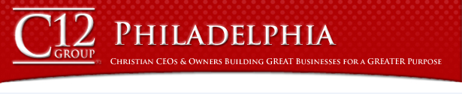
Leveraging the Possibilities

You Can't Manage what you Don't Measure

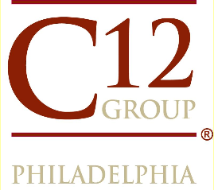
A special opportunity for business owners/CEOs presented by the members of the

Friday, June 20, 2014
10:00 am to 1:00 pm

Homewood Suites, Newtown
110 Pheasant Run
Newtown, PA

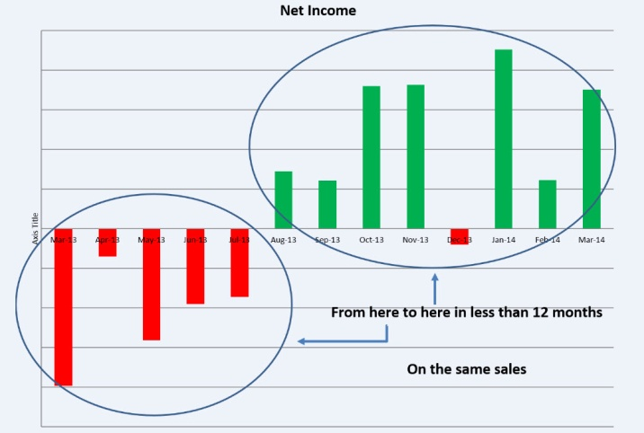
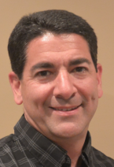
Is it possible to go from the brink of bankruptcy to abundant profits within 9 months and do it without increased sales?

Learn from the methods and metrics applied by one manufacturer and the possibilities they hold for you. These are actual net profit results made possible by the strategies and practices of which you will hear.
Rich Speeney President, MRI Flexible Packaging

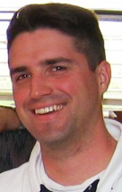
Don Barefoot, President and CEO of the C12 Group, will reinforce the vital role metrics play in our business and the possibilities that unfold when you track and hold your team accountable to them. For 20+ years prior to C12, Don served as consultant to senior executives of both S&P 500 companies and smaller, privately held businesses, guiding substantial turn-around and growth initiatives, from which he will share.

Meet an Ivy League grad who will tell you his greatest practical business education has been as and while a member of the C12 Group. Hear how intentionality of purpose and accountability have transformed this owner and his business.
Frank Ableson, President, navitend, inc.
Join us on June 20 to hear how multiple successful companies raised the bar for what is
possible, both in company performance and as stewards of what the Lord has given them.

Register at: http://c12philadelphia.com/possibilities
Questions?
Dave Shoemaker 973.615.4120
dave.shoemaker@c12group.com

Included: Lunch and optional tour of MRI Flexible Packaging
Cost: $79

