Press
Sunnyvale, CA, June 17, 2014
Osram introduces multi-chip laser diode for projectors

The first compact laser module with a 50 W optical output

Osram Opto Semiconductors has introduced the first compact laser multi-chip package. The new PLPM4 450 module can pack up to 20 blue laser chips into a single "butterfly" package for projection applications. Instead of taking the laborious approach and constructing a light source from individual laser diodes, it is now possible to reduce the complexity of laser projectors significantly. Osram has also succeeded in doubling the optical output of the individual chips, with the result that the new laser module now offers an overall blue light output of 50 W. This means that professional laser projectors can achieve a brightness level of more than 2000 lumens with only one component.

Unique optical output power
Blue laser diodes in combination with a converter wheel, which converts part of the blue light into the two primary colors of red and green, are used as the light source for laser projectors. Up to now, to achieve sufficient brightness for professional applications, more than 20 individual laser diodes had to be combined. With its optical output of 50 W, the new laser module offers projection brightness levels of more than 2000 lumens from only one package. If several modules are installed in a projector, brightness levels far in excess of 5000 lumens are possible – for example, in devices for large conference rooms. To achieve the high optical output of the PLPM4 450, engineers at Osram Opto Semiconductors optimized the chip parameters to double the single-chip output from 1.6 to 3.2 W and also improved the thermal resistance of the module.

Osram Opto Semiconductors is strengthening its leading position in light sources for laser projectors with its PLPM4 450 multi-chip package. It is an extremely powerful laser module that can be more easily integrated into projectors. The package measures 25.5 by 35 millimeters (mm) and accommodates four copper bars with up to five blue laser chips connected in series and operated at 2.3 A each. This multi-chip module offers a light output of 50 W from a typical electrical input of 165 W, with wavelengths of 440 to 460 nanometers (nm), and achieves an efficiency of 30%.

Lower system costs for laser projectors
This unique technical performance is particularly attractive, and so too are the costs for the new laser module. Thanks to the special design and the improved optical output power of the individual chips, the price per optical watt can be significantly reduced. Another benefit comes from the greatly reduced production costs – installation and alignment of a multi-chip package requires less time and lower costs than for a large number of individual metal can packages. The light from all the laser chips can therefore be collimated with a single lens array. "This innovative package simplifies the integration of laser technology in projectors considerably, enabling a breakthrough in the projection market," said Sevugan Nagappan, Marketing Manager at Osram Opto Semiconductors.

Volume production of the PLPM4 450 will start at the end of 2014. Samples will be available in the summer. The Osram Specialty Lighting Business Unit will also be integrating the multi-chip package in a new generation of phaser light modules for projection applications. Phaser in this case is a hybrid word formed from phosphor and laser. Phaser light modules based on the multi-chip package will feature a particularly compact design and will be capable of being used in combination, making them very easy to integrate in existing projector architectures.
Technical data:
Dimensions | 25.5 mm x 35 mm (emission surface 16 mm x 16.5 mm)
Optical output power | 50 W (at a package temperature of 50°C)
Wavelength | 440 nm to 460 nm
Lifetime (50% reduction in light) | Up to 20,000 hours (depending on ambient conditions)

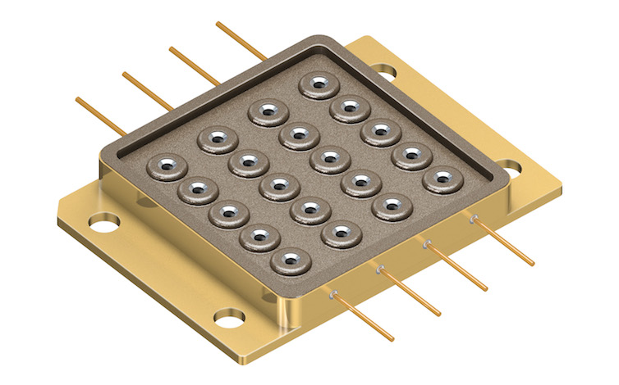
Impressive 50 W optical output power: The PLPM4 450 is the first multi-chip package to provide a blue light output of 50 W.
Picture: Osram

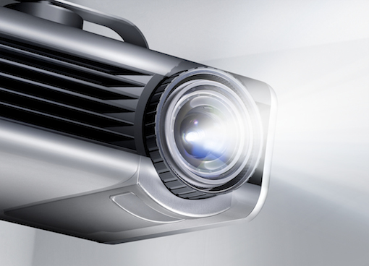
The new Osram multi-chip package provides a light output of 50 W – ideal for professional projectors with system brightness levels in excess of 2000 lumens.
Picture: Osram

http://www.osram-os.com/press/pr-multi-die-laser

ABOUT OSRAM OPTO SEMICONDUCTORS

OSRAM, Munich, Germany is one of the two leading light manufacturers in the world. Its subsidiary, OSRAM Opto Semiconductors GmbH in Regensburg (Germany), offers its customers solutions based on semiconductor technology for lighting, sensor and visualization applications. Osram Opto Semiconductors has production sites in Regensburg (Germany), Penang (Malaysia) and Wuxi (China). Its headquarters for North America is in Sunnyvale (USA), and for Asia in Hong Kong. Osram Opto Semiconductors also has sales offices throughout the world. For more information go to www.osram-os.com.

Press Contact:  Kate Cleveland  Tel. 248-277-8018  Fax 248-596-0395  Email kate.cleveland@osram-os.com | Technical Information:  OSRAM Opto Semiconductors  Tel. 866-993-5211  Email info@osram-os.com

