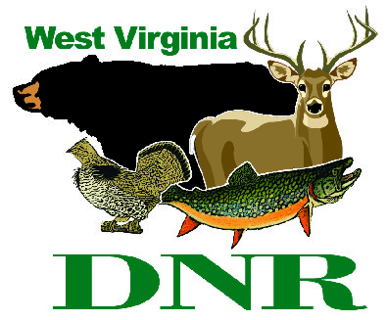 | West Virginia Division of Natural Resources  www.wvdnr.gov  Earl Ray Tomblin, Governor  Frank Jezioro, Director  News Release: June 16, 2014  Facebook: West Virginia State Parks  Hoy Murphy, Public Information Officer 304-957-9365 hoy.r.murphy@wv.gov  Contact: Tara Sheets, twinfallssp@wv.gov 304-294-4000  Paul Redford, District Administrator 304-558-2764 dnr.parks@wv.gov

Twin Falls State Park seeks businesses to sponsor “Cool! Pool Days”

to encourage outdoor recreation for kids and families

MULLENS, West Virginia – Businesses, organizations or individuals can help keep kids and adults swimming in the summer months by sponsoring a “Cool! Pool Day” at Twin Falls State Park near Mullens in Wyoming County.
An outdoor swimming pool is a traditional recreation amenity at many West Virginia State Parks. The expectation of a swimming pool at a park is an important consideration for families and youth. Swimming pools are great summer employment opportunities. Swimming pools are social settings in the outdoors. State park swimming pools, especially in rural settings, are often the only swimming facility within miles.
“We struggle with use vs. operational costs,” said Paul Redford, a district administrator with West Virginia’s state park system. “We have a responsibility to keep youth and family outdoors activities fun, accessible, affordable and safe. What better way to encourage youth and families to stay active outdoors than swimming for free on a ‘Cool! Pool Day?’”
Redford and the staff at Twin Falls State Park have elected to increase use as a way to justify keeping the outdoor pool open with this new “Cool! Pool Day” program that gives individuals and businesses an opportunity to sponsor this needed recreational facility at no cost to the swimmers.
Twin Falls is accepting sponsorships to fund free-swim days from 11 a.m. until 6 p.m. The sponsorship cost is $275. The pool would be open to the public at no charge as the result of the sponsorship.
“Evening pool gatherings are limited by decreasing light and increasingly cooler water in the summer months,” explained Scott Durham, park superintendent at Twin Falls. “Our employees suggested that daytime sponsorships make better sense. The other aspect is that swimming attendance has been down in recent years and costs to maintain pools are up. We are going to find a way to keep tradition alive, and these sponsorships will help. Summer fun at the swimming pool is an important state park amenity.”
Daily rates for swimming at Twin Falls State Park are $4 for adults and $3 for youth ages 12 and younger. Season passes are available as well as two-day passes and ticket books of 10.
Businesses, corporations, organizations or individuals willing to sponsor “Cool! Pool Days” at Twin Falls State Park may contact Tara Sheets or other Twin Falls staff at 304-294-6000 or email twinfallsps@wv.gov. A “Cool! Pool Day” sponsor form is posted at www.twinfallsresort.com.
“Cool! Pool Day” dates and sponsors will post to the Twin Falls website and on Twin Falls Facebook page as an event, and at media information posts and signage at the park and surrounding area.

**DNR**

Photo Courtesy of the West Virginia Department of Commerce.

