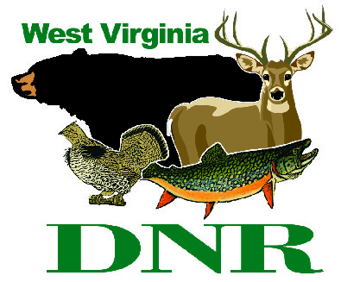 | West Virginia Division of Natural Resources  www.wvdnr.gov  Earl Ray Tomblin, Governor  Frank Jezioro, Director  News Release: June 16, 2014  Facebook: West Virginia State Parks  Hoy Murphy, Public Information Officer 304-957-9365 hoy.r.murphy@wv.gov  Contact: Sissie Summers, Parks and Recreation Section 304-558-2764 Sissie.A.Summers@wv.gov

“At-A-Park” for things to do in West Virginia’s state parks this summer

SOUTH CHARLESTON, West Virginia – Sunshine fuels summer outdoor activities at West Virginia’s state parks, and visitors have many from which to choose when “At-A-Park.” Visit www.wvstateparks and look for the “At-A-Park” links or check park bulletin boards when visiting this summer for lists of fun and educational activities available to state park visitors.
“Most state parks employ seasonal interpreters and activities coordinators who plan and run programs to keep people busy and having fun,” said Sissie Summers, state parks programming coordinator. “These guys and gals are passionate about sharing nature with children and adults. Activities are family oriented and often focus on recreational games that include an unexpected learning aspect.”
Programs include night hikes and conservation of bat habitat and the importance of bats in West Virginia, bird identification, nature hikes, water study and guided discovery to see things that creep, crawl and live in streams and water edges. Parks with nature centers offer open hours to explore “what’s outside” with the naturalist. Activities also include organized campfire programs, hay rides and specific tours.
“Planned activities vary from park to park and week to week and are generally free and a treat to attend,” Summers said.
Parks with summer employees to organize activities and nature study include Beech Fork, Cass Scenic Railroad, Canaan Valley, North Bend, Watoga, Tygart, Blackwater Falls, Cedar Creek, Stonewall Resort, Babcock, Holly River, Blennerhassett Island, Cacapon, Pipestem, Lost River and Twin Falls state parks and Greenbrier State Forest.

**DNR**

Photo Courtesy of the West Virginia Department of Commerce.
West Virginia state parks offer a wide variety of summer programs and activities led by seasonal interpreters.

