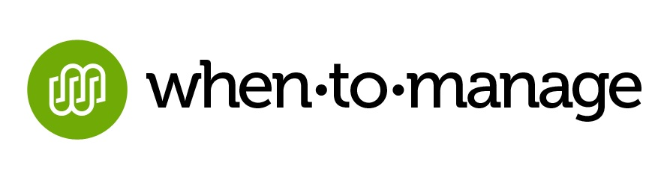

**For Immediate Release**

**Olga’s Kitchen Deploying WhenToManage Inventory and Labor Management Apps for**

**Improved Functionality and Extensibility**

**Norwalk, CT, June 18, 2014** – [WhenToManage](http://whentomanage.com/), the leading innovator of cloud-based software for the restaurant, hospitality and retail industries, is excited to announce its new partnership with Michigan-based restaurant, [Olga’s Kitchen](https://www.olgas.com/). The 36-unit restaurant chain chose WhenToManage’s Labor and Inventory Management software for its ease-of-use and superior functionality, as well as longer-term capabilities for simplified customization and scalability. With deployment already underway, both applications should be fully operational at all Olga Kitchen locations within 45 to 60 days.

“After seeing a demonstration of WhenToManage’s modern and incredibly user-friendly software we immediately recognized the value of making the switch,” says Howard Hardy, Director, Business Systems/Process Optimization, Olga’s Kitchen, Inc. “In addition to enabling us to run a more efficient operation and streamline costs, we are extremely excited by the long-term opportunity presented by WhenToManage’s Peach platform which we anticipate being the most extensible and scalable in the industry.”

Once armed with WhenToManage throughout the organization, Olga’s will be well positioned to maximize its workforce and better align inventory with real-time performance of each restaurant location for reduced food costs.

“With all things being equal, our customers typically lower labor costs by one to two percent during the first eight months of usage,” says Walker Thompson, Vice President of Sales and Marketing, WhenToManage. “Our inventory management solution results in managers saving an approximate two hours a week, while also shaving food costs by an average of ½ of a percent which is significant for an operation of Olga’s size.”

For more information about WhenToManage’s cloud-based software, email [info@whentomanage.com](mailto:info@whentomanage.com). For a taste of some of WhenToManage’s new, under-development technologies, check out Log and Flow, free apps for task management and employee communications respectively, available by clicking [here](https://store.whentomanage.com/).

**About Olga’s Kitchen, Inc.**

Founded in 1976, Olga’s Kitchen, Inc. owns and operates 36 restaurants in Michigan, Ohio and Illinois, providing both dine-in and carry out service. Featuring a Mediterranean-inspired menu, Olga’s Kitchen offers lunch and dinner served in a comfortable, family-friendly environment, with a commitment to delivering a unique and compelling casual dining experience. Visit [www.olgas.com](http://www.olgas.com/) for more information, including details about the full menu and a list of locations. Olga’s Kitchen is headquartered in Troy, Mich.

- more -

- 2 -

**About WhenToManage**

WhenToManage is comprised of a team of professionals with years of true restaurant operations experience from the top down, and a passion for creating software that they, in turn, would be excited to use. The result is a restaurant operating system that is more accessible, easier to use, and requires less training and support. WhenToManage offers subscription-based solutions for POS intelligence, inventory management and employee scheduling, as well as customized deployments. For more information, please visit <http://whentomanage.com>.

WhenToManage is also the founder of Community Plates, a 501(c)3 non-profit organization committed to ending food insecurity in the United States through food rescue. Founded in 2011, Community Plates utilizes breakthrough, proprietary technology to manage food donors, receiving agencies and volunteer drivers. Community Plates’ Go Rescue App, created by WhenToManage, was awarded the 2013 Computerworld Honors Program 21st Century Achievement Award.  To donate, volunteer and get involved, visit <http://www.communityplates.org>.

* * *

**Media Contact:**

Lynn Schwartz

Newsmaker Group for WhenToManage

[lschwartz@newsmakergroup.com](mailto:lschwartz@newsmakergroup.com)

973-736-7118