Press Release

New Guide Provides a “Crash-Course in Funding Jewish Innovation”
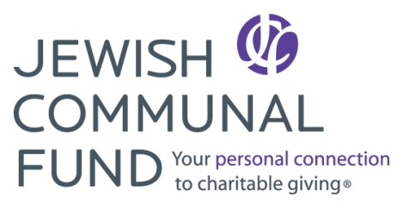

FOR IMMEDIATE RELEASE
MEDIA CONTACT:
Tamar Snyder
Associate Director, Strategic Initiatives & Communication
Jewish Communal Fund
646-843-6894
tamar@jcfny.org
The Jewish Communal Fund and Slingshot collaborate to foster innovation in Jewish life; newly published guide provides concrete steps for finding & funding Jewish innovation
NEW YORK – June 23, 2014 – The Jewish Communal Fund (JCF) and Slingshot recently released Funding Jewish Innovation: A Resource Guide, which can be downloaded for free at http://www.jcfny.org/innovation. The guide answers four common questions around funding innovation in Jewish life, offers reflections from funders in the field, and provides practical next steps for individual donors to select innovative projects and organizations to fund. The guide also features Innovation Snapshots – brief examples of how Jewish organizations both young and old (including Our Jewish Community, the Pearlstone Center, Hillel’s Ask Big Questions and G-dcast) are using innovative approaches to remain relevant in today’s 21st century world.
“As a collective of Jewish funders and as an institution, Jewish Communal Fund is interested in fostering innovation in Jewish life,” said Karen Adler, President of Jewish Communal Fund. “At JCF, we continue to innovate our service offerings, providing state-of-the-art technology that makes grant-making simple and efficient, as well as producing helpful and engaging educational resources that benefit our fund holders and the charities they generously support.”
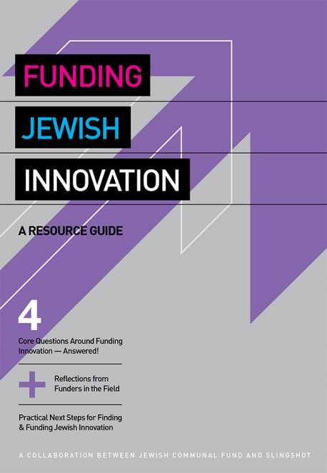
JCF, the largest Jewish donor advised fund in the country, currently manages $1.25 billion in charitable assets for 3,100 funds. During the past three years, more than 365 JCF fund holders recommended nearly $4 million to dozens of innovative Jewish organizations profiled in Slingshot. The Slingshot Guide is an annual resource highlighting the most innovative organizations in Jewish life; it is often perceived as a stamp of approval for innovative organizations seeking funding and other resources necessary to grow. (The 2013-2014 Slingshot Guide can be downloaded here).
Slingshot and JCF have forged a strong partnership over the past several years. JCF housed Slingshot in its midtown offices for two-and-a-half years until January 2014, when Slingshot outgrew the space available. The goal of the joint project is to shine a spotlight on the field of Jewish innovation and encourage individual fund holders to consider dedicating a portion of their philanthropic portfolio to this exciting and important area.
The guide begins by answering an oft-repeated question; namely, what exactly is “innovation”? “Being ‘innovative’ is a short-cut term to describe organizations that have built the drive for relevancy and impact into their DNA,” says Will Schneider, the Executive Director of Slingshot. “Innovation is not an end goal, but rather a mode of operating. These organizations will change existing programs, throw out ineffective tactics and blaze new trails if it means better addressing their ‘reason for being’ or mission.”
Funding Jewish Innovation: A Resource Guide is a crash-course in funding Jewish innovation. “Rather than presenting a ‘one-size-fits-all’ solution, this guide is designed to guide you on this exciting journey of supporting innovation in Jewish life.”
Click here to read a PDF version of Funding Jewish Innovation: A Resource Guide.
###
About Jewish Communal Fund
Jewish Communal Fund is one of the largest networks of Jewish funders, currently managing $1.25 billion in charitable assets for more than 3,000 donor advised funds. JCF's donor advised funds make giving easy, flexible and efficient. Learn more at www.jcfny.org.
About Slingshot
Slingshot uses philanthropic tools to connect next gen Jews with innovative Jewish organizations. Slingshot's best known product is the annual Slingshot resource guide, which features the most innovative organizations in Jewish life. Learn more at www.slingshotfund.org.

