**(PRWEB) June 18, 2014**

**Kuhner Shaker, Inc. expands with second location: Boston Area**

**Kuhner Shaker, the leading provider of high-quality shaker-incubators to the Life Science and Biotechnology sector, is pleased to announce the opening of a second location near Boston, MA. With this development Kuhner Shaker is expanding its domestic supply of instruments, accessories, parts and service to better support their customers on the East Coast.**

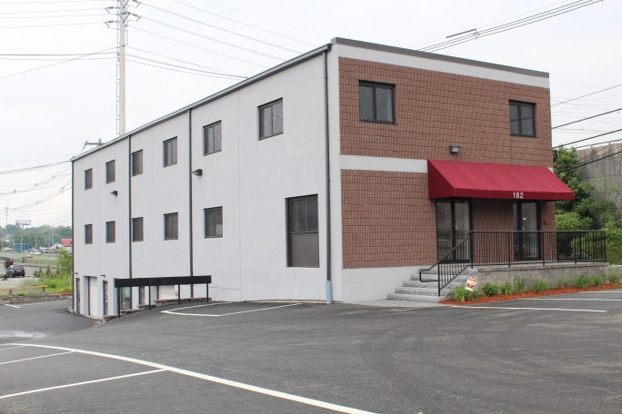Kuhner Shaker, the leading provider of [shaker-incubators](http://www.kuhner.com) to the Life Science and Biotechnology sector, is pleased to announce the opening of their second US office, this one near Boston, MA. From this new office and warehouse the company is expanding its capacity to offer a local supply of instruments, accessories, parts and service to their customers on the East Coast. The Boston operation is capable of providing fast response and full support to its rapidly expanding East Coast customer base. The location has been designed with an open concept layout to facilitate evolving customer needs.

Kuhner Shaker Inc, Boston Office.

David Laidlaw, CEO of Kuhner Shaker, Inc. states, “We are thrilled to have Brian Trippe, Director of Sales and Service, join our operations and to have added our second US office in as many years. From this new office we offer expanded hours of availability and access to Kuhner service for our East Coast customer base. Additionally, from this facility we will enjoy expanded time-zone overlap with our headquarters and factory in Basel, Switzerland – where 100% of our design, fabrication, assembly and Quality Control take place. Together we will continue to work with our Swiss office to provide the level of customer experience we expect for our valued customers.”

Quote startKuhner Shaker is excited to offer this new level of service and support to our North American customer baseQuote end

Brian Trippe comments, “Our immediate objective is to provide an elevated level of local contact for our existing customer relationships on the East Coast. Our customers deserve a fast response to their requests; this is the value of having a local office. Boston is a major biotechnology hub and being here are allows a quick, local response which extends all the way down the coast. As we establish this location we are eager to work with our end-users to shape the specific services we provide for them.”

Established in 1949, privately held Kuhner Shaker manufactures shaker-incubator instruments at their headquarters in Basel, Switzerland. Kuhner Shaker has additional offices in the U.K., Spain and now with two locations in the USA (CA and MA). Worldwide operations are supported through a combined network of Kuhner offices and distribution partners. The company maintains an active role in the scientific community supporting academic institutions and providing instructional seminars on shaken cultivation of all types of cells. For more information you may contact them directly or visit their website at: <http://www.kuhner.com>.