UMOM Contact:
Jessica Palacio
Director of Marketing
UMOM New Day Centers
Cell: (602)615-9065
jpalacio@umom.org

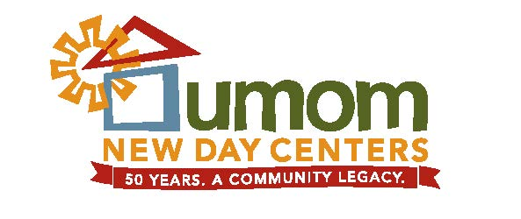
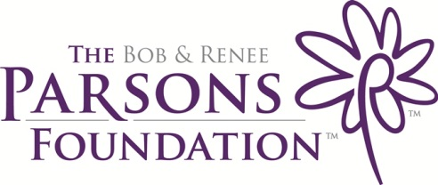

Press RElease

UMOM New Day Centers announces a new affordable housing project generously funded by the Arizona Department of Housing and The Bob & Renee Parsons Foundation

Phoenix, AZ (June 24, 2014) – Thanks to the Arizona Department of Housing (ADOH) and The Bob & Renee Parsons Foundation, UMOM New Day Centers will undertake a new affordable housing project for at-risk families in Phoenix. On Friday, June 6, ADOH awarded UMOM approximately $9.4 million in financing to build a new housing community. Today, The Bob & Renee Parsons Foundation announced that it will provide an additional $3 million in funding to support the project.

“The financing from the Arizona Department of Housing and funding from The Bob and Renee Parsons Foundation will allow UMOM to continue toward our goal of providing every needy family with an affordable place to live,” said UMOM CEO Darlene Newsom. “The additional housing units will go a long way to support the ever growing need for affordable housing in our community.”

“Home – a simple word that means so much,” said Renee Parsons. “Yet for thousands of people in our community home doesn’t exist. By partnering with UMOM to build additional affordable housing units, Bob and I believe that we can help inspire hope and be part of a rapid-rehousing solution for homelessness.”

In 2011 UMOM acquired North Mountain Lodge Motel in the Sunny Slope area, located adjacent to one of organization’s Next Step Housing properties, Casa de Paz Sahuaro Apartments. The investments from ADOH and The Bob & Renee Parsons Foundation will allow UMOM to demolish the dilapidated structure and construct 48 brand new one, two and three bedroom affordable housing apartments.

The funds will also support the build-out of a 5,500 square foot community programs service center to support the needs of residents at both properties. The center will provide critical services such as job search assistance, GED tutoring and wellness programs.

On any given day 50 to 75 families are on UMOM’s shelter waiting list and hundreds more seek affordable housing. The 48 additional units will greatly assist UMOM in moving people off the waitlist and into a home. Of the 48 units, at least 34 will be set aside for chronically homeless individuals and families with preference given to Veterans. UMOM anticipates construction to start early next year with occupancy in Fall 2015.

“The idea of standing idle while a waitlist for affordable housing grows is simply not an option,” said Bob Parsons. “There are families in this community who need a leg-up and a second chance at becoming first-class citizens. Renee and I have every intention to help make a long-term difference in the fight to end homelessness in the greater Phoenix area and we believe that UMOM’s new housing community is a great next step.”

The Bob & Renee Parsons Foundation is a long-time supporter of UMOM New Day Centers. In 2012 the Foundation awarded UMOM $5 million to enable the center to pay off their mortgage on the 7.2 acre main campus, which provides emergency shelter and transitional housing, and dramatically expand the programs and services available.

UMOM’s Mission: to prevent and end homelessness with innovative strategies and housing solutions that meet the unique needs of each family and individual.

The Bob & Renee Parsons Foundation: The Bob & Renee Parsons Foundation inspires hope by providing critical funding at critical times to communities striving to make a difference. The foundation primarily focuses on issues in the greater Phoenix area. The Bob & Renee Parsons Foundation believes every person is entitled to an education, good nutrition, medical care, a stress-free, happy environment and the hope that they too, will share in the American Dream. Find out more about the foundation at www.TBRPF.org.

