Salt Lake City, UT 22 July 2014

Beijer Electronics launches rugged panel PC
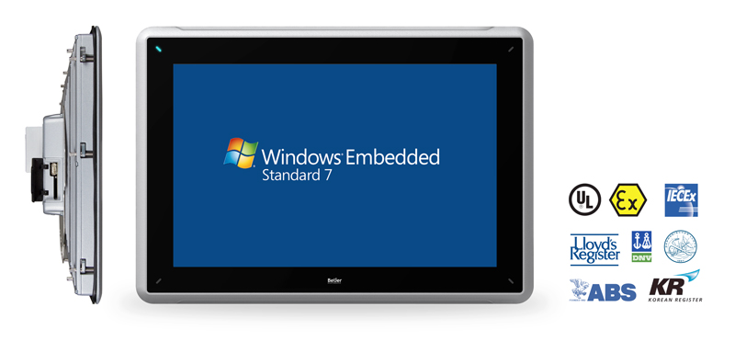
The rugged 15.4 inch panel PC is designed for long and productive service life in challenging environments. The new PPC is certified to withstand wind, snow and rain, works in heavy duty motors in remote locations, in direct sunlight, in steamy offshore engine rooms, and in sub-zero power generation deployments.

The rugged PPC T15BR is certified by major classification societies for hazardous environments (UL, IECEx, ATEX) as well as to marine standards (ABS, DNV, GL, LR, KR).

Proven to the extremes
The rugged PPC T15BR is certified by major classification societies for hazardous environments (UL, IECEx, ATEX) as well as to marine classification societies (ABS, DNV, GL, LR, KR). The rugged panel PC is designed for an operating temperature of -30 to 70°C and conforms to NEMA 4 and IP66 standards.
The design of the panel PC and the wide range of certificates ensures reliable HMI operation in challenging environments of industries such as oil & gas, power generation, marine, off-shore, mining, water/wastewater, agriculture & food production, pulp & paper, etc.
The Windows® Embedded Standard 7 (WES7) runtime environment provides a perfect platform to load industrial software applications on the PPC T15BR.
See: http://beijerinc.com/product/industrial/ppc-t15br.php
Features:
- Rugged basic performance panel PC designed for Windows applications
- Windows® Embedded Standard 7 runtime environment for intelligent industrial systems
- Bright 15.4”, 1280 × 800 pixel, LED lighted, TFT color display, 1,000 cd/m² sunlight readable for outdoor deployment in bright conditions
- Extended operating temperature -30 to +70°C without external heating or cooling
- NEMA 4 / IP66 dust and water ingress protected sealing for harsh industrial settings
- Extended reliability with fan-less operation for high vibration environments
- Safe deployment in semi-explosive and maritime settings through hazardous area and marine certifications
- Broad communication options with 2 × Ethernet, 2 × serial, 3 × USB standard

About Beijer Electronics
Beijer Electronics is a fast growing technology company with extensive experience of industrial automation and data communication. The company develops and markets competitive products and solutions that focus on the user. Since its start-up in 1981, Beijer Electronics has evolved into a multinational group present in over 20 countries with sales of $204.4 million in 2013. The company is listed on the NASDAQ OMX Nordic Stockholm Small Cap list under the ticker BELE.

Contact
For more information please contact: Jeff Hayes, Product Manager, tel: +1 801 466 8770, email: Jeff.Hayes@BeijerInc.com, web: www.beijerinc.com
Pictures
- PPC T15B_PR_print

