Press Release Contacts:
For Immediate Release Vinitaly International
International Media Dept.
+39 045 8101447
media@vinitalytour.com
www.vinitalytour.com
Twitter: @VinitalyTour
Join Vinitaly International Network on LinkedIn

Vino: Italian Wine Pavilion at Expo 2015 finally has a name

Emotion, engagement, technology and sustainability, are the key words that best embody the new Italian Wine Pavilion at Expo 2015 presented for the first time during Monday’s press conference in Rome together with the official hashtag, #vino2015. The Minister of Agricultural Policies, Maurizio Martina, was joined on the stage by top brasses of Veronafiere, Architect Italo Rota and other members of the Scientific Committee appointed to give birth to the pavilion.
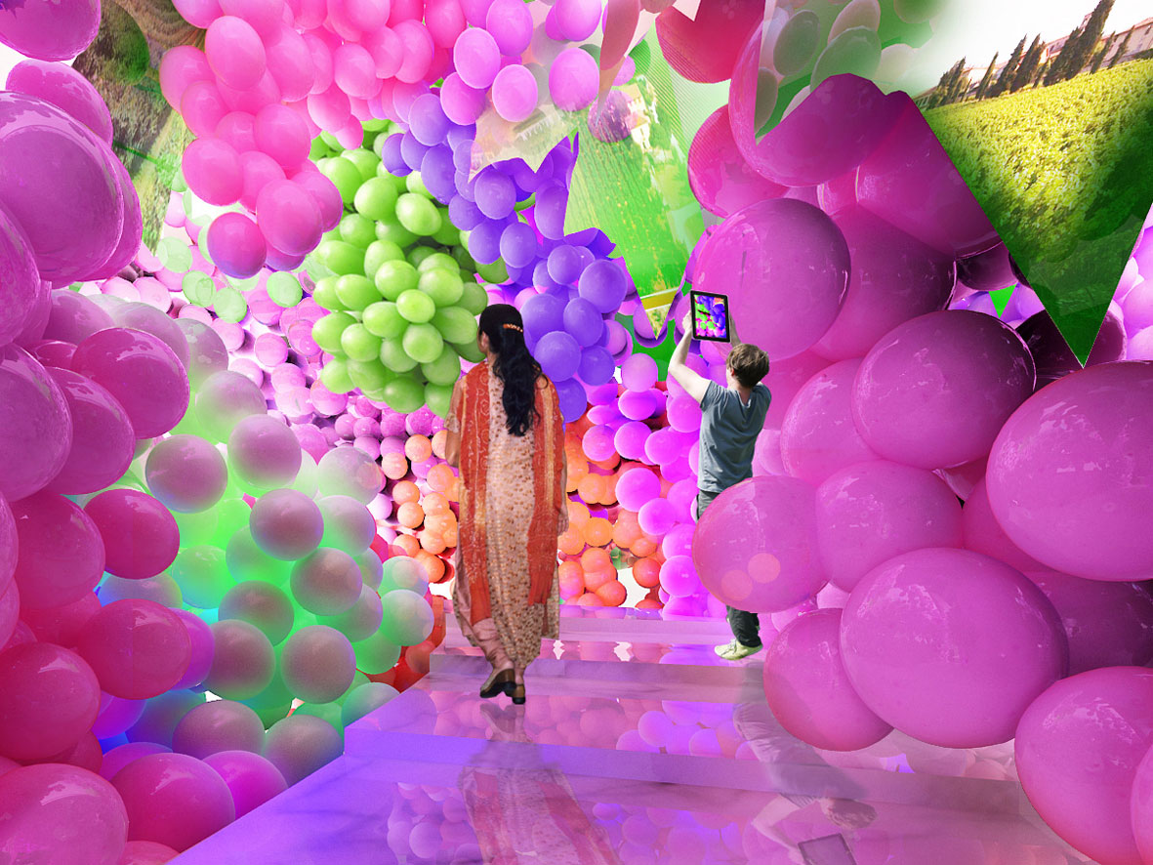

The new project was presented to a public of Institutional figures, journalists and wine producers. Amongst these, Piero Antinori of Marchesi Antinori Winery and member of the
Scientific Commettee, who together with many others, expressed an optimistic view on the positive impact that the Italian Wine Pavilion will have on the world of Italian wine: “I think that this is a great opportunity for Italian Wine to present Italy as a major wine producing country to the world. 20-24 million people are expected to come so I think that this area devoted to fine wines is really going to be a great opportunity”.
“Italian Wine Pavilion as a "house" for Italian Vino is a great concept” added Livio Felluga “Vino not only as something that is good, but also as the expression of the beauty, tradition, passion, history, culture, art of our country. In my opinion this "house" should be as close as possible to nature.”
Vino | A Taste of Italy will be developed on a three-level 2000 sqm area where visitors will be able to physically immerse themselves in an emotional, interactive and multisensory experience.
“In this Pavilion, the world of wine, which may sometimes appear highly subjective and difficult to communicate, becomes tactile and multi-sensorial, opening hearts and minds to the truly all-round experiential nature of wine” explains Marilisa Allegrini, owner of Allegrini Estates who was also present at the conference. “The space showcases a fantastic new way of communicating all the artistry, creativity and innovation that lies at the very heart of Italian personality and shows us how Italian oenology can help to underline our unique Italian artistic and cultural heritage acting as a powerhouse for our economy and our reputation as a nation on the world stage of Expo 2015.”
The second level of the Italian Wine Pavilion will be entirely dedicated to Italy’s diverse and extensive wine production, strongly entrenched in its past and tradition but, at the same time, intensely projected towards the future. But the future of Italian Wine also lies in an in–depth knowledge of the present, of the great diversity of Italian wines and terroirs. With this in mind, the Scientific Commettee in collaboration with Vinitaly International, will be organizing an intensive educational program where the Vinitaly International Academy will once again take centre stage: the new educational project was launched back in February by Stevie Kim (Managing Director of Vinitaly International) and Ian D’Agata (Scientific Director of VIA) with the aim of explaining, divulging and broadcasting the characteristics of Italy’s myriad grape varieties and the high quality of its many wines.
“It is clear that one of the main objectives of this new project we have presented today is to broadcast the Italian wine experience” explained Maurizio Martina, Minister of Agricultural Policies “With this purpose in mind we are now in the position of using a combination of different tools: the Italian pavilion on the one hand and the Vinitaly International Academy on the other. I think that in the months to come we will have the opportunity to work on this combination and take the Italian wine experience around the world, way beyond Italy’s borders, also thanks to educational initiatives such as this”.
“I think Italian wine has many challenges around the globe” said Architect Italo Rota when speaking about the exclusive Academy ”and one of these is also to educate: many of its wines are excellent, even the most simple, the most popular and hence they need to be broadcasted and explained within the context of their territory. This is very important. Italy, from Trentino to Sicily, is made up of different realities and different wine making processes.”

About:

Veronafiere is the leading organizer of trade shows in Italy including Vinitaly (www.vinitaly.com), the largest wine event in the world. The 48th edition of Vinitaly counted some 155,000 visitors (+6%) in four days of event, of which 56.000 were international attendees representing 36% of the total. On 100.000 square meters, 4.000 exhibitors welcomed trade professionals, media and producers alike. The next instalment of the fair will take place on 22 – 25 March 2015. The premier event to Vinitaly, OperaWine (www.vinitalyinternational.com) “Finest Italian Wines: 100 Great Producers,” will unite international wine professionals on March 21st 2015 in the heart of Verona, offering them the unique opportunity to discover and taste the 100 best Italian wines, as selected by Wine Spectator. In 1998 Veronafiere also created Vinitaly International to develop a global platform for the promotion of Italian wine producers in foreign markets such as Russia, China, USA and Hong Kong.

# # #

