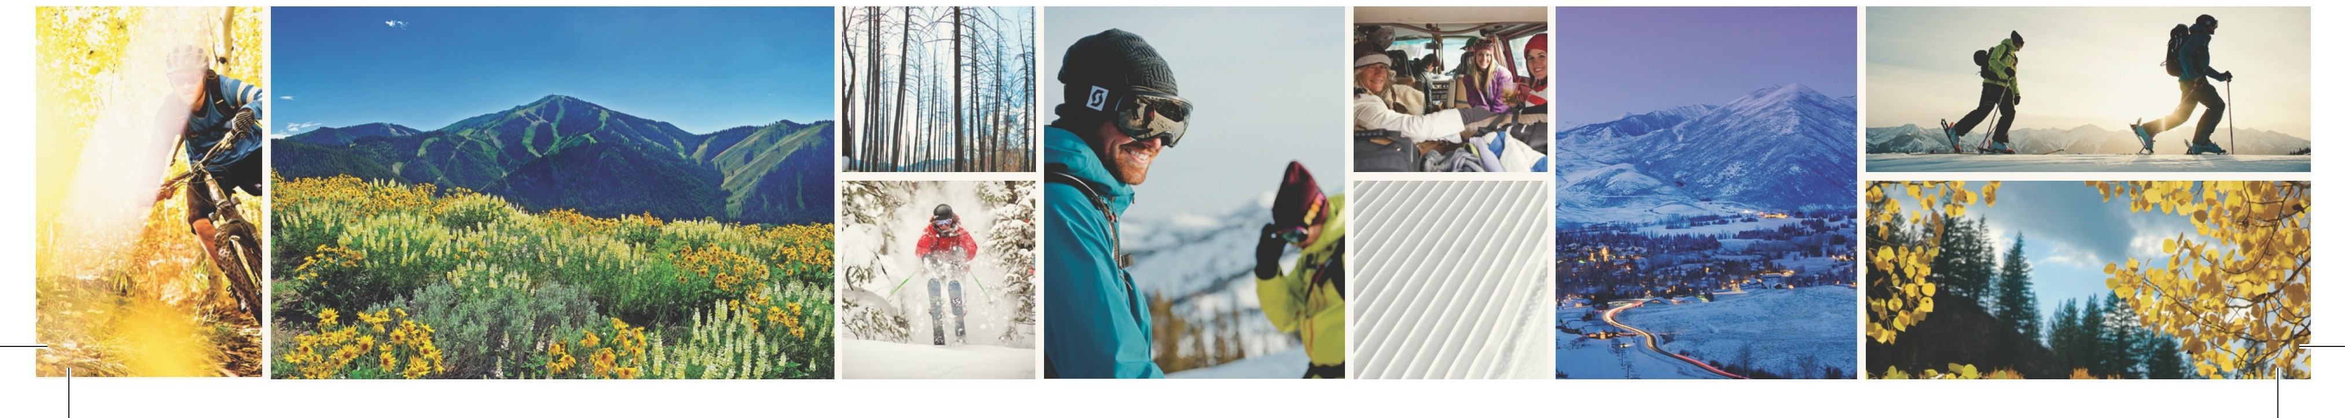

Hailey Named Top 10 Small Town for 2014
Livability Touts Hailey’s Healthy Lifestyle and Small Town Values
Media Contact:
Greg Randolph
greg@visitsunvalley.com
For Immediate Release (Sun Valley, ID) Hailey, Idaho, one of four towns which comprise the immediate Sun Valley region, was recently recognized by Livability as one of its Top 10 Small Towns.

Hailey was recognized for not only great schools, low pollution, and high community involvement but also low crime, a high level of employment, and the greatest income distribution of any of the other towns which made the list.
Hailey is home to a population of happy, healthy people that thrive in a town recognized for its amazing quality of life.

Livability says, “The people who live in Hailey enjoy a laid-back lifestyle filled with outdoor excursions to the nearby ski resorts, hiking/biking trails, and fishing holes. The City of Hailey maintains several parks and trails including Hop Porter Park which hosts the Northern Rockies Music Festival. The City is currently in the midst of improving its rodeo grounds by adding an ice skating rink, expanding the adjacent skate park and adding more parking spaces.”

Livability goes on to recognize Hailey for its great dining scene as well as lively arts and culture community. Located 15 miles from the city of Sun Valley and the ski areas of Bald Mountain and Dollar Mountain, Hailey is a bedroom community for one of the nation’s premier four season resorts that was founded as the first destination ski resort in North America in 1936.

Livability is a group focused on researching the best places in the United States to live and visit ranking them according to values such as walkability, cultural amenities, sustainability, access to recreation, income, crime rates, quality of schools and other values held which make a place special.

