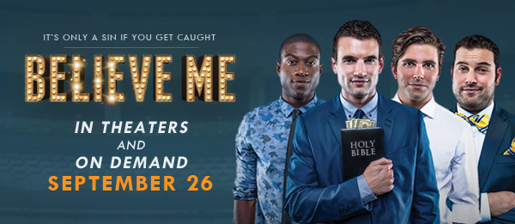
CONTACT:
Michael Conrad 214-616-0320
Michael@Lovell-Fairchild.com

CAST AND CREW BIOS

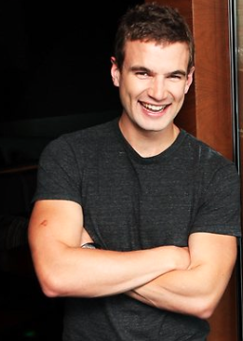
Alex Russell (Sam) Australian Alex Russell had a breakout role in the 2012 sci-fi drama CHRONICLE and has seen his star steadily rise since. Russell played the role of bad boy Billie Nolan in the 2014 reboot of CARRIE with Chloe Grace Moretz and Julianne Moore and appears in Angelina Jolie’s directorial debut, UNBROKEN, in theaters Christmas 2014.

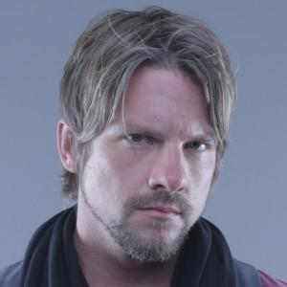
= Zachary Knighton (Gabriel) Zachary Knighton played Dave in the ABC
sitcom Happy Endings for the entirety of the beloved show’s three year run
and is also known for his roles in It’s Always Sunny in Philadelphia,
FlashForward, and THE HITCHER. He has signed on to star in FOX’s
upcoming ensemble comedy, Weird Loners.

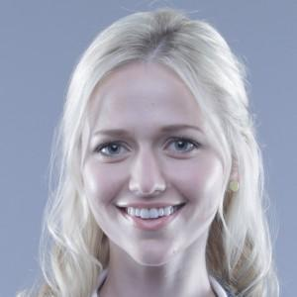
Johanna Braddy (Callie) Johanna Braddy headed to Hollywood from her hometown of Atlanta and quickly landed film and TV roles in popular shows such as Greek, and Criminal Minds and in films including EASY A and PARANORMAL ACTIVITY 3. She can be seen starring as Jenny Matrix in the hit web series, Video Game High School.

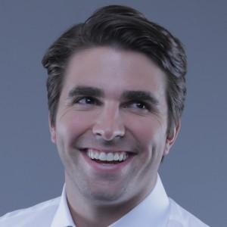
Miles Fisher (Pierce) Miles Fisher, a Dallas, TX, native, has appeared in TV shows like Mad Men and Gossip Girl, as well as movies like FINAL DESTINATION 5 and J. EDGAR. In SUPERHERO MOVIE (2008), Fisher's caricature of Tom Cruise talking about scientology quickly recorded over 10 million views after being posted. Fisher is a musician, often producing comical videos, and he hosts a faux-sports talk web series called "Bad Sports."

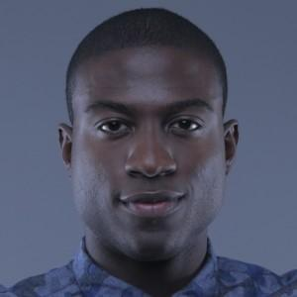
Sinqua Walls (Tyler) Sinqua Walls gain national stardom as Boyd on the MTV’s cult classic, Teen Wolf, and as Jamarcus Hall on the long-running Friday Night Lights. After playing the lead in the film SHARK NIGHT 3-D, he landed the role of Sir Lancelot in ABC's Once Upon A Time and is now filming Power, a STARZ Original, in New Jersey.

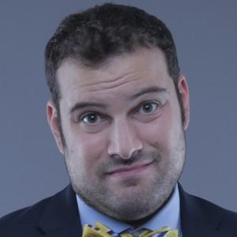
Max Adler (Baker) After numerous film and TV roles, Max Adler was scheduled for one appearance on the hit show, Glee. He so impressed the show’s producers that one episode turned into 21 as Adler’s Dave Karofsky captured hearts across the nation. Max can be seen on ABC Family’s Switched At Birth, where he plays the character of Tank.

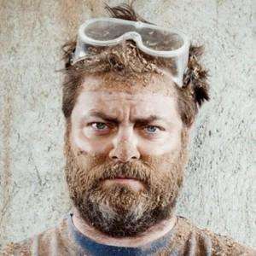
Nick Offerman (Sean) Nick Offerman is an actor and producer known for his roles as Ron Swanson in NBC’s Parks and Recreation and Deputy Chief Hardy in 21 JUMP STREET. Offerman carries over his traditionally sarcastic personality in the role of Sean, the academic advisor.

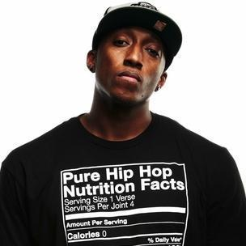
LeCrae Moore (Dr. Malmquist) Mononymously known as Lecrae, Mr. Moore is an American Christian hip-hop artist. His 2012 album, Gravity, won a Grammy Award for Best Gospel Album at the 2013 awards. This marks LeCrae’s debut in a feature film.

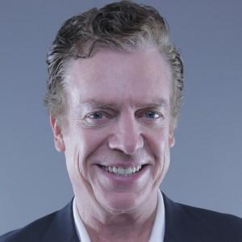
Christopher McDonald (Ken) Since leaving his native New York state for
Southern California in 1978, Christopher McDonald has claimed more
than 160 film and television roles. Recently seen in the hit HBO series
Boardwalk Empire, McDonald is well known for work in series that include
the Law & Order and Stargate franchises, The Sopranos, and the movies
THELMA AND LOUISE and HAPPY GILMORE.

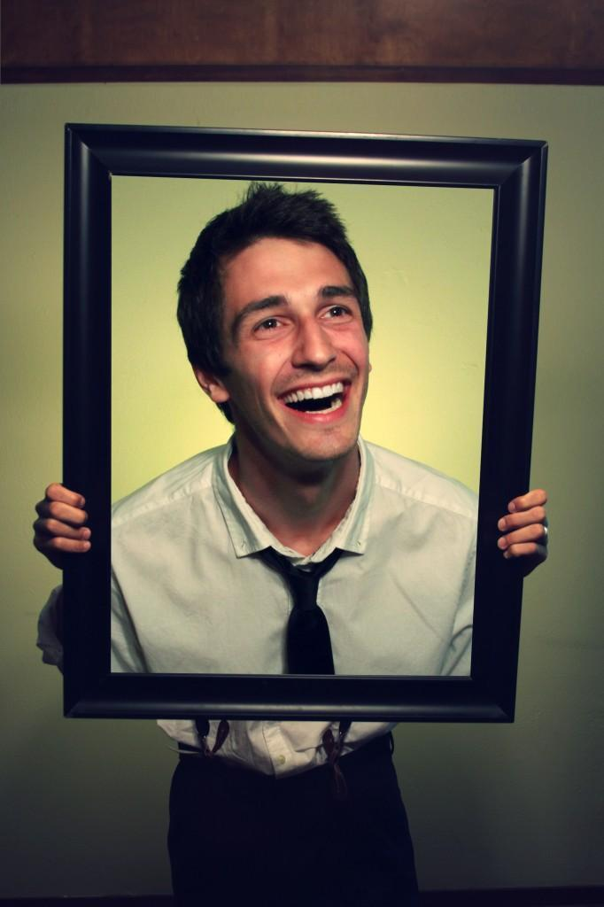
Michael B. Allen (Co-Producer, Co-Writer) The Swiss Army Knife of Riot Studios, Michael B. Allen has served in roles both creative (writing, producing) and technical (web development) and contributing original music to previous films. Equally artistic and analytic, Michael brings integral balance to the Riot universe. After starring in ONE NATION UNDER GOD and BEWARE OF
CHRISTIANS, Michael co-wrote BELIEVE ME, for which he served as co-
producer and on-set script supervisor.

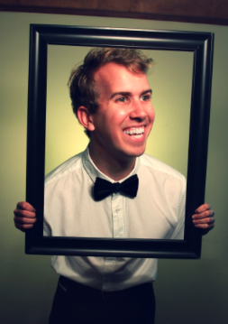
Will Bakke (Director, Co-Writer) Will Bakke is an award-winning filmmaker and the director of BEWARE OF CHRISTIANS and ONE NATION UNDER GOD. While still in college, Will was hired by MTV to write and develop a comedy series that landed him on the prestigious "Top 25 Filmmakers on Campus" list presented by MTVU. On the strength of his two documentaries and a burgeoning cult following from his sketch comedy shorts, Will secured an international distribution deal for his films, accepted in more than 17
festivals worldwide.

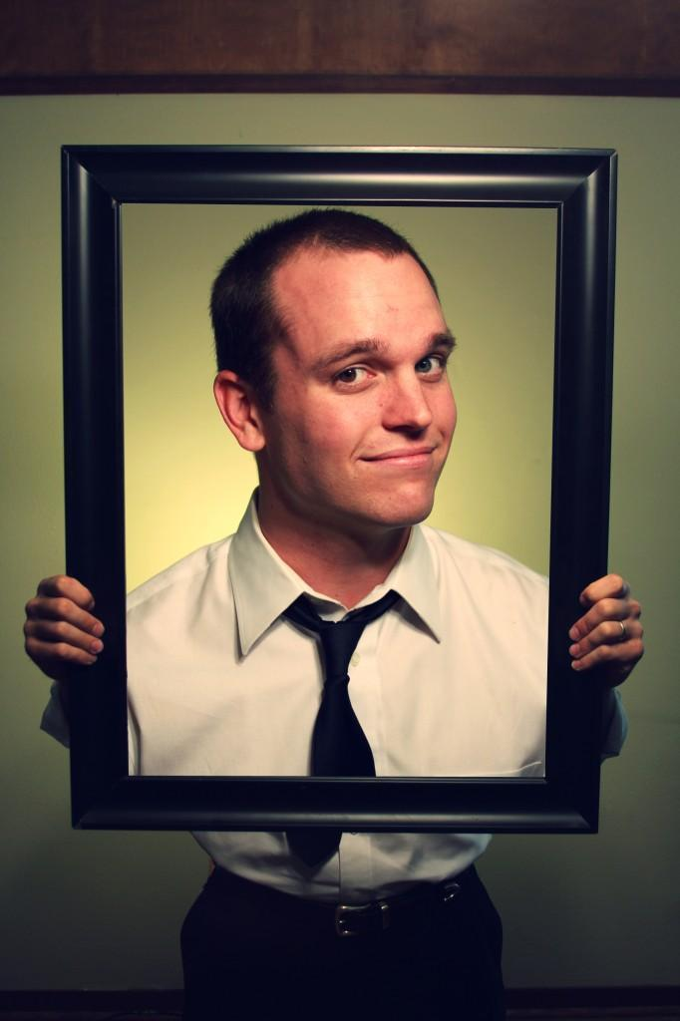
Alex Carroll (Producer) A graduate of the McDonough Business School at Georgetown University, Alex Carroll translated his business acumen into four successful start-ups before jumping into the dynamic and notoriously challenging film industry. A former college football player, Alex parlayed his trademark ferocity into creating the unique distribution model for BEWARE OF CHRISTIANS that led to 176 shows nationwide. Alex is the lead producer for BELIEVE ME.

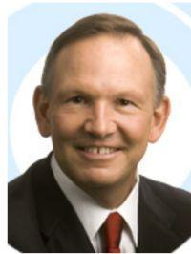
Gary Cogill (Co-Producer) Lascaux Films is a Dallas based production company, led by Richard Toussaint, MD, Wade Barker, MD, and Gary Cogill. Lascaux Films was launched in 2010 and is engaged in the development, production and financing of motion picture films. Lascaux has emerged onto the scene with a series of quality projects. Words and Pictures, a Latitude Productions and Lascaux Films produced film, is scheduled for release by Roadside Attractions on May 23, 2014 and Life Itself, starring Morgan Freeman and Diane Keaton, co-produced and co-financed by Lascaux, is slated for release later this year.
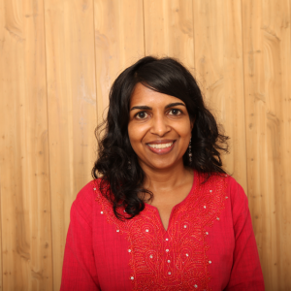
Sandhya Shardanand (Co-Producer) After receiving her M.B.A. at the University of Texas and rising to director of marketing for an Austin-based software company, Sandhya Shardanand dabbled in the Austin film industry by volunteering at film festivals and helping out on friends' sets. She has since moved into film full time, producing three Terrence Malick projects (THE TREE OF LIFE, TO THE WONDER, THE NEW WORLD)
and served as line producer for BELIEVE ME.

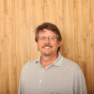
Steve Markham (Co-Producer) Steve Markham brings 30 years of entrepreneurial and business experience to BELIEVE ME, where his multifaceted skills find many uses. Currently he’s with Matter Media Studios, an L.A. production house of commercial, industrial, short and feature films. He has been a successful producer and executive producer on several projects. His recent works include DRAGON DAY and JAMAA.

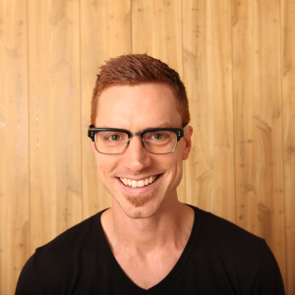
John W. Rutland (Director of Photography) John W. Rutland, visual storyteller, has drawn critical acclaim in the narrative, commercial and documentary worlds. His work as a cinematographer has screened at the world’s top film festivals, including the Berlin International Film Festival, Toronto, Tribeca and SXSW.

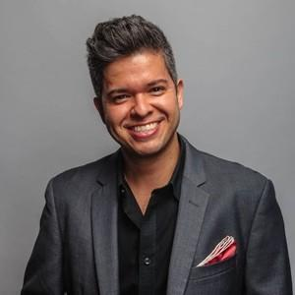
J.C. Cantu, C.S.A. (Casting Director) J.C. Cantu founded Beverly Hills-based Rising Phoenix Casting in 2011 and has since found happy homes on screen for many of Hollywood's elite—actors like Robert de Niro, Benicio del Toro, Jessica Alba, William H. Macy, Joel McHale and Aubrey Plaza. He has cast more than 50 films and worked for directors Steven Soderbergh and Robert Rodriguez.

To learn more, visit: BelieveMeFilm.com
Facebook.com/BelieveMeFilm
twitter.com/believemefilm

And visit BelieveMeFilm.com/pressroom for:
- BELIEVE ME Official Theatrical Trailer Press Release
- BELIEVE ME Curtain Raiser Release
- BELIEVE ME Fact Sheet
- BELIEVE ME Cast and Crew Bios
- BELIEVE ME Suggested Interview Questions

About Riot Studios RiotStudios.com
Riot Studios made headlines in 2012 with the unique content and distribution model of its second documentary BEWARE OF CHRISTIANS. The film followed Riot’s Bakke, Allen, and Carroll around Europe as they gathered man-on-the-street interviews about Christianity and Christians—part college road comedy, part thought-provoking dialogue on how trying to follow Jesus in the 21st century might look. Riot Studios exists to tell stories that compel viewers to challenge their beliefs, weigh the alternatives, and laugh while doing so. They aspire to make transparent and thoughtful art through film.

About Lascaux Films LascauxFilms.com
Lascaux Films is a Dallas based production company, led by Richard Toussaint, MD, Wade Barker, MD, and Gary Cogill. Lascaux Films was launched in 2010 and is engaged in the development, production and financing of motion picture films. Lascaux has emerged onto the scene with a series of quality projects. Words and Pictures, a Latitude Productions and Lascaux Films produced film, is scheduled for release by Roadside Attractions on May 23, 2014 and Life Itself, starring Morgan Freeman and Diane Keaton, co-produced and co-financed by Lascaux, is slated for release later this year.

About Distribution Headline Features Gravitas Ventures
Headline Features and Gravitas Ventures are set to distribute Believe Me. The film will be released in theaters and on demand on Sept. 26.

