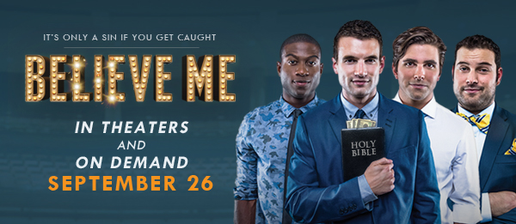CONTACT:
Michael Conrad 214-616-0320
Michael@Lovell-Fairchild.com

FACT SHEET

TITLE BELIEVE ME

TAGLINE It’s only a sin if you get caught.

LOGLINE Desperate, broke and out of ideas, four college seniors start a fake charity to embezzle money for tuition.

SYNOPSIS In BELIEVE ME, Sam Atwell (Alex Russell) stands on stage as thousands of fans go wild. Smart, charismatic, handsome, he moves them with his message, and when he calls for donations to his charity, the money pours in.

Only thing, Sam doesn’t believe a word he’s saying.

Just months earlier, Sam was a typical college senior focused on keg stands, hookups and graduation. But when a surprise tuition bill threatens his dream of law school and leaves him thousands of dollars in the hole, he’s forced to think outside the box. Convincing his three roommates they can make a killing exploiting the gullible church crowd, the guys start a sham charity and begin campaigning across the country, raising funds for a cause as fake as their message.

For Sam, embezzling money is easy compared to getting attention from the person he cares about the most. When Callie (Johanna Braddy), the tour manager and Sam’s love interest, finally uncovers the guys’ ruse, it's Sam's moment of truth.

On the final night of the tour, before a packed auditorium but alone in the spotlight, it’s time for Sam Atwell to decide what he really believes.

DISTRIBUTION Headline Features, Gravitas Ventures

PRODUCTION A Riot Studios Production in association with Lascaux Films

RELEASING Sept. 26, 2014, in theaters and on demand

FEATURING Alex Russell (Sam) CHRONICLE, CARRIE, UNBROKEN
Zachary Knighton (Gabriel) Happy Endings
Johanna Braddy (Callie) EASY A
Miles Fisher (Pierce) FINAL DESTINATION 5
Sinqua Walls (Tyler) Teen Wolf
Max Adler (Baker) Glee
LeCrae Moore (Dr. Malmquist) Grammy-winning rap artist
with Nick Offerman (Sean) Parks and Recreation
and Christopher McDonald (Ken) Boardwalk Empire

DIRECTED Will Bakke

PRODUCED Alex Carroll

CO-PRODUCED Gary Cogill, Richard Toussaint, Sandhya Shardanand,
Steve Markham

WRITTEN Michael B. Allen and Will Bakke

To learn more, visit: BelieveMeFilm.com
Facebook.com/BelieveMeFilm Twitter.com/BelieveMeFilm

And visit BelieveMeFilm.com/pressroom for:
- BELIEVE ME Official Theatrical Trailer Press Release
- BELIEVE ME Curtain Raiser Release
- BELIEVE ME Fact Sheet
- BELIEVE ME Cast and Crew Bios
- BELIEVE ME Suggested Interview Questions

About Riot Studios RiotStudios.com
Riot Studios made headlines in 2012 with the unique content and distribution model of its second documentary BEWARE OF CHRISTIANS. The film followed Riot’s Bakke, Allen, and Carroll around Europe as they gathered man-on-the-street interviews about Christianity and Christians—part college road comedy, part thought-provoking dialogue on how trying to follow Jesus in the 21st century might look. Riot Studios exists to tell stories that compel viewers to challenge their beliefs, weigh the alternatives, and laugh while doing so. They aspire to make transparent and thoughtful art through film.

About Lascaux Films LascauxFilms.com
Lascaux Films is a Dallas-based production company led by Richard Toussaint, MD; Wade Barker, MD; and Gary Cogill. Launched in 2010, Lascaux Films develops, produces and finances motion picture films and emerged on the scene with a series of quality projects. WORDS AND PICTURES, from Latitude Productions and Lascaux Films, is scheduled for release by Roadside Attractions on May 23, 2014, and LIFE ITSELF, starring Morgan Freeman and Diane Keaton, co-produced and co-financed by Lascaux Films, releases later this year.

About Distribution Headline Features Gravitas Ventures
Headline Features and Gravitas Ventures are set to distribute Believe Me. The film will be released in theaters and on demand Sept. 26, 2014.

