June 4, 2014

COPE Committee on Publishing Ethics
COPE, 22 Nelson Close,
Harleston,
Norfolk IP20 9HL, UK

Tel: +44 (0) 1379 854181
Fax +44 (0) 844 443 1087

Linda Gough cope_administrator@publicationethics.org

ATTN: Linda Gough
Administrator

Dear Ms. Gough,

RE: Request to retract Stephan Lewandowsky et al (2013): "NASA Faked the Moon Landing - Therefore, (Climate) Science is a Hoax: An Anatomy of the Motivated Rejection of Science" http://pss.sagepub.com/content/early/2013/03/25/0956797612457686.abstract

“Some people believe that true scientific peer review
begins only on the date a paper is published.”
ICMJE - “Peer review”

Further to our correspondence to the Association for Psychological Science (APA) of May 1, 2014, copied to your organization, Friends of Science Society respectfully request that the paper "NASA Faked the Moon Landing - Therefore, (Climate) Science is a Hoax: An Anatomy of the Motivated Rejection of Science" (herein after “NASA Faked..”) be withdrawn on grounds of violating numerous Committee on Publication Ethics (COPE) ethical guidelines. These are our opinions.

Overview:

- We believe this paper to be flawed and misleading; its manner of expression, particularly in the title, to be damaging to a broad sector of legitimate climate scientists and engaged citizens who hold dissenting views on climate change from that of the often alleged ‘consensus’ position.

- We allege unethical research and academic misconduct on grounds that the lead author had prior knowledge of the damaging psychological impact of such a paper’s style, title and content, evident in prior publications, academic and informal, on the spread of misinformation and how difficult it is to correct, once published - and proceeded anyway.

- Following the above, research on reactions to being ostracized, such as rage and fury, could indeed be the anticipated outcomes on which the lead author recently reported in a subsequent paper (recently retracted from “Frontiers”) entitled: “Recursive fury: Conspiracist ideation in the blogosphere in response to research on conspiracist ideation” http://journal.frontiersin.org/Journal/10.3389/fpsyg.2013.00073/full - these typical reactions are reported on in the work of Kipling Williams on ostracization, and are referenced in the lead author’s 2012 paper “Misinformation and Its Correction: Continued Influence and Successful Debiasing“ http://psi.sagepub.com/content/13/3/106.full.pdf+html?ijkey=FNCpLYuivUOHE&keytype=ref&siteid=sppsi .

- We find that the data in “NASA Faked..” cannot be claimed to be sound, complete or empirically sufficient or conclusive to make the claims the author makes, as not a single ‘rejectionist’ blog posted the on-line survey central to the claim. With no responses from blogs of ‘rejectionists’ and with heavy reliance on the blog Skeptical Science, (operated by the lead author’s frequent co-author John Cook, a source that does not appear to be sufficiently at arm’s length) it is our opinion that the claim of empirical evidence is unsupported. Therefore, the conclusions of the authors should not be relied upon by subsequent researchers. The on-line visitors to the ‘skeptical/rejectionist’ blogs listed in the supplementary files (Appendix C herein) are typically oriented toward scientific discussions on the various aspects of climate change. The questionnaire made no allowance for divergent views on climate change - therefore any respondent could not have expressed a view other than one fitting a conspiratorial ideation. With the questionnaire being posted on sites hostile to rejectionist views, it cannot be said that respondents who may have been rejectionist would answer honestly, clearly aware by the style of question and relative comparisons to various hoaxes they were being lead to what appears to be a designed result.

- Fundamental flaws in premise and factual errors include the claim that ‘domain experts agree’ on Anthropogenic Global Warming (AGW). The paper relied heavily on a claimed ‘consensus’ - arguing that Anderegg et al (2010) and that Doran & Zimmerman (2009) and Oreskes (2004) demonstrated a consensus.

In fact, Anderegg et al (2010) reviewed lists of signatories to public declarations for and against the IPCC position, incorrectly assuming all IPCC contributors agree with the IPCC declaration, and found that 34% dissented/rejected the IPCC declaration. This cannot be said to be a slim minority of ‘whackos.’ Reviewing the qualifications of these scientists indicates they are unlikely candidates for conspiracy ideation. This paper was also submitted to the Proceedings of the National Academy of Sciences under a special “Contributed” category that does not undergo the typical extensive and stringent blind peer-review of the “Direct Submission” method. (See Appendix A)

Doran & Zimmerman (2009) approached 10,000 earth scientists, some 3,146 responded, but of these only 77 and 76 out of 79 self-selected (qualifications unknown) scientists made up the alleged 97%. M.K. Zimmerman’s original thesis “The Consensus on the Consensus” http://www.lulu.com/shop/m-r-k-zimmerman/the-consensus-on-the-consensus/ebook/product-17391505.html includes numerous angry emails from scientists refusing to participate in an opinion poll on an empirical subject.

Oreskes (2004) survey was rerun by Peiser (2005) demonstrating that Oreskes’ claim of a 75% consensus saying “Remarkably, none of the papers disagreed with the consensus position.” This statement was incorrect; only 13 out of 1117 scientists (Oreskes 2004 re-run by Peiser 2005) explicitly agreed with the stated IPCC declaration - most held no position.

- In light of these statistics, the paper is clearly based on a faulty premise. Likewise, lacking any representation from the 8 selected ‘rejectionist’ sites, it cannot be conclusively said that the paper reflects accurate empirical evidence are there are no survey results from a ‘rejectionist’ site whatsoever.

RE: Ethical Considerations

- COPE Code - specifically Section 1.5 “champion freedom of expression” we allege that the title of this paper alone violates this principle. Referring to “APA Manuscript Preparation Guide” http://www.apa.org/pubs/authors/new-author-guide.pdf found at:
http://www.psychologicalscience.org/index.php/publications/journals/ms-structure-guidelines authors are instructed (under “Style”) to ‘avoid bias in language, which is particularly important in demonstrating sensitivity to such concerns as participants’ mental illness…”

Assume for a moment that climate rejectionists do suffer from some compromising ideation - how does the mocking, awkwardly contrived title demonstrate any sensitivity?

Now, based on the foregoing deconstruction of the claimed ‘consensus’ - which is non-existent - how does this mocking title ‘champion freedom of expression’ - when Lewandowsky’s 2012 paper on misinformation demonstrates how effectively such a title will delegitimize those who dissent on climate change science in his statement “Throw mud...it will stick.”.

- “Do no harm” - Lewandowsky et al (2012) cites the research by Kipling D. Williams on the devastating impact of ostracization (Lewandowsky 2012) as well as citing the work of Macdonald & Leary (2014) and Eisenberger, Lieberman, Williams (2003) on how ostracization causes equivalent sensation to physical pain. COPE guidelines ‘encourage responsible behaviour and discourage misconduct.” Surely the knowing application of methods that will cause pain and ostracization are not in keeping with COPE guidelines.

The journal Psychological Sciences is signatory to COPE which references the APA Code of Conduct.

Under the COPE umbrella is the APA Code of Conduct/Ethical Principles.

The APA’s Ethical Principles “Preamble” calls for psychologists to:
- commit...to the use of such knowledge to improve the condition of individuals, organizations, and society.
- respect and protect...the central importance of freedom of inquiry and expression in research, teaching, and publication.
- help the public develop informed judgements
- Principle A: Beneficence and Nonmaleficence...’take care to do no harm’
- Principle B: Fidelity and Responsibility: …”aware of their professional and scientific responsibilities to society….and seek to manage conflicts of interest that could lead to exploitation or harm.” It is our opinion, based on the available evidence, that Lewandowsky et al (2013) have a particular view on climate change; their work has exploited the untrue, social proof claim of a >90% consensus, and caused harm of ostracization and public humiliation of legitimate scientists.
- Principle C: Integrity…” do not engage in ..intentional misrepresentation of fact….In situations in which deception may be ethically justifiable to maximize benefits and minimize harm, psychologists have a serious obligation to consider the need for, the possible consequences of, and their responsibility to correct any resulting mistrust or other harmful effects that arise from the use of such techniques.”
- Principle D: Justice “..fairness and justice entitle all persons to access to and benefit from the contributions of psychology and to equal quality in the processes..”
- Principle E: Respect for Rights and Dignity “do not knowingly participate in or condone activities of others based upon ...prejudices.” As noted above, if one assumes Lewandoswky’s position that those who reject (climate) science are in the grip of conspiracy ideation, how would mocking them help?
- If you accept our position that those who dissent on scientific grounds are disadvantaged by a minority position in a society that values ‘compli-racy’ © then it is clear that this paper has made it even more difficult to have a rational debate on climate science.[“Compli-racy” © is a term we have coined for the self-evident nature of humans, well established by research in the social sciences and psychology (Feinberg, Willer, Schultz 2014) “Gossip and Ostracism Promote Cooperation in Groups.”]. Compli-racy © also applies to peer pressure to conform in academia and science. As many critics of established scientific or mathematical theories have discovered, experts often close ranks when protected territory is threatened by evidence or innovation that challenges ‘the faith.’ Keepin & Wynn (1984) Keepin (1984) - or as Benoit Mandlebrot discovered when questioning assumptions of modern finance he was “about as welcome in the established church of economics as a heretical Arian at the Council of Nicene.” Mandlebrot & Hudson (1984) pg 167
- As noted by author and mathematician and author David Orell “...if scientific models are used to set policy, and to make important public and private decisions, then we need to know how accurate they are. This is made difficult by the nature of the models, which are written in a highly specialized language that can be understood only by other scientists with experience in the field. Since such people often share the biases of the model makers, glaring problems go undetected, or unremarked….” and he references Bart Kosko on “Fuzzy Logic” - that the world is not so black and white.
- This message is confirmed by a recent presentation by Ross McKitrick who deconstructed the apparent precision of Integrated Assessment Models which are based on climate models, demonstrating that the flaws in both lead to wildly exaggerated results. He quoted economist Robert S. Pindyck’s 2013 paper Climate Change Policy: What Do the Models Tell Us?" in the Journal of Economic Literature who wrote: “[The] models are so deeply flawed as to be close to useless as tools for policy analysis. Worse yet, their use suggests a level of knowledge and precision that is simply illusory, and can be highly misleading.” We suggest that the Lewandowsky paper is such an attempt to ‘close ranks’ in a disrespectful, publicly humiliating way, by delegitimizing all who question the orthodoxy of apocalyptic climate doom.

People are easily lead to comply - or typically threatened into compliance
It is not a conspiracy - but there is a ‘compli-racy’© rooted in human nature, often driven by ‘top-down’ directives. (e.g. See “Informing an Effective Response to Climate Change” excerpt Appendix B)

In reviewing all of Lewandowsky’s published titles, “NASA Faked…” one is the only pejorative title: “NASA faked the moon landing -Therefore (Climate) Science is a Hoax: An Anatomy of the Motivated Rejection of Science” - clearly could humiliate those holding opposing views.

Humiliation is intended to exclude people from the group and make others avoid them, resulting in social isolation and public mockery. Ostracism is physically painful (MacDonald & Leary 2005); rejection can be seen as physical pain in neuroimaging (Eisenberger, Lieberman, Williams 2003)

This effort to publicly humiliate those holding dissenting views on climate science has risen to the highest levels of politics with President Obama’s declaration that ‘I don’t have time for a meeting of the Flat-Earth Society’ – yet the evidence herein clearly shows that his entire Georgetown speech’s premise that there is a 97% scientific consensus on climate change is false.

Schacter (1959) experimented with social isolation, finding it had immediate, devastating impacts on individuals; his work was followed up on by Sarnoff and Zimbardo (1961) who largely replicated Schachter's results with a twist.

Their findings showed that when anxiety is aroused in a person, theoretically that person would seek isolation from others. However, when fear is aroused and if the person is unable to run away from the threat, that person then welcomes a chance to join with other people.

In contemplating these findings, clearly the threat of global warming, as presented by charismatic figures like Al Gore, makes ordinary people both anxious and fearful. “Climate” is something no one can escape – but one is able to join many groups that are engaged in the ‘fight against global warming.’ Consequently, these dual primal emotions are powerful motivators – both of which can supersede rational thought.

The language and visuals used by most of these groups in their materials and online websites invoke fear and anxiety and encourage individuals to join and take action.

The stubborn ‘consensus’ resisters are thus confronted by an army of angry climate change activists, fearful of human extinction caused by those who won’t join the herd.

Regarding the Role of Psychological Science Journal Peer Reviewers
Even if the peer-reviewers are unaware of the divergent views on climate change amongst scientists, we submit that it would have been self-evident, both from prior research cited in the “NASA Faked…” paper and from well-known research in psychology on social proofs and ostracization, public humiliation and bullying, that a paper with such an inflammatory and contrived title - would necessarily smear any dissenting scientist or citizen with its caustic meme, no matter how qualified they were or how reasoned their scientific position.

- Lack of scrupulous honesty - Returning to the APA Manuscript Preparation Guide we cite the reference on page 10 “Whereas selectivity in presentation is important, it is crucial to present facts objectively, both those that refute and those that support one’s position. “Scientists demand that scientific reporting be scrupulously honest. Without such honesty, scientific communication would collapse” (Sternberg, 1988, p. 5)

We allege the paper fails many times in this regard - misrepresenting a broad consensus that is non-existent, not including any rejectionist blogs in the survey sample yet claiming empirical evidence, misuse of psychological research on exclusion and ostracization in a manner that could clearly cause harm under the guise of an awkward title - which bears no relation to any of the other academic papers of Lewandowsky. (Violation of APA Ethical Standards 1.01)

- Competence - APA Ethical Standards 2.01 “(a) Psychologists provide services, teach, and conduct research with populations and in areas only within the boundaries of their competence.” Lewandowsky and co-authors Oberauer and Gignac are not climate scientists and yet they make a claim that "More than 90% of climate scientists agree that the global climate is changing, largely because of carbon dioxide emissions resulting from human activity…..” and cite Anderegg et al (2010) and Doran & Zimmerman (2009). In fact these surveys do not address these questions. Neither survey supports this statement by Lewandowsky et al.

Anderegg et al (2010)

Anderegg et al (2010) approached the subject by assessing authors as to whether they were “Convinced by Evidence” (CE) or “Unconvinced by Evidence” (UE) of the tenets of Anthropogenic Climate Change (ACC) as defined by the Intergovernmental Panel on Climate Change (IPCC). This was evaluated by a review of what type of public statements scientists may have signed. A contributor to the IPCC report was automatically assumed to support the IPCC declaration. This is an unjustified assumption; many IPCC contributors disagree strongly and publicly with IPCC declarations. Anderegg et al further attempted to establish the credibility of the various scholars according to the number of publications on climate change issues in select journals and by counting the number of times the selected authors’ work was cited.

As the “Climategate” emails revealed, the influence of ‘confirmation bias’ on these publication results is certainly a factor for consideration. This is supported by many complaints from scientists who support a review of natural forces as being more influential on climate. These scientists challenge the IPCC mandate to examine only human-induced influences on climate change. Their challenges are supported by the Dutch government which has recently called for a restructuring of the IPCC to include a review of natural influences.
“The IPCC needs to adjust its principles. We believe that limiting the scope of the IPCC to human-induced climate change is undesirable, especially because natural climate change is a crucial part of the total understanding of the climate system, including human-induced climate change.”

Doran and Zimmerman (2009)
Doran and Zimmerman (2009) claimed a survey base of some 10,257 earth scientists of which 3,146 responded. They claimed 97% agreement on AGW but worded their questionnaire in a very tricky way.

Upon review it appears that of the 3,146 respondents, only 79 were identified as ‘climate scientists’ (though no definition of ‘climate scientist’ or qualifications were ever provided). Of those, some 76 agreed with the opinion (‘risen’) in the first question: Q1: “When compared with pre-1800’s levels, do you think that mean global temperatures have generally risen, fallen, or remained relatively constant?”

The question does not mention any human-caused reason for a rise in temperature, therefore it cannot rightly be said to show any consensus of the IPCC AGW declaration. Most geologists would agree temperatures have risen because since 1880 the earth has been warming out of the cold period known as the Little Ice Age. The cause is the subject of debate, but the warming to 1940 could not have been caused by CO2 emissions because these emissions were too low.

As noted in emails to Zimmerman from respondents, her question asks for an opinion, not a statement of evidence, and has no parameters of time. Doran and Zimmerman were assessing a group of earth scientists (primarily geologists) whose view of time may stretch over eons. The main focus of AGW is from 1880 forward; geologists reviewing the Holocene period dating back 11,700 years Before Present would likely see an overall cooling temperature in earth’s climate. Consequently many respondents to the survey declined to participate because the questionnaire was improperly phrased by not including time parameters, and the survey relied on opinion, not empirical evidence.

Likewise, the second question by Doran and Zimmerman (2009): Q2: "Do you think human activity is a significant contributing factor in changing mean global temperatures?"

The word "significant" cannot be quantified. The IPCC AGW statement is that GHGs cause more than 90% of the warming. The IPCC declaration singles out GHGs from human activity, but does not ascribe all human activity (which includes land disturbance, urban warming and black soot on snow, etc). Neither of the two questions mentions human-caused GHG emissions, so neither can evaluate the agreement with the IPCC AGW statement.

Nonetheless, Doran and Zimmerman claimed a 97.4% consensus to this question – based on a “yes” response by 75 out of 77 self-identified ‘climatologists’ (the credentials of whom were never detailed). This would mean only 2.38% of 3,146 scientists agree with an undefined expression of AGW.

Excluded from the Doran and Zimmerman (2009) survey of earth scientists would be scientists in other relevant climate disciplines such as solar scientists, space scientists, cosmologists, physicists, astronomers and meteorologists.

Clearly the peer-reviewers at Psychological Sciences cannot be faulted for not appreciating that key references were incorrectly applied or that these references themselves were faulty; however now that this information is made clear, we expect a retraction. Were Lewandowsky et al climate scientists, they would have been aware of these very important nuances and the statistical manipulations in these studies and would not have had any citations to support their claim of agreement on AGW by ‘more than 90% of climate scientists’.

- Delegation - The paper violates APA Ethical Code Section 2.05 Delegation of Work to Others, which states “must take reasonable steps to (1) avoid delegating such work to persons who have a multiple relationship with those being served that would likely lead to exploitation or loss of objectivity; and…(3) see that such persons perform these services competently… (see Standards 9.01 Bases for Assessments, and 9.07 Assessment by Unqualified Persons.)

The survey was delegated for posting on web-sites hostile to those who reject the AGW ‘consensus’ view. One such website which is also cited as a general example of the demographic response compared to a Pew Research study of Americans’ belief in AGW, is that of John Cook, a long-time collaborator of Lewandowsky and an ardent supporter of the AGW theory. This may have resulted in a loss of objectivity - we do not know what kind of postings were placed on these sites during the time of the survey; were they inflammatory in any way, intended to heighten the angst or in some other way skew the survey results? There is no empirical evidence either way.

With regard to (3) - a review of these sites currently shows the debate here appears to be more political than scientific (Appendix D). Without a single example of survey results from a rejectionist site, we are unable to know whether the pro-AGW sites in anyway attempted to compromise the survey results. This may also have happened unwittingly by word-of-mouth through social media where people posing as ‘rejectionists’ filled out the form to paint a wilder picture. Likewise, since the survey questions do not allow for rational scientific or evidence based objections to the ‘consensus’ view, there is no test of validity. We argue that the technical survey infrastructure may have lacked a competent factor to properly validate who was completing the survey; there are no checks or balances that we know of wherein site content was monitored to see if it had been altered in any way to inflame the conversation.

Likewise, according to the Ajzen & Fishbein (1977) ‘attitudes will often be unrelated to behavior as these are defined by their “target, action, context, and time elements.” The context of the pro-AGW websites being what they are, may result in an action (filling out of the survey) that is not a reliable predictor of attitude or behaviour. Further, the survey’s discrepancy of including non-climate related questions (i.e. HIV/AIDS, NASA -moon-landing, Princess Diana, JFK, Martin Luther King, 911) would seem to clearly tip off any respondent of the contrived nature of the study.

Due to these factors, we also find the paper in violation of Section 9.01 (b) of the APA Ethical Principles “...When, despite reasonable efforts, such an examination is not practical, psychologists document the efforts they made and the result of those efforts, clarify the probable impact of their limited information on the reliability and validity of their opinions, and appropriately limit the nature and extent of their conclusions or recommendations.”

We find instead that a sweeping generalization has been made of all dissenting parties as suffering from conspiracy ideation, a notion that is unsupported by evidence or survey results.

- Avoiding Harm - Section 3.04 “Psychologists take reasonable steps to avoid harming their clients/patients, ...and others with whom they work, and to minimize harm where it is foreseeable and unavoidable.” While we believe to have shown that the survey was deeply flawed, the fact that Lewandowsky had previously written about the ease with which a smear can be spread and how difficult it is to ‘debias’ or remove it, we find there was no attempt to minimize harm by rewriting the title to be less inflammatory in style; curiously the key part of the title’s ‘meme will always pop up first as it just fits the 40 character maximum recommended by the ICMJE - International Committee of Medical Journal Editors 3.a. Title page “Some journals require a short title, usually no more than 40 characters..” http://www.icmje.org/recommendations/

- Personal relationships or agendas - ICMJE - International Committee of Medical Journal Editors “Recommendations for the Conduct, Reporting, Editing, and Publication of Scholarly Work in Medical Journals Section 2. d. Integrity.” We allege there are issues with the integrity of the paper in question and that of personal relationships or agendas. Based on previous work by Lewandowsky and Cook on the “Debunking Handbook” as early as 2009, the author Lewandowsky clearly has an agenda in terms of climate change debate. We further find in a number of his papers, a tendency to single out a particular individual (Steve McIntyre, ClimateAudit) who was party to a well-known challenge of the work of one of Lewandowsky’s more recent co-authors (Nov 8, 2013) http://www.psychologicalscience.org/index.php/publications/observer/2013/november-13/the-subterranean-war-on-science.html .

The Lewandowsky paper in question exhibits what appears to be a disturbing personal focus on Steve McIntrye, with the reference “The influence of blogs should not be underestimated: For example, one skeptic blogger (Steven McIntyre of the “Climate Audit” blog, at climateaudit.org) has triggered several congressional investigations…” This is a misrepresentation of the facts. It was the peer-reviewed combined work of Steven McIntyre and Dr. Ross McKitrick, professor of economics, University of Guelph, that triggered these congressional investigations - because McIntyre and McKitrick contested the findings of other scientists. The work McIntyre and McKitrick critiqued purported to prove extremely unusual temperature highs in this century alone and was used as justification for extreme climate change measures and stringent GHG reduction targets, very costly to society and industry. The team of McIntyre and McKitrick demonstrated that the work was faulty - and this is what lead to the congressional investigations, as summarized in this article “Statisticians blast Hockey Stick.” Various academic and peer-reviewed references can be seen here: http://www.rossmckitrick.com/paleoclimatehockey-stick.html

- New Evidence - Finally, as noted in our previous letter to the APA, copied to you, there is new evidence about climate change issues - making it vitally important that society be able to discuss these matters in a calm and rational way. As psychologists are experts, skilled in conflict resolution, we see COPE, and more importantly the APA, as having a moral obligation to assist in toning down the rhetoric on climate science and shifting it to a debate founded on evidence.

In September of 2013 the Intergovernmental Panel on Climate change (IPCC) admitted there is a hiatus in global warming of some 16+ years and that despite a rise in carbon dioxide, warming had stagnated. Likewise, these climate experts state in the Sept.27, 2013 Technical Summary on pages 114 and 115 that there is low confidence in any extreme weather trends based on the evidence, which disputes the Somerville (2011) claim that climate patterns are changing. These “Key Uncertainties” are included as the last pages of this document for your convenience. Original source see: http://www.climatechange2013.org/images/report/WG1AR5_TS_FINAL.pdf

Billions of dollars of public funds are being spent every day to ‘stop climate change by reducing GHGs or reducing carbon dioxide’ - when this evidence makes it clear that the climate models have likely over exaggerated the effect of carbon dioxide.

Based on this new evidence and the many violations of COPE ethical codes outlined in this letter, we recommend the retraction of the Lewandowsky et al (2013) “NASA Faked…”

We respectfully request your help to restore rational, respectful debate about the climate science and policy issues. Thank you for your review.

Sincerely,
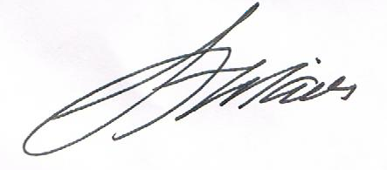
Len Maier, P. Eng.
President

Friends of Science Society
P.O. Box 23167, Mission P.O.
Calgary, Alberta
Canada T2S 3B1
Toll-free Telephone: 1-888-789-9597
E-mail: contact@friendsofscience.org

Low Confidence and Many Uncertainties Cloud IPCC Global Warming Predictions
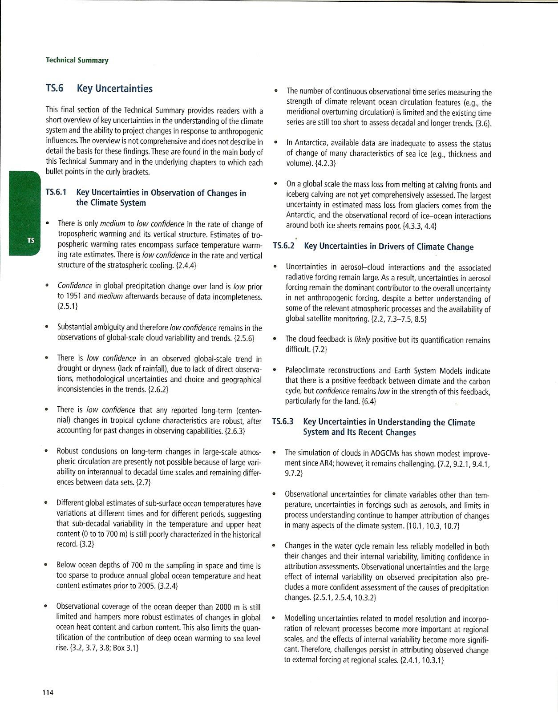

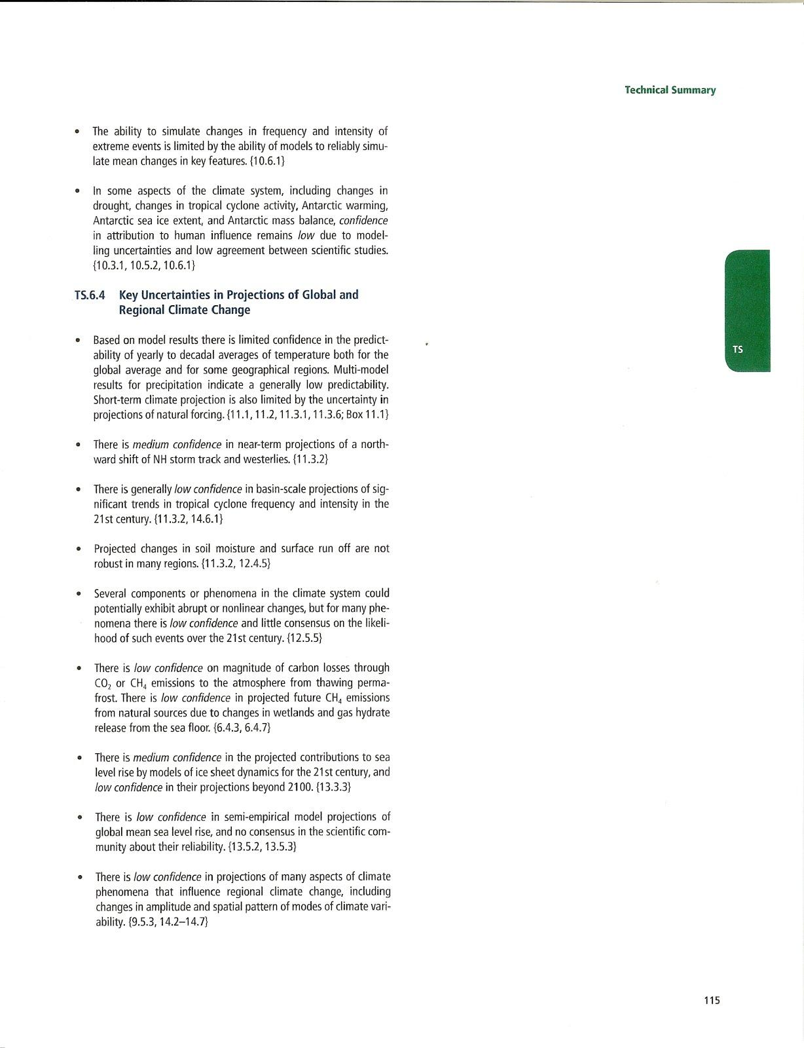
Appendix A
Proceedings of the National Academy of Sciences - Contributed Articles
An Academy member may submit up to four of his or her own manuscripts for publication per year. To contribute an article, the member must affirm that he or she had a direct role in the design and execution of all or a significant fraction of the work and the subject matter must be within the member’s own area of expertise. Contributed articles must report the results of original research. A special obligation applies to a Contributed paper for which the member or coauthors disclose a significant financial or other competing interest in the work. We no longer consider such submissions using the contributed route. Members who disclose a significant conflict of interest must submit their manuscripts using standard Direct Submission. When submitting using the contributed process, members must secure the comments of at least two qualified reviewers. Reviewers should be asked to evaluate revised manuscripts to ensure that their concerns have been adequately addressed. Members' submissions must be accompanied by the names and contact information, including e-mails, of knowledgeable experts who reviewed the paper, along with all of the reviews received and the authors' response for each round of review, and a brief statement endorsing publication in PNAS. Reviews must be on the PNAS review form. Members must select reviewers who have not collaborated with the authors in the past 24 months. See Section iii for the full conflict of interest policy. Members must verify that reviewers are free of conflicts of interest, or must disclose any conflicts and explain their choice of reviewers. The Academy member must be a corresponding author on the paper. These papers are published as "Contributed by" the responsible editor. As of July 1, 2011, members may contribute PNAS Plus articles. http://www.pnas.org/site/misc/iforc.shtml

PNAS conventional peer review method - Compare the ‘Contributed” process above with the real peer reviewed process below:
The standard mode of transmitting manuscripts is for authors to use Direct Submission. Authors must recommend three appropriate Editorial Board members, three NAS members who are expert in the paper's scientific area, and five qualified reviewers. The Board may choose someone who is or is not on that list or may reject the paper without further review. A directory of PNAS member editors and their research interests is available at http://nrc88.nas.edu/pnas_search. The editor may obtain reviews of the paper from at least two qualified reviewers, each from a different institution and not from the authors' institutions. For Direct Submission papers, the PNAS Office will invite the reviewers, secure the reviews, and forward them to the editor. The PNAS Office will also secure any revisions and subsequent reviews. The name of the editor, who may remain anonymous to the author until the paper is accepted, will be published in PNAS as editor of the article. Papers submitted directly are published as “Edited by” the responsible editor and have an additional identifying footnote.

Appendix B
National Academy of Sciences published the book (a free download) “Informing an Effective Response to Climate Change” in 2010 – which specifically refers to Oreskes’ unsupported claims in her study that “Politicians, economists, journalists, and others may have the impression of confusion, disagreement, or discord among climate scientists, but that impression is incorrect.”

“Another important barrier to improved public understanding in the United States has been the well-organized and well-financed campaigns by special interests, contrarian scientists, and defenders of the status quo to create public perceptions of scientific disagreement and to promote the idea that climate change is not happening, and that if it is happening, it is caused by natural factors or cycles, or will actually be a good thing (McCright and Dunlap, 2003; Menestrel et al., 2002; Oreskes, 2004).” Oreskes, N. 2004. The Scientific Consensus on Climate Change. Science 306(5702):1686.
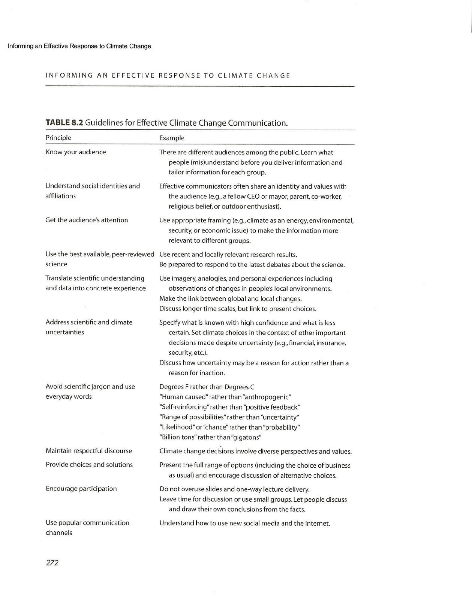

Appendix C - EXCERPTS of Site Rules for 2 Rejectionist websites

CLIMATE AUDIT - Steve McIntyre (excerpt of website comment rules)

Some Site Rules:
I oppose the censoring of scientific comments at realclimate and do not do that here. Unfortunately, light moderation opens the door for ad homs and taunting, which quickly involves everybody. I don’t have time to monitor everything so my handling of taunting has been inconsistent: sometimes I’ve let it go because the person is just making a fool of himself, sometimes I’ve got fed up and deleted it. A reader has written with the following suggested ground rules which are hereby adopted:
Blogs like this one provide a wonderful opportunity to people like me (a retired scientist) to get involved in an ongoing debate and it is very disappointing when the debate generates into one of these slanging matches. May I suggest some ground rules for posts:
1. Refrain from personal abuse and swearing,
2. Never attribute ulterior motives to another participant
3. Be patient with people who know less science or maths than you do yourself.
People who consistently break rule 1 and 2 should be issued with a yellow card by the moderator. If they continue they get a red card and are banned from the site.

Politics
While there’s a little politics from time to time, by and large, I would prefer that you don’t talk politics; there are plenty of other perfectly good places to do that.
Religion
I don’t allow discussion of religion and will mark anything even close as spam. I will not make any effort to snip such posts to recover salient non-offending portions.
New Posters:
New posters sometimes get tripped up in our spam filter. Unfortunately in today’s world, a blog like this gets attacked by hundreds of spams a day and they are screened by a computer filter. Some of the things that the spam filter looks for is a sudden burst of activity from an unrecognized address; it may allow some posts through and then get triggered after a while and start rejecting posts. If one of your posts doesn’t go through, don’t keep sending them in; it just inflames the spam filter. If you have yahoo or hotmail address, the spam filter may also screen you. Sometimes people get filtered for reasons that I don’t understand. However, despite this, we are reliant on the spam filter. Contact us by email if you get caught up- see contact category at right.

---------------

Roger Pielke Jr. offers a ‘rejected comments’ page on his blog

Comment policy: I welcome and encourage comments. Those that I deem to be inappropriate, trolling or otherwise unacceptable will be deleted without comment. Others may be moved here. If you do not like this policy or its application, I suggest getting your own blog.

Feel free to post here any substantive comments that I have rejected on another post for a second look. I will apply a lower threshold of acceptability to this thread.

Thanks!

Appendix D
Samples of the blogs that did post Lewandowsky’s survey
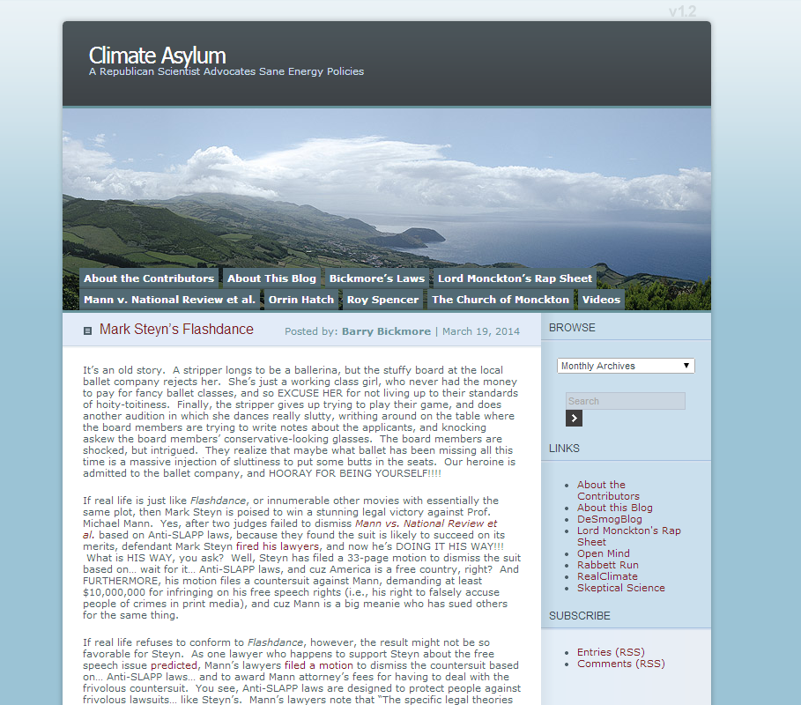

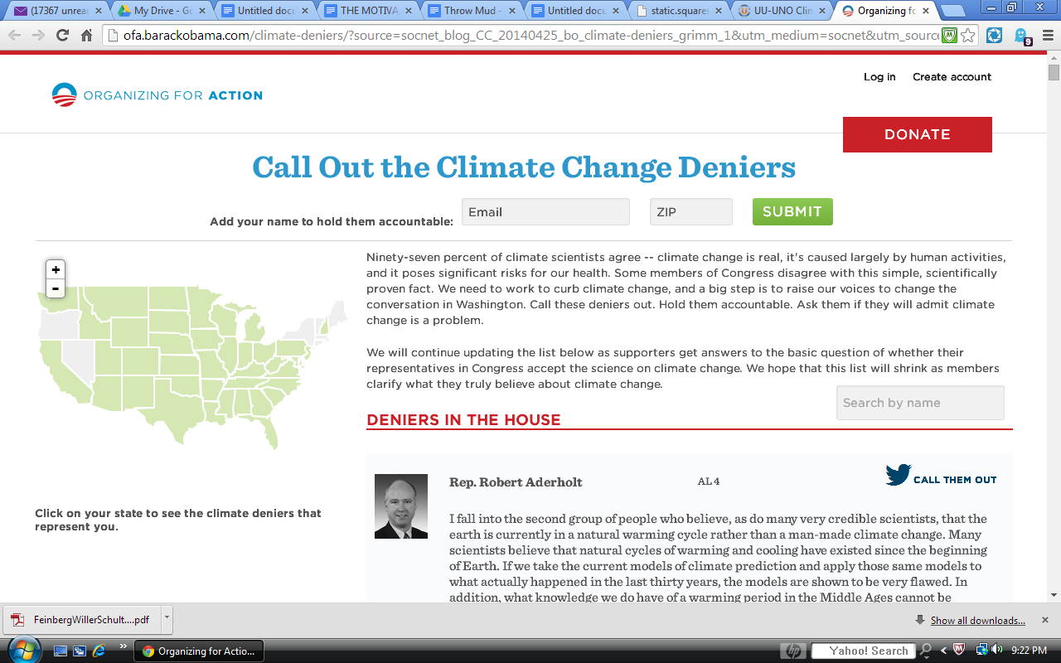

Who are we?
The Unitarian Universalist United Nations Office promotes well-being, peace, and justice throughout the world. Crucial to this effort is combating the impacts of the man-made global warming trend of climate change. The VISION of the UU-UNO Climate Change Initiative is a world with mitigated climate change viable for us and future generations. The MISSION is to provide motivation for climate action. An ambitious project is sparking and facilitating the creation of a national network of Climate Action Teams or CATs in UU Congregations. Click HERE for information.

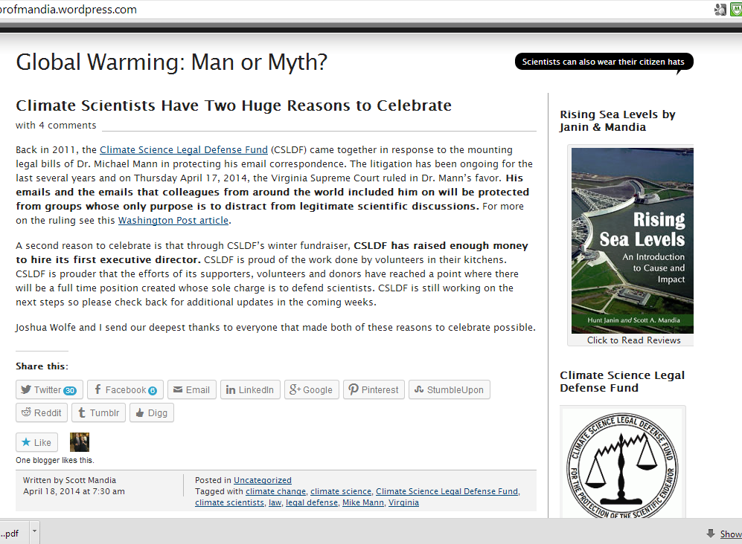

Written by Scott Mandia
April 11, 2014 at 1:25 pm
Posted in Uncategorized
Tagged with climate change, global warming, scientific consensus

Climate Science Legal Defense Fund Needs Your Help!
with 10 comments
The Climate Science Legal Defense Fund (CSLDF) was launched in January 2012 by Scott Mandia and Joshua Wolfe to provide valuable legal resources to our climate scientists who are in need. CSLDF needs your help.
CSLDF needs to raise $80,000. The great news is that philanthropist Charles Zeller has graciously offered to MATCH the first $40,000 that is raised and philanthropist Peter Cross has offered to put up the first $10,000. This means CSLDF already has the first $20,000 and needs only to raise another $30,000 in private donations to reach the goal. We need your help so CSLDF can reach this goal.
For the previous two years, CSLDF has been managed by Scott and Josh “from their kitchens”. They both have full-time jobs and families with small children and neither receives compensation for their time. Scott and Josh have accomplished much over the years on a part-time basis. To date, CSLDF has:
- Raised litigation fees to help Dr. Michael Mann defend climate science from politically-motivated witch-hunts.
- Provided resources to legal experts from Public Employees for Environmental Responsibility (PEER) so they could offer free legal advice to scientists at professional conferences.
- Offered legal counsel to scientists hit with frivolous Freedom of Information Act requests.
- Provided legal workshops to scientists at professional conferences.
- Offered a series of legal education webinars partnering with American Geophysical Union (AGU).
But now it is time to “go professional” and that is where you can help. $80,000 can move the organization to this next level. CSLDF will use your tax-deductible donations to hire a full-time Executive Director who will manage the day-to-day operations of providing legal help to our experts as well as increasing fundraising efforts. Having the full-time professional helps to assure that CSLDF will be there for our scientists years down the road. After all, climate change is not going anywhere and the sad fact is that neither will the legal attacks on our scientists.
Donations are tax-deductible and can be sent by visiting the CSLDF website atclimatesciencedefensefund.org and clicking the Donate button. Donations are sent to our fiscal sponsor PEER but are earmarked for CSLDF. Through PEER (Public Employees for Environmental Responsibility), a private non-profit organization organized under Section 501(c)3 of the Internal Revenue code, your contribution will be tax-deductible.
You can also send a check made out to PEER, with Climate Science LDF on the memo line, to support efforts to help scientists defend themselves:
Climate Science Legal Defense Fund
c/o PEER
2000 P Street, NW #240
Washington, D.C. 20036
International donors can use PayPal. Send to info@peer.org as the recipient and put CSLDF in the subject line of your payment.
Thank you for your support.
Joshua Wolfe (left) and Scott Mandia (right) at 2012 AGU
Update (03/20/14 @ 2:50 PM ET): CSLDF is NOT providing financial support for Dr. Michael Mann’s defamation suit against CEI, Simberg, National Review, and Steyn nor for the libel case against Tim Ball.

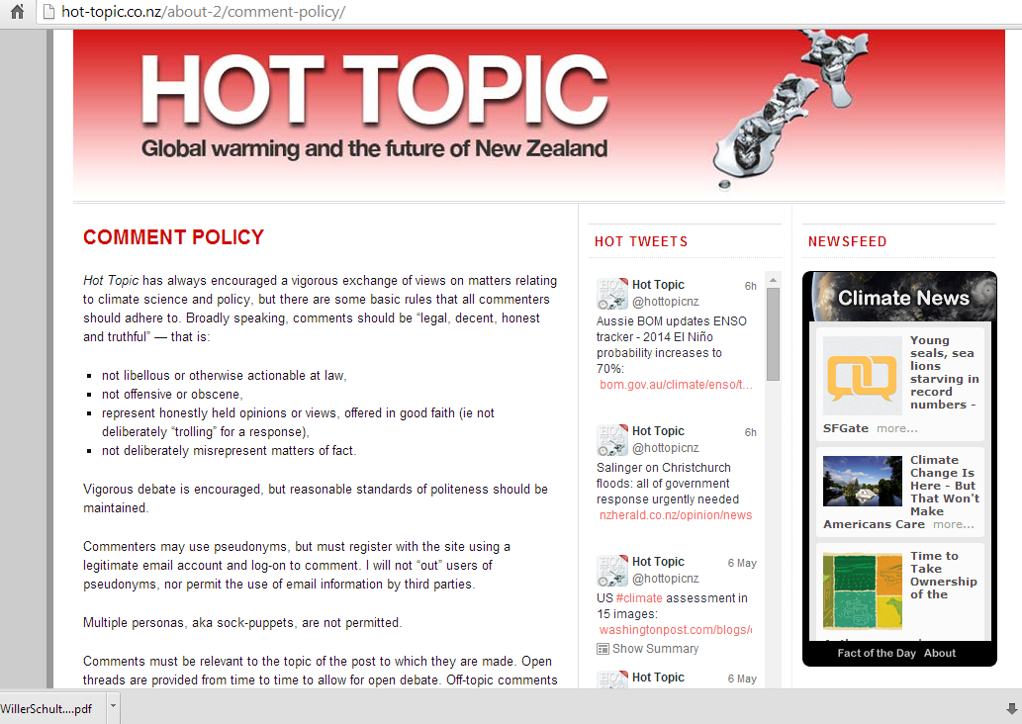

ICMJE - International Committee of Medical Journal Editors “Recommendations for the Conduct, Reporting, Editing , and Publication of Scholarly Work in Medical Journals” http://www.icmje.org/recommendations/
http://pss.sagepub.com/content/early/2014/01/24/0956797613510184.abstract
https://proxy.reeds.uvsq.fr/galleries/broceliande7/scandal-international-institute-applied-systems-analysis-iiasa-energy-scenarios
http://link.springer.com/article/10.1007%2FBF00138708
http://www.amazon.com/Apollos-Arrow-David-Orrell/dp/0002007401/ref=la_B002Y9P8XO_1_8?s=books&ie=UTF8&qid=1401540020&sr=1-8
http://sipi.usc.edu/~kosko/scientific%20american.pdf
http://www.friendsofscience.org/index.php?id=750
http://web.mit.edu/rpindyck/www/Papers/PindyckClimateModelsJELSept2013.pdf
http://www.sozialpsychologie.uni-frankfurt.de/wp-content/uploads/2010/09/MacDonald-Leary-20051.pdf
http://www.ncbi.nlm.nih.gov/pubmed/14551436
http://sanlab.psych.ucla.edu/papers_files/39-Decety-39.pdf
Example: Roger Pielke, Jr. discusses the bizarre placing of his scientist father on a ‘skeptic’ list and the Anderegg ‘blacklist’: http://rogerpielkejr.blogspot.ca/2010/06/new-black-list.html#comment-form_7941903830291770203
http://www.pnas.org/content/early/2010/06/04/1003187107
http://www.ipcc.ch/ipccreports/tar/wg2/index.php?idp=22 “The Intergovernmental Panel on Climate Change (IPCC) was established by World Meteorological Organization and United Nations Environmental Programme (UNEP) in 1988 to assess scientific, technical, and socioeconomic information that is relevant in understanding human-induced climate change, its potential impacts, and options for mitigation and adaptation.”
http://www.knmi.nl/research/ipcc/FUTURE/Submission_by_The_Netherlands_on_the_future_of_the_IPCC_laatste.pdf
http://onlinelibrary.wiley.com/doi/10.1029/2009EO030002/abstract
http://www.lulu.com/shop/m-r-k-zimmerman/the-consensus-on-the-consensus/ebook/product-17391505.html
http://www.skepticalscience.com/Debunking-Handbook-now-freely-available-download.html
http://www.uoguelph.ca/~rmckitri/research/WegmanOp-Ed.pdf

