” Resno® Urinal “
residential no Flush Urinal

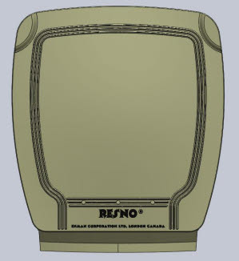

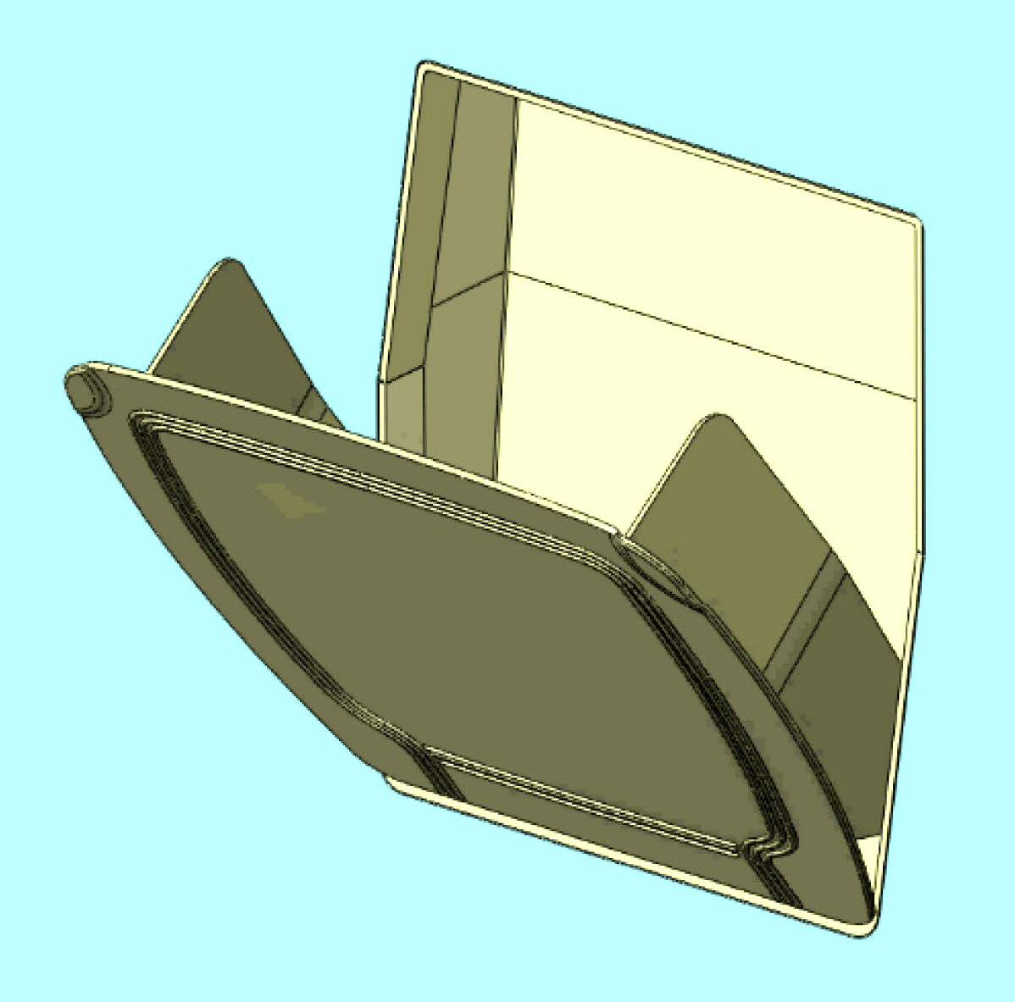

A Plumbing Fixture, specifically intended for residential use,
designed to be installed permanently into a 2x4 stud wall, for the purpose of disposing of male urine into a sewer system in a convenient and sanitary manner. The unit includes a tip-out door,
stopping at a specific angle, to provide a trough for the purpose of directing the urine into the drainage system. The one-piece trough/door easily lifts out for periodic sanitizing.

For generations, wall mounted flush urinals have been installed in public buildings. In the last 20 years, thousands of these have been replaced by similar looking “waterless urinals”. The reasons….. very low maintenance, yearly savings of Thousands of Dollars in water and sewer charges; but most important, the conservation of millions of gallons of water. The “ no water “ principle is very simple……….the trap utilizes a lighter than water “liquid seal”, through which the urine passes on its way down the drain. Odours are prevented from escaping up into the room by this seal. This liquid seal may occasionally need topping up, costing a few pennies. Periodic sanitizing is recommended, similar to a toilet. Waterless urinals are also more sanitary than traditional flush units. The reason is, that many bacteria require media such as water in which to survive. By eliminating the media, you eliminate the bacteria and the accompanying odours. Certified for use under Plumbing Codes in both Canada and USA.

The residential design is intended to provide a convenient and aesthetically acceptable fixture suitable for installation in rooms frequented also by females. Such rooms may include bedrooms, mud rooms, recreation and pool rooms. This invention also accommodates the age-old problem for women, toilet seat up; and urine splash around the toilet.

The "Resno® Urinal" installed in a wall, requires no added sq. footage to the size of the house. Installer friendly, of durable ABS construction, it is also designed for retrofitting into existing homes.

"If half the homes in London Ontario had “Resno® Concealed Waterless Urinals” it would save over a million gallons of water per day."

Excerpt from the report by Derek Satnic, P.Eng, LEED AP. (assumes 130,000 dwelling units, with 1.3 males per unit, using flush toilets.)

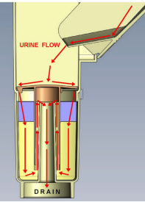

Patented. nwbrooks@rogers.com
Resno Corporation Ltd. N.W.Brooks* Pres.
716 – 517 Fanshawe Park Rd. W. London, ON
N6G 0C1 www.resno.ca 519-668-6200

*Lifetime Member – London Home Builders Association.

