So, what is ONICS?

To put it simply, ONICS is a solution to transform an "everyday" car into a smart car, using the power of your smart phone.
As transportation and mobile computer technology continue to develop, more and more consumers are looking for ways to integrate their smartphone into their vehicle for music, entertainment, and other connected usages. ONICS Corporation is a San Diego, California based car aftermarket company that developed a proprietary system that aims to accomplish that goal, and so much more for the consumer. With our patented (some claims still pending) double-din unit, ONICS allows the consumer to unlock the power of their smart phone to not only be used as their in-dash radio, but also as a GPS, and even further granting access to information ranging from the temperature outside to the temperature of your engine coolant. The ONICS system unlocks all the power and capability of a smart phone, software applications, as well enhanced user interfacing to create a safer, smarter, and better way to drive.
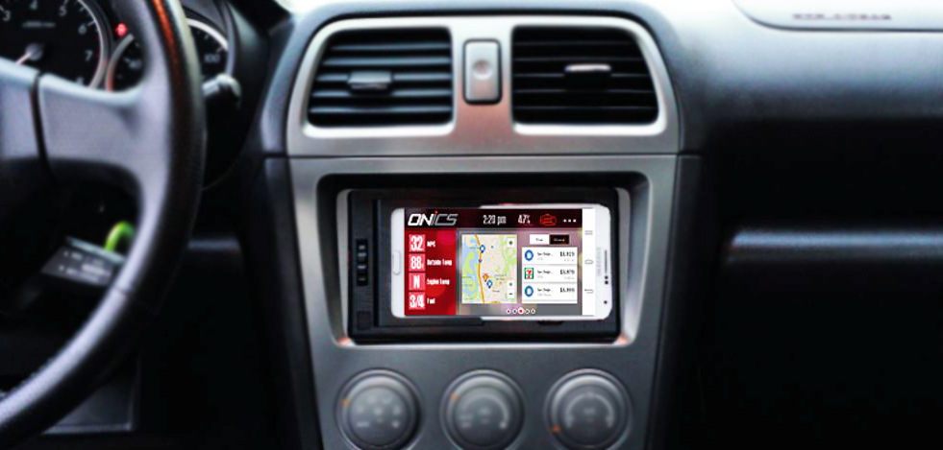
With ONICS' "hotword" application, you simply say: "Call Beth (example)" and you are calling your friend. No need to take your hands off the wheel. Safety comes first.
More and more car stereo manufacturers are attempting to mirror the abilities of a smart phone into the computer that manages the cars "infotainment" system. ONICS evolves your experience with integrating your smartphone and your cars infotainment system, and turns your car into a smart car. Any car with an on-board diagnostic system (OBD or OBD-II) -which is every car on the road since 1996 - ONICS turns one's car into a smart car to rise above the best original equipment manufacturer (OEM) infotainment system.
Video about our product:

VIDEO: https://vimeo.com/103683034

What ONICS does differently for the consumer, is it takes something as simple as your gas tank being close to empty, and it directs that information towards an end-user benefit. The ONICS system knows your gas is low, and it knows how far you can go until you run out. Additionally, it knows how much the gas costs when you get to the gas station, and offers up directions so you don't lose your way getting there.
Competitors in the market currently are unable to view and react to the needs of the consumer effectively; either they are trying to put a dated computer into a car that will pull data from a smart phone (Apple’s CarPlay/Android Auto), or they provide a decent software foundation but no hardware. These opportunities in comparative systems also include dated touch screens and sub-par graphical interfaces, as well as slower processors. Most systems require running cables or attaching a cradle via a suction cup mount (dash, car mode provided by major carriers, iBolt, etc.), and in other instances, they involve expensive aftermarket stereo units which do not have the software support nor the hardware to keep up with advances in technology (Pioneer, Alpine, Kenwood, JVC, etc.).
By providing an affordable aftermarket stereo that provides smart car functionality, ONICS uniquely positions itself as the only solution to allow the consumer to use the powerful computer they already own in their pocket, while safely (and aesthetically) integrating it into their vehicle’s dashboard. Users can switch out their smart phone with a newer one at the touch of a button, using ONICS’ patented faceplate technology. This great feature allows one to constantly upgrade their “smart system” by using a more powerful and more capable device.
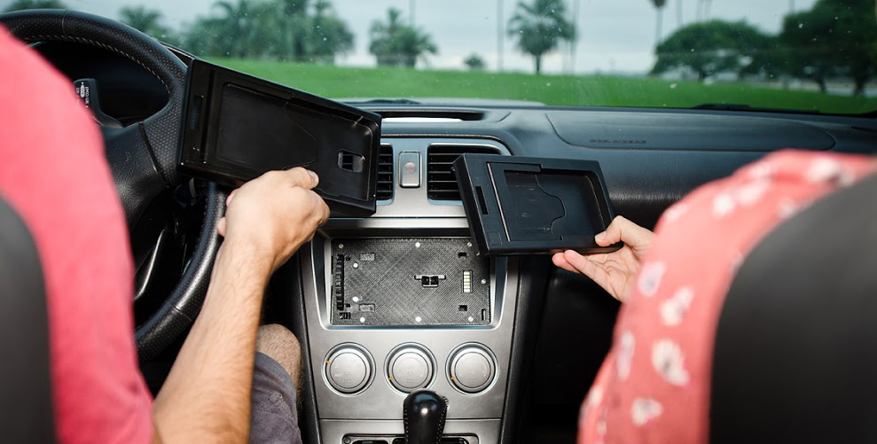
ONICS works with virtually every phone, and every car.
How did ONICS start?
Key Features:
- Bluetooth connection so phone does not need to be docked to use for features
- Any application on your phone can be used inside ONICS
- Voice-to-text and voice-calling built in. MUSIC/GPS/ETC
- Parental Controls for driving available: See if your son or daughter is using the phone while driving or speeding to school
- Smart car applications built into ONICS application
Two hourly retail-sales “geeks” start a tech company...
ONICS was born 3 years ago when the CEO and Founder, Aaron Speach, drove to work each day seeing phone suction-cup mounts and cables hanging all over the dashboards of people's cars. Working as a sales associate in a big-box retailer, he often heard customers telling him that they wanted a better way to integrate their phone into their car; mainly to use basic functions like maps and music. Aaron immediately went to the drawing board, and put a large amount of time and money into coming up with the solution that would later transform into ONICS. He patented a unique way to interchange the numerous shapes, brands, and sizes of smart phones (which at the time were not as smart as today's devices). The idea was a great one, yet Aaron needed assistance in the realization of this vision, and he enlisted the help of a good friend and co-worker to help bring this product to reality. Chad Sherwood was brought in as the Chief Operations Officer and Co-Founder, and he immediately began working on hardware and software solutions to integrate all the benefits of a smart phones capability with the computer of a car.
Comparison to Apple Carplay and Android Auto
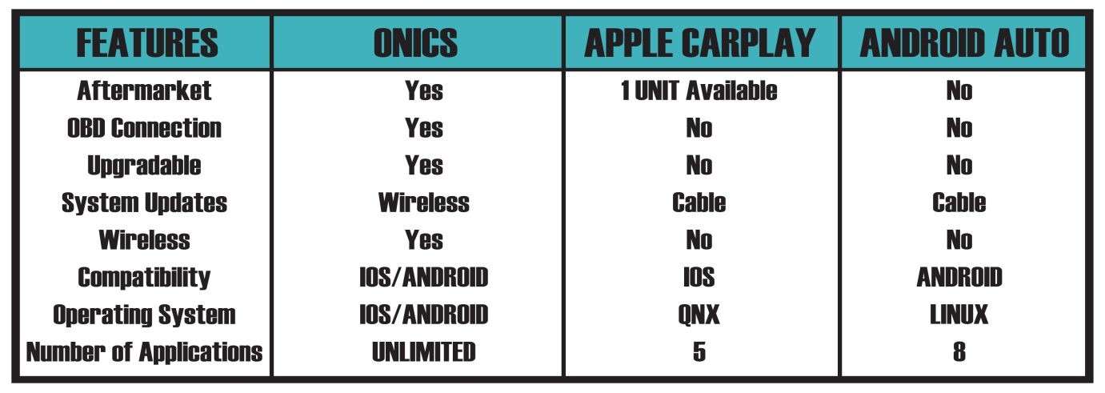
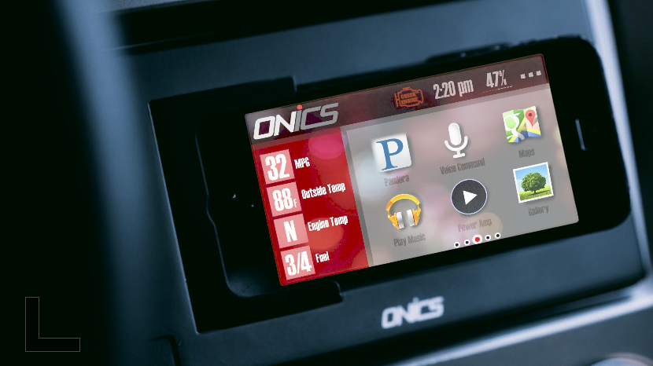

Below are some highlights to read. A private video about our company can be viewed by clicking the link:

- 2 retail sales people from San Diego went out to start a tech company (3 Years active) after listening to customers complain about current technology availability inside the store

- ONICS Corporation was formed this year, and it now has offices in San Diego (Carlsbad and Santee to be specific). ONICS has been working with big names like Texas Instruments to design the circuit board and release the product in the market; the lead engineer from a VERY well recognized audio/headphone company is also our lead electrical engineer at ONICS

- ONICS will compete directly with Android Auto and Apple's Car Play, yet will be tailored to the car aftermarket space

- With patented faceplate technology, the user can place their Smart Phone into the dash of their car, and can use unlimited applications, as well as upgrade their phone over time to improve their experience with ONICS

- ONICS connects to the computer(s) in the car, and directs that information for an end-user benefit using the Smart Phone's connectivity

For further questions and contact information, please see information below:
Chad Sherwood: chadsherwood@onicsusa.com
760 | 908 | 5246
www.onicsusa.com

