

**VITAL FORCE TECHNOLOGY**

**STRESS RELIEF FORMULA EFFECTS**

Experiments on mice and research with humans

**Introduction: About Stress**According to the American Medical Association, stress is a major cause of human illness and disease. Further, in its annual “Stress in America” survey, the American Psychological Association reports that Americans continue to experience high levels of stress, with adults 50 and over in caregiver roles showing the most acute levels. The report goes on to state that many stressed Americans rely on unhealthy behaviors such as sedative drugs and overconsumption of alcohol to manage stress.

**Stress Relief from Energy Tools**

Research with mice and humans shows that materials infused with energy from a unique proprietary process called Vital Force Technology reduces stress and anxiety, promoting a normal state without the sedative effect found with many drugs. Developed by noted Russian physicist Dr. Yury Kronn, Vital Force-infused Stress Relief compounds, liquids and other materials have been successfully used by complementary medicine practitioners to reduce the effects of stress and promote a sense of well-being.

Vital Force Technology’s Stress Relief energy signature can be applied to almost anything, including minerals, herbs and liquids. The energy signature is a stable, non-chemical process that enhances and amplifies the stress-reducing effects of any existing formula or compound. Research further shows that along with the reduction of stress comes more energy and focus.

**Research**

Research on the effects of Vital Force-infused Stress Relief formula was conducted in Europe at the Riga Stradin University in Latvia, and in the U.S. at the Center for Cognitive Enhancement in Glendale, AZ; at Beech Tree Labs in Providence, RI; at the Veteran’s Hospital in Dayton, OH; and at Schuylkill Bio-Nutritional, Inc. in Schuylkill Haven, PA.

***These experiments, taken together, demonstrate that Stress Relief formula not only positively affects the central and autonomic nervous systems, but also enhances the viability of cells in stressful conditions*.**

In the tests at Riga University, mice were subjected to the Open Field test, a test widely used to gauge the effects of drugs. Mice are placed in an enclosure and closely observed. The results in the Vital Force/Stress Relief tests were dramatic. Mice who drank water infused with the Stress Relief energy pattern exhibited a higher level of motion activity than the control group.The mice walked further, ran faster and had more fast movement episodes than mice who had not received Stress Relief formula. They also demonstrated more central zone crossing activity, indicating a significantly lower fear level (**Fig.1**). Fearful mice tend to stay close to the sides of the enclosure.

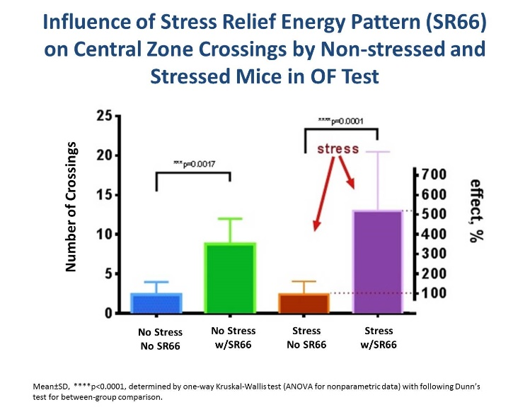

**Fig.1**

Another key measure of stress is blood glucose. Generally, the more glucose in the blood, the higher an animal’s stress level. Blood glucose tests were conducted with all mouse groups to determine

physiological changes produced by stress. The results showed that stressed mice that did not drink water with Stress Relief had significantly elevated levels of glucose in the blood, 30%, higher than in the control group. On the other hand, stressed mice that drank water with Stress Relief had the same glucose level as non-stressed mice in the control group (**Fig.2**).

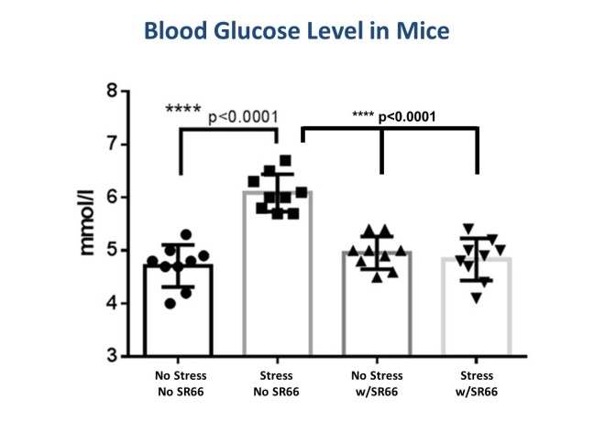

**Fig.2**

***The results showed that stressed mice that did not drink water with Stress Relief had significantly elevated levels of glucose in the blood, 30%, higher than in the control group.***

**Additional Studies**

In addition to studies involving mice and stress, researchers also looked at the direct result of Stress Relief formula on humans and human cells.

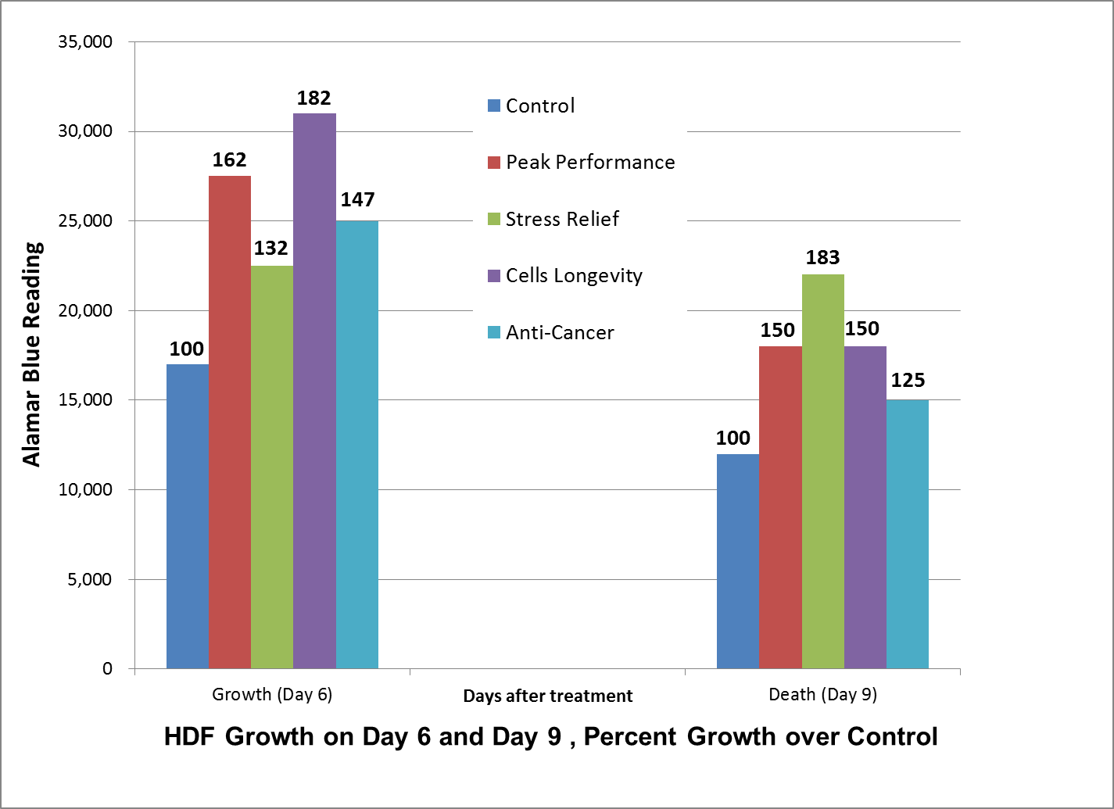

**Human Dermal Fibroblast Cells Growth on Day 6 and Day 9, Percent Growth over Control**

At Beech Tree Labs in Providence, RI, involving experiments on human skin cells (**Fig.3**) results showed even with the stress of “food deprivation” conditions,Stress Relief formula prolonged cell life by 83% and enchanced cell growth by 32%.

In a study at the Center for Cognitive Enhancement (**Fig.4**), human participants used Stress Relief three times daily for a period of 14 days and were measured with the Perceived Stress Assessment.

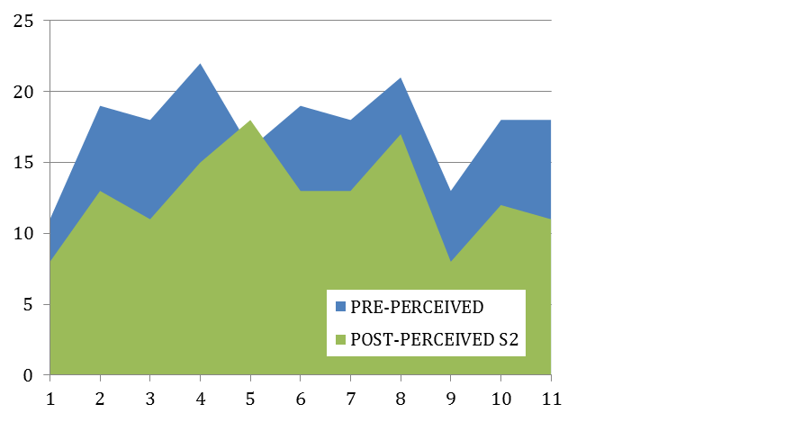

**Fig.4**

**Perceived Stress Assessment Data pre- and post-**

**Fig.3**

As the graph shows, all subjects registered a stress level between 11 and 22, (the lower number indicating less stress) prior to the use of stress formulas. After using the formula, all subjects registered a stress level between 8 and 18. On average, Stress Relief formula diminished the stress level by about 25%. Further, using a Stress Profiler tool, a majority of the subjects indicated they felt less stress and anxiety in their life. Group scores also showed significant stress reduction. The average score of this group prior to using the stress formula was 222, putting the group into the “A Little on Edge” category. After using Stress Relief, the average score from the Stress Profiler was reduced to 187, putting the group into the “Easygoing” category.

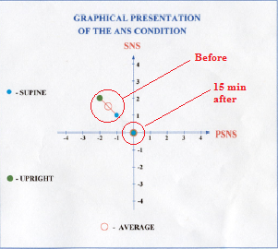

**Fig.5**

**Heart Rate Variability Test**

**Presentation of the ANS condition**

**Heart Rate Variability Test**

**Presentation of the ANS condition**



Further human tests were carried out at Schuylkill Bio-Nutritional, Inc. using a standard heart rate variability test. (**Fig.5**). Results revealed that Stress Relief significantly improves the balancing of the sympathetic nervous system; which releases stress hormones when we feel threatened, and parasympathetic nervous system which regulates relaxation.

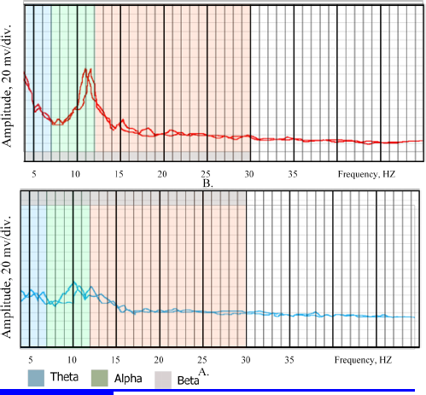In another human experiment with brain waves, electroencephalograms (EEGs)at the Veteran’s Hospital in Dayton, OH, subjects showed increased synchronization of the left and right hemispheres of the brain after using Stress Relief formula. Brain synchronization has been found to be useful for meditation, relaxation and creativity. Subjects also showed stimulation of greater alpha wave rhythm activity synchronously in both hemispheres of the brain (**Fig.6**). Alpha waves are also associated with meditation and relaxation.

After

**Fig.6**

**Synchronization of the left and right hemispheres of the brain**

**Fig.5**

**Conclusion**

Research with both mice and humans has demonstrated the stress-reducing effects of Vital Force Technology’s Stress Relief formula. Stress Relief formula not only positively affects the central and autonomic nervous systems, but also enhances the viability of cells in stressful conditions. Additional research shows that Stress Relief increases focus and energy, promotes a sense of well-being and helps the brain operate at its best by helping balance and synchronize the body’s nervous system

Beforee

**References**

Carnegie Mellon University. "Stress Contributes To Range Of Chronic Diseases, Review Shows." ScienceDaily. ScienceDaily, 10 October 2007. <[www.sciencedaily.com/releases/2007/10/071009164122.htm](http://www.sciencedaily.com/releases/2007/10/071009164122.htm)>.

American Psychological Association, “Stress in America Survey,” Jan. 2012, http://www.apa.org/news/press/releases/stress/2011/final-2011.pdf

Energy Tools International website, <http://www.energytoolsint.com/who-we-are/dr-yury-kronn/>

If you have been looking for that “missing ingredient” to complete and help differentiate your product from the hundreds of stress-relief formulas and systems, contact Energy Tools International:

[www.energytoolsint.com](http://www.energytoolsint.com/) | [www.vitalforcetechnology.com](http://www.vitalforcetechnology.com)

Real Science. Real Solutions.

PO BOX 981 Eagle Point, OR 97524

T: 800-341-7458 | O: 541-830-0411 | F: 541-830-0119