FOR IMMEDIATE RELEASE

For more information, contact: Mary Crotty: 704-968-8286
marycrottywriting@gmail.com

ACCHL and NC State Hockey Announce Stephen Russell Memorial Tournament for October 10-13, 2014

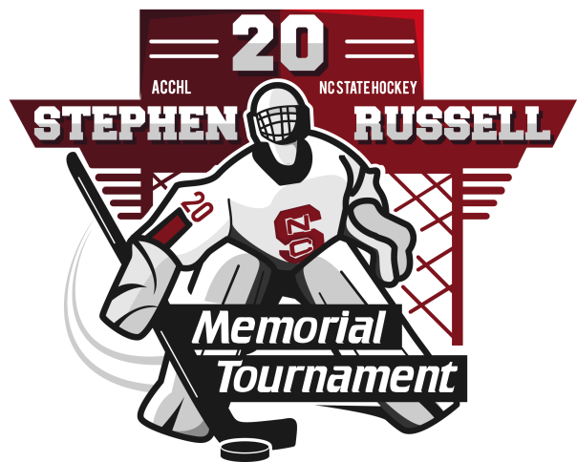
RALEIGH, NC – (September 2, 2014) – The Atlantic Coast Conference Hockey League (ACCHL), in cooperation with NC State Hockey and Stephen’s family announced today that the Stephen Russell Memorial Tournament will take place October 10-13 in Raleigh, North Carolina. The tournament is the official kick-off for the league’s 2014-2015 men’s ice hockey season.

Since 2009, NC State Hockey, in association with Stephen’s family, has sponsored the memorial tournament in honor of the former goalie, a member of the NC State hockey club from 2006 until his death on July 4, 2009. This year, the ACCHL joins forces with host team NC State to expand the tournament’s power to showcase the league’s talent while raising money for national charities, Defending the Blue Line and Wounded Warrior Hockey.

“The ACCHL is so proud to be involved with the Stephen Russell Memorial Tournament,” said Mike Walley, ACCHL Commissioner, RDML (ret.), USN. “In learning about Stephen’s life and legacy, he represented the best of hockey both on and off the ice – character, commitment and competitiveness – exactly what our league strives to engender in the young men who play for our member schools.”

The tournament will take place over Columbus Day weekend at the Raleigh Center Ice and the Raleigh Iceplex rinks. It will feature a Skills Competition and North vs. South All-Star Game. The tournament schedule will be published later this month and tickets will be available at the door.

All nine ACCHL teams will participate in the tournament as the league’s season kick-off. This includes Duke University, Elon University, George Washington University, Georgetown University, NC State University, the University of North Carolina at Chapel Hill, Wake Forest University, the US Naval Academy, the University of Virginia and High Point University. In addition, the University of North Carolina at Charlotte has also committed to play.

“We are so pleased about the scope of this tournament. It is truly a celebratory event; we showcase the game of hockey, and we remember and celebrate a beautiful boy. We hope to have a great turnout of fans, and invite hockey players young and old to come out to watch the games,” said Kelly Buckley, Stephen’s mother.

About the ACCHL
The Atlantic Coast Conference Hockey League (ACCHL) is an ice hockey conference consisting of several Mid-Atlantic colleges and universities. Founded in 1995, it is the objective of the league to promote the growth of college ice hockey, and ice hockey in general, in the Mid-Atlantic and Southern regions of the United States. For more information, visit http://acchockey.com/.

About NC State Hockey
The NC State hockey organization was established in the late 1970s and has continued to grow ever since. For the past two seasons, the team has been the ACC Regular Season Champion. In addition to promoting the sport of ice hockey on and around campus, the team is also active in charitable endeavors. For more information about NC State Hockey or the Stephen Russell Memorial Tournament, visit http://www.ncsuhockey.org/.

