ELIGIBLE AREAS IN LAS VEGAS VALLEY
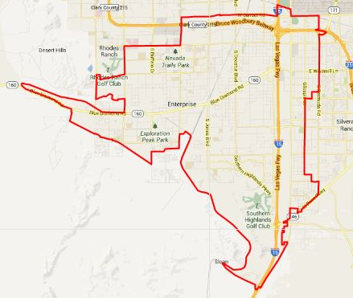
SUMMERLIN SOUTH
http://www.maptechnica.com/us-city-boundary-map/city/Summerlin%20South/state/NV/cityid/3270900
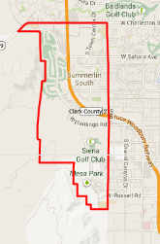
ENTERPRISE
http://www.maptechnica.com/us-city-boundary-map/city/Enterprise/state/NV/cityid/3223770
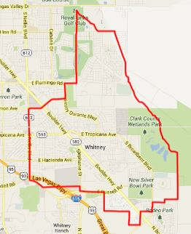
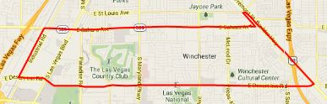

WINCHESTER
http://www.maptechnica.com/us-city-boundary-map/city/Winchester/state/NV/cityid/3284600

WHITNEY
http://www.maptechnica.com/us-city-boundary-map/city/Whitney/state/NV/cityid/3283800

