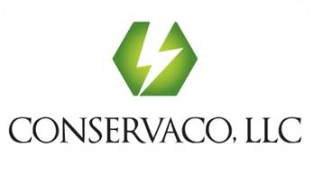
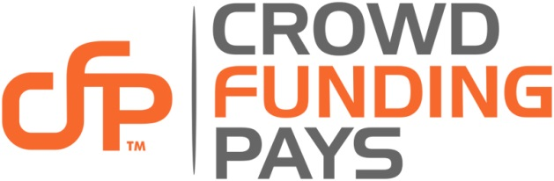

Largest Ever Crowdfunding Hackathon Taking Place in Irvine, CA

“A Forum for Entrepreneurs and Developers Alike to Transform Ideas into Reality”

CrowdFundingPays Hackathon All Weekend of October 10th - It’s on Us!

September 2, 2014 | Source: Crowd Funding Pays (CFP)
Irvine, California, September 2, 2014 (PRWEB) –300 of SoCal’s most brilliant developers, entrepreneurs, and mentors will collaborate at FundHack.com to bring visions to life. Joined by the UC Irvine Antrepreneur Center and Blackstone Launchpad, Crowd Funding Pays, a division of Conservaco, LLC (www.crowdfundingpays.com), is hosting a FREE Hackathon for entrepreneurs and developers to gain mentorship and assemble as many as 46 innovative crowdfunding projects in 46 hours.

The event will feature interesting speakers, prizes, and knowledgeable mentors, who will coach participants through the process of their choice. All meals and snacks will be provided at no charge.

The event will commence on Friday, October 10th at 6 pm and will end Sunday, October 12th at 4 pm at the Eureka Building, 1621 Alton Parkway, Irvine, CA 92606. Plenty of free parking for all attendees. Onsite helicopter landing reservations must be made in advance.

Space is limited to 300 participants, so any interested participants should register immediately! The event is free to all pre-registered participants. Individuals can sign up as a team (maximum of 5 members), or they can sign up individually and join with other individuals at the event.

Participants have three options: they may 1) take an existing idea and post it on CrowdFundingPays.com to gain funding, 2) create a product, service, or non-profit initiative and develop a campaign to post when ready, or 3) Just have fun creating their hack, app or other cool tech idea.

Mark Thimmig, Chairman, CEO states, “CrowdFundingPays.com is also offering an exclusive rate of 50% off CFP’s platform fees for all participants, so participants can post their ideas on CrowdFundingPays.com at the end of the weekend for as little as 2% of the total funds a campaign raises.”

In addition to UCI and Blackstone Launchpad, various local businesses have generously sponsored this event to keep it free for participants. We welcome additional sponsors for funding, prizes and giveaways. Further sponsorship information or event details and registration can be found at www.FundHack.com.

About Crowd Funding Pays:
Crowd Funding Pays, (CFP) a division of Conservaco, LLC, formed to meet the rapidly growing demand for rewards-based crowdfunding. Launching in mid-September, 2014, CFP offers a simple crowdfunding platform to present your vision and persuade others to pitch in. We are a place where you will find everything you can imagine: music, films, theater, comics, games, art, design, technology, nonprofits, small businesses and so much more. We also offer courses through LearnCFP.com to help the crowdfunding do-it-yourselfer, or get all the help you need through our fully integrated Marketing and PR agency through IgniteCFP.com for those who want start-to-finish guidance and support.
There is no fee for you to create and launch your campaign on CrowdFundPays.com. We provide a simple to use service that gives you all the tools needed to make your story come alive and raise the funds you need.

For more information, visit www.FundHack.com.
Media Contact: Mark F. Thimmig, mthimmig@crowdfundingpays.com

