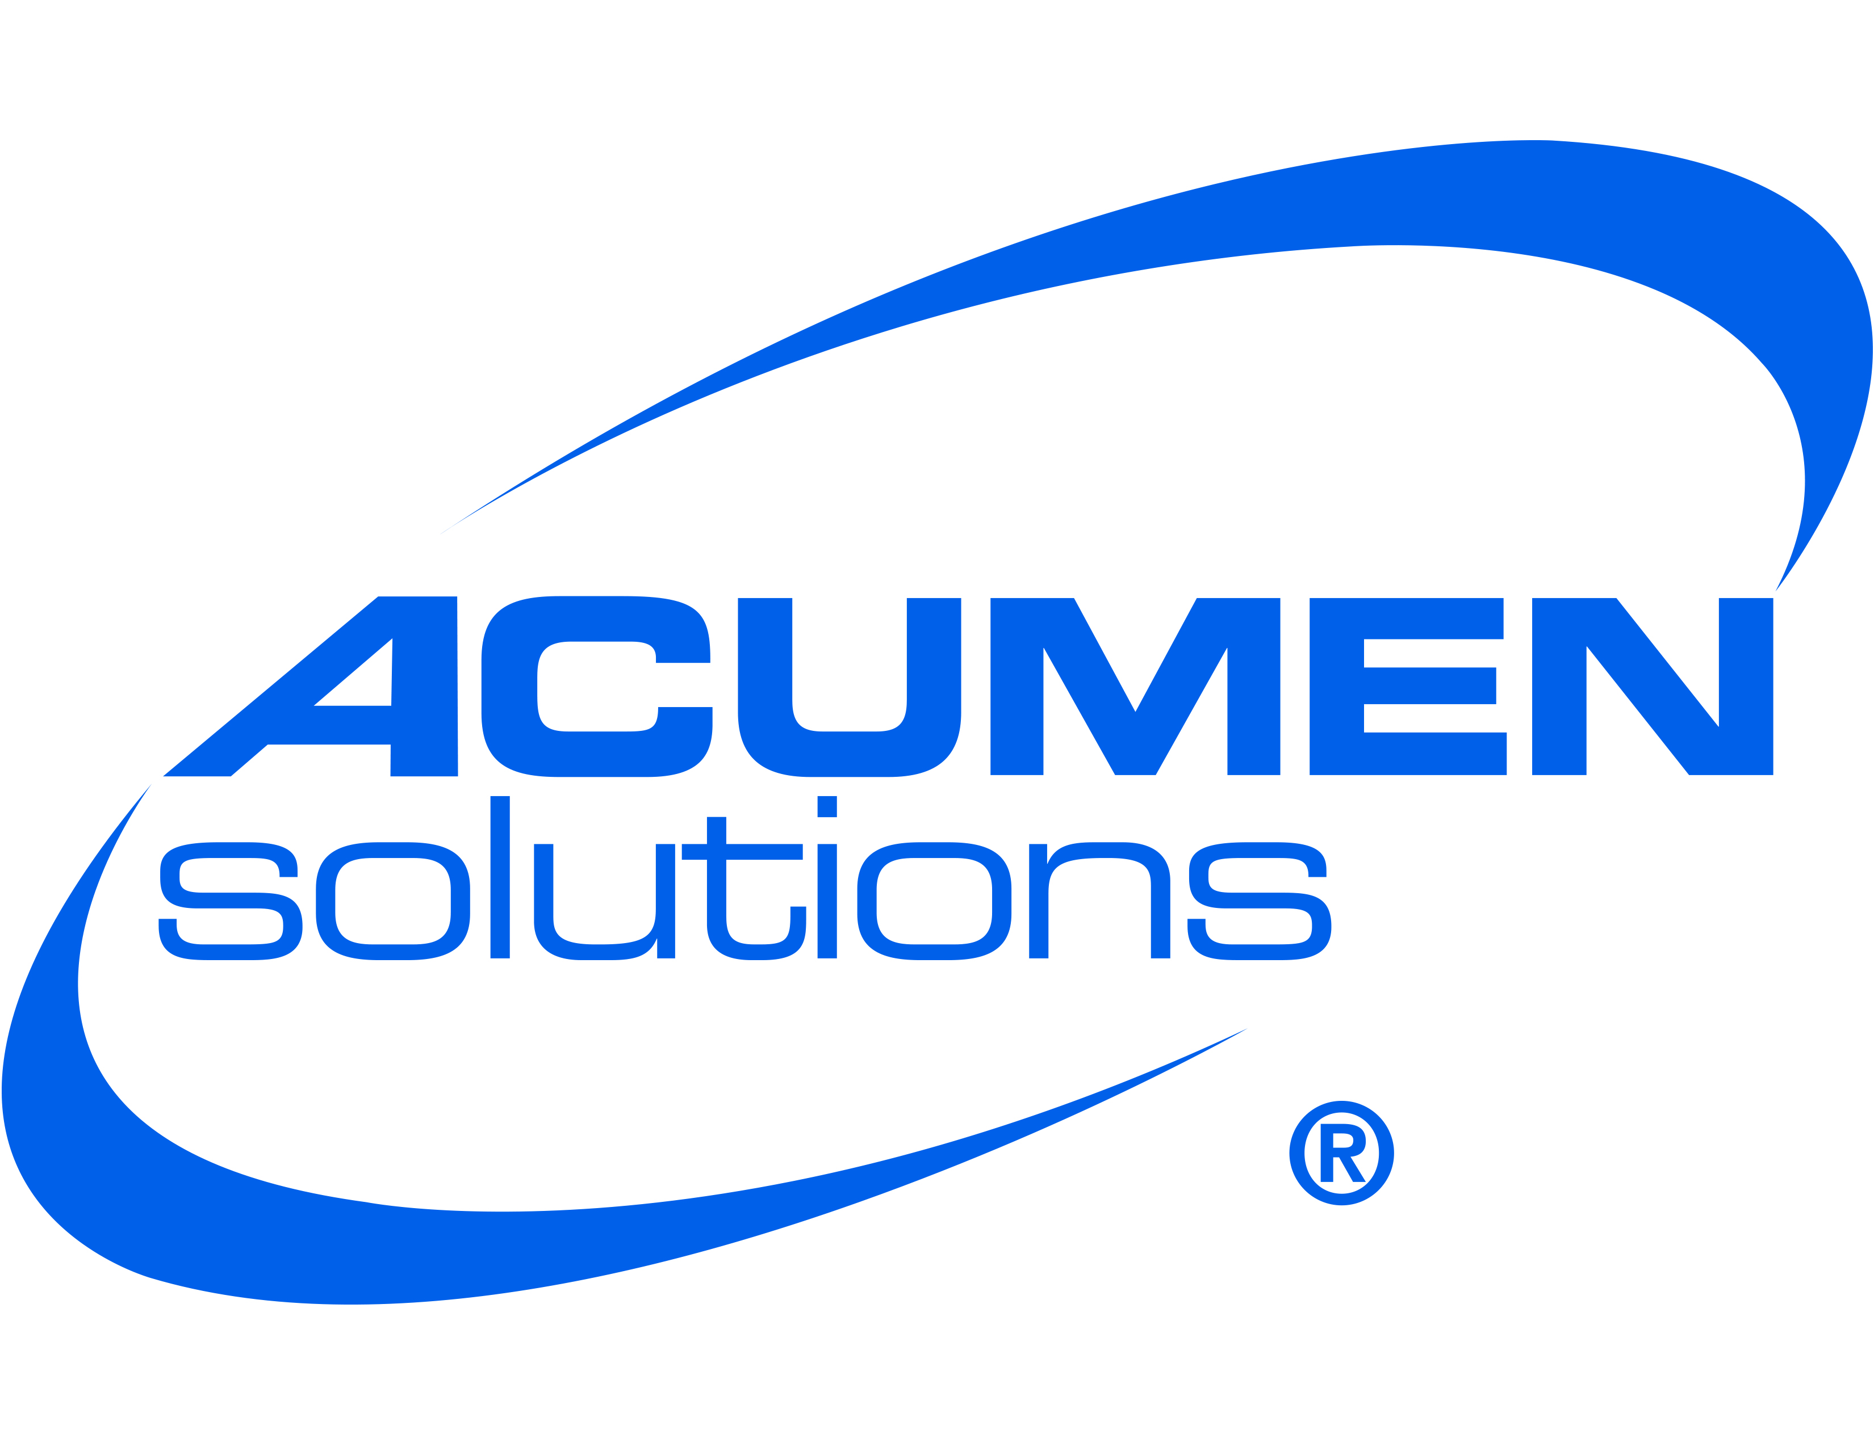
FOR IMMEDIATE RELEASE

ACUMEN SOLUTIONS’ 6TH ANNUAL RACE FOR A CAUSE™
SET FOR SUNDAY, OCTOBER 19
Leader in Enterprise Cloud Transformation Gives One Hundred Percent of Net Race Proceeds Back to Local DC Metro Nonprofits

MCLEAN, VA – (September 2014) – Acumen Solutions, the trusted leader in Enterprise Cloud Transformation and an avid supporter of community outreach initiatives, is pleased to announce that its 6th Annual Acumen Solutions Race for a Cause™ 8k and 1-Mile Fun Run, will take place in Arlington, VA, on Sunday, October 19, 2014, beginning at 8 a.m. The company’s signature philanthropic event was created to help raise proceeds for local nonprofit organizations in the greater DC Metro area, and to provide them with an avenue for increased exposure and expansion of their volunteer and support networks. Last year, the race marked its highest registration to date, attracting more than 3,600 runners and distributing more than $250,000 to 10 local nonprofit organizations.

"The Race for a Cause™ event was developed by, and is executed under, Acumen Solutions’ Corporate Social Responsibility program, and is integral to our philosophy, spirit and culture,” states David Joubran, President and CEO of Acumen Solutions. “The goal of our race is to support various nonprofits we work with, while also bringing all of our supporters together in one place. Our race day is easily one of the most exciting and rewarding days of the year for me, and the volume of family, friends, clients and partners who come out to support us is truly inspiring.”

The Race for a Cause™ is intended for those of all ages and skill levels – from families with youngsters to serious runners – making it a popular event within the DC Metro community. The race will take place on a fast out-and-back, flat course that begins and ends on North Quincy Street, near the intersection of Wilson Boulevard in Arlington. Participants with young children and babies (strollers welcome!) are encouraged to join in the 1-Mile Fun Run. In addition to raising money for a good cause, the race allows participants to enjoy the company of friends, while supporting both their personal health and local community.

One hundred percent of the net race proceeds are allocated to qualifying nonprofits, while Acumen Solutions also donates the time of its employees in order to promote and execute this annual event. Over the past six years, Acumen Solutions’ innovative approach to the fundraising for this event has greatly increased race proceeds, sponsors, and registrants. This race offers each participant the opportunity to “vote” for their preferred charity when registering. Participating nonprofits, along with Acumen Solutions, are equally responsible for promoting the race and obtaining a minimum number of registrants for their organization to qualify for any race proceeds. In 2013, Boys and Girls Club of Greater Washington registered the most runners, and American Childhood Cancer Organization was a close second.

-- more --

Page 2 of 2, Acumen Solutions’ 6th Annual Race for a Cause™

This year’s Nonprofit Beneficiaries include:

- American Childhood Cancer Organization
- Boys and Girls Club (Alexandria-Olympic Branch)
- GRREAT: Golden Retriever Rescue, Education & Training
- Literacy Council of Northern Virginia
- National Fatherhood Initiative
- Ronald McDonald House
- Shelter House
- The Reading Connection
- The Women’s Center
- Young Playwrights' Theater
Registration for the race is open now through October 16, 2014. Participants can register online by visiting www.theraceforacause.com. Cost to participate in the 8k is $35 (through Packet Pick Up on Oct. 18); $40 on race day. For the 1-Mile Fun Run the cost is $30 (through Packet Pick Up on Oct. 18); $35 on race day. All adult registrants receive a technical race shirt; youth registrants get a “fun” t-shirt, and everyone is eligible to win one of the fabulous raffle prizes, which will be awarded post-race.

Additional Resources:
• For additional race information, please visit www.theraceforacause.com
• Like Acumen Solutions Race for a Cause™ on Facebook: https://www.facebook.com/Acumensolutionsraceforacause8k
• Follow Acumen Solutions on Twitter: https://twitter.com/AcumenSolutions (hashtag #AcumenSolutions and #R4AC)

About Acumen Solutions Corporate Social Responsibility (CSR) program
The mission of the Acumen Solutions Corporate Social Responsibility (CSR) program is to maximize impact by providing financial, intellectual, and human capital to select nonprofit partners that inspire our employees. Our innovative approach is employee-driven and is focused on supporting deserving charities located where our employees live, work and volunteer. Our community support takes on three forms: funding, pro-bono service (training and skills), and hand-on service (human capital).

About Acumen Solutions
Acumen Solutions is the trusted leader in Enterprise Cloud Transformation, helping organizations realize dramatic improvements in productivity and profitability through innovations in business and technology. For over 15 years, Fortune 500 companies and government agencies have relied on our global consultants to deliver cloud solutions that yield exceptional results. We apply this same focus on results to our unparalleled social responsibility program, generating sustainable impact across our local communities. For more information, please visit our website at www.acumensolutions.com or follow us on Twitter at @AcumenSolutions.

# # #

MEDIA CONTACT:
Heather Noll | Chalkboard Communications | 415.290.2891 | heather@chalkboardcommunications.com

COMPANY CONTACT:
Andrea Moran | Acumen Solutions | 703.600.4000 | amoran@acumensolutions.com

